- The sentences below are about monomers making polymers in nature.
State whether the sentences are true or false.
Write ‘T’ or ‘F’ in the box.
- Examples of carbohydrates include sugar and starch.  - Carbohydrates are made of hydrogen and carbon only.  - Glucose is an example of a sugar.  - Starch is an example of a polymer made from glucose monomers.  - Glucose monomers can also form a polymer called cellulose.  - When sugar makes a polymer, no other product is made. | T  T  F  F  T  T

- The table shows some naturally occurring monomers that can form polymers.

- Complete the table.
 | 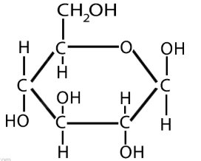 | 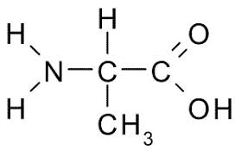 | 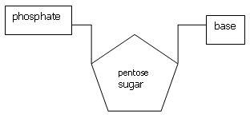
Name of type of monomer | Answer: Sugar. | Answer: Amino acid. | Answer: Nucleotide.
Name of polymer type | Answer: Starch or cellulose. | Answer: Protein. | Answer: DNA.
- What is a functional group in a molecule?
Answer: A part of the molecule that determines how it reacts (its chemical behaviour).
- Circle the carboxylic acid functional group in this molecule:

- This question is about the structure of DNA.
Use some of the words from the box to complete the sentences below.
condensation helix polynucleotide addition
intermolecular four water nucleotide
ring-shaped ionic six hydrogen chloride

DNA is an important polymer essential for life.

Monomers called nucleotides make DNA.

There are four different types of monomer.

When the nucleotide monomers join together to form DNA they also form water.

This means that this type of reaction is called a condensation polymerisation.

The DNA strand is made of a double helix of two very long polynucleotide strands that run in opposite directions.

These strands are held to each other by intermolecular forces.

- Sucrose is a sugar called a disaccharide.
This means that it is made of two sugar molecules joined together.
Sucrose is made from two other sugars called glucose and fructose.

Here are the structures of glucose and fructose:
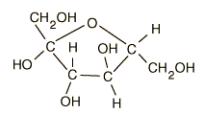
Fructose
Glucose

- Use the molecular structures of glucose and fructose to write their molecular formulas:

Glucose | Answer: C₆H₁₂O_{6.}
Fructose | Answer: C₆H₁₂O_{6.}
- On the diagram above, a dotted ring has been drawn around parts of the glucose and fructose molecules. This shows that a small molecule will be formed.
What is the name of this small molecule?
Answer: Water.
- Using the information in this question, write down the formula of the disaccharide formed called sucrose.
Answer: C₁₂H₂₂O₁₁.

