Superbugs and their chemical reactions

Learning objectives
- Draw an energy level diagram for both a catalysed and uncatalysed reaction.
- Explain the effect of catalysts on the profile of a reaction.

Introduction

Energy changes in reactions can be described as exothermic and endothermic. Endothermic reactions absorb energy from the surroundings and exothermic reactions release energy to the surroundings.

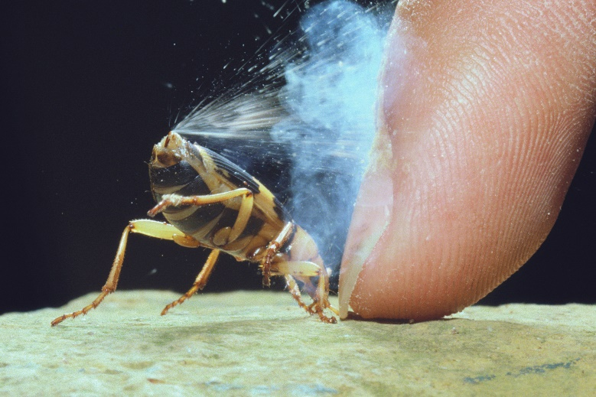
Bombardier beetle

There are lots of examples of animals across nature which rely on chemicals or a mixture of chemicals to help them avoid being eaten. Some spray acid whereas some spray oils. However, the bombardier beetle is slightly different. In this activity you will read an excerpt from an article published in Education in Chemistry and then use your knowledge to answer some questions.
© Nature Production/naturepl.com

An excerpt from ‘Wonder weapons’

Written by Emma Davies

‘When a bombardier beetle is under threat it produces a chemical explosion in its abdomen before expelling a jet of hot, noxious liquid, accompanied by a loud popping sound. The beetles can spray accurately in any direction up to distances of 20 centimetres.

With perfect timing, the beetles release hydroquinone and hydrogen peroxide from two reservoirs into a reaction chamber. There, the substances mix with catalase and peroxidase catalysts to create a foul-smelling, defensive spray containing two major quinones: 1,4-benzoquinone and 2-methyl-1,4-benzoquinone (p-toluquinone). Because the chemical reaction is strongly exothermic, the spray is close to boiling point when the beetles expel it.’

Questions
- Draw an energy level diagram for this reaction. Label the diagram with the following: reactants, products, activation energy, energy, reaction profile, enthalpy change.

- What is the effect of the catalysts in this reaction?

- The article tells us that the reaction is exothermic. How might this benefit the beetle?

- How might an exothermic reaction be a problem for the beetle?

- Draw another energy level diagram for this reaction if it was uncatalysed (using a second colour on the same graph).

Extension questions
- The overall chemical equation for this reaction is:

____$C_{6}H_{4}{\left(OH\right)}_{2}(aq)$ + ____$H_{2}O_{2}(aq)$ $→$ ____$C_{6}H_{4}O_{2}(aq)$ + ____$H_{2}O(l)$

Balance the equation.
- The reaction is catalysed by catalase and peroxidase. Are the catalysts mentioned in the chemical equation above? Explain why.

_____________________________________________________________________________

______________________________________________________________________________

- The overall chemical reaction gives out 202.6 kJ. What sign (+/-) should be put in front of this number? Explain your choice.

_____________________________________________________________________________

______________________________________________________________________________

- As this reaction releases so much energy, what might happen to the water that is produced as a liquid in the chemical reaction?

