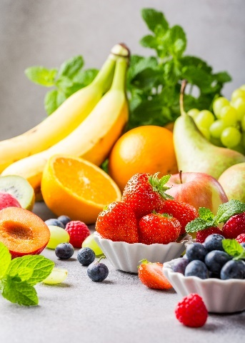
- Many fresh fruit and vegetables produce ethene.
This gas may then ripen other fruit which is unripe.

The table below shows how much ethene (in cm³) is produced from 1 kg of fruit each hour.
Source: Envato Elements
Name of fruit or vegetable | Volume of ethene produced by 1 kg of fruit in 1 hour (in cm³)
Apricot | 30
Avocado | 150
Rhubarb | 0.25
Banana | 3.2
Pineapple | 1.2 × 10^{–3}
Passion fruit | 235
Pear | 85
- Write the volume of ethene produced by 1 kg of pineapple per hour as a normal number (that is, one not in standard form).

- Calculate the volume of ethene produced by the following masses of fruit.
Remember to give units in your answers.
- 2 kg of bananas in 1 hour

- 200 g of apricots in 1 hour

- 4 kg of pears in 2 hours

- 150 g of apricots in 30 minutes

- Calculate the mass of passion fruits that will produce exactly 1.00 dm³ (1 litre) of ethene in 1 hour.
Give your answer to 3 significant figures.

- Scientists have produced ethene scavengers that are based on the metal called palladium.
These can reduce the ethene concentration by 95%.
i) A sample of gas contains 5000 dm³ of ethene.
Calculate the volume of ethene that remains after the ethene scavengers have been used.
Show your working.

ii) Explain why companies that transport fruit and vegetables may use palladium-based ethene scavengers.

- Propene has the molecular formula C₃H₆.

- Draw the structure of a propene molecule showing the chemical bonds.

- Propene is described as an unsaturated hydrocarbon, define each term in the table below.
Unsaturated
Hydrocarbon

- State the name of a chemical substance that could be used to show that propene is unsaturated.

- Give the result of the test when using the substance in part f).

- Consider some reactions of propene with other molecules.
Draw the structure of the product molecules in each case.
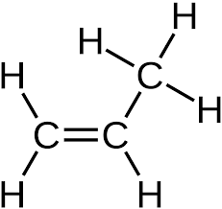
Bromine, Br₂

Chlorine, Cl₂

Hydrogen gas and nickel catalyst at 150ºC

Steam with a phosphoric acid catalyst

- Explain why alkenes often burn with a smoky flame, whereas the corresponding alkanes do not.

