Making hydrated copper sulfate crystals
Education in Chemistry January 2019, rsc.li/2SdSqkQ
Name: Group:
Read through the whole sheet and discuss what you will be doing with your partner before you start the practical activity
In this activity you will:
* React copper oxide with sulfuric acid | * Filter the copper sulfate solution | * Evaporate some of the water | * Crystallise the copper sulfate

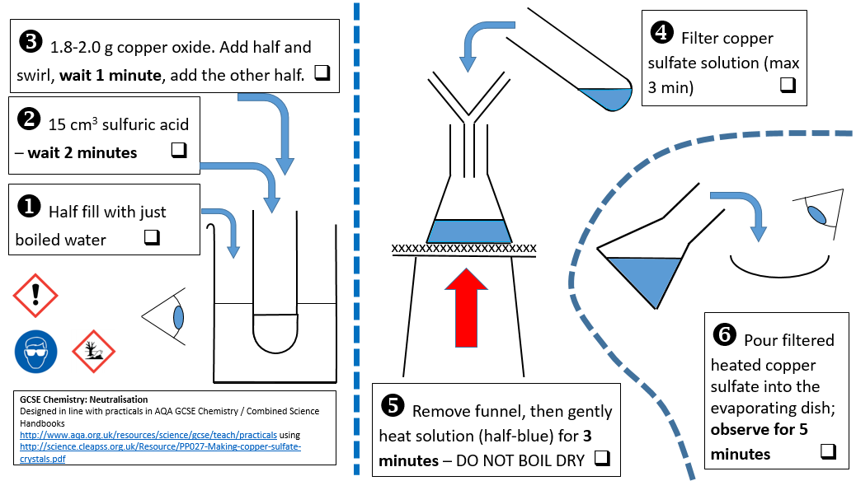
Time finished

Time started

Questions | Answers
What observation(s) did you make that showed you that a chemical reaction had occurred?
What was the purpose of step 5 – gently heating the solution for 2 minutes?
Describe the purpose of step 6.

Evaluation | Response (thinking about just the practical work)
Overall, how easy/hard did you find the practical (circle one number)? | 1 2 3 4 5  very neither easy very  easy nor hard hard
How did the instructions help you understand what you were doing?
How did the instructions help your confidence in completing the practical?

