The politics of energy – structure strip

This resource accompanies the article Energy boost, in Education in Chemistry which can be viewed at: https://rsc.li/3t8AKMl

Learning objectives
- Explore how the raw materials for energy production are linked to global politics.
- Revisit organic chemistry concepts in a new context.

Introduction

This resource helps students revisit some key topics from organic chemistry and atmospheric chemistry within a new context.

How to use the article

Some of the language in the accompanying article may be difficult for learners with a reading age below their actual age. In this situation, the resource is recommended as a whole class activity. This will give learners the support they may need to access the text as well as a good environment for concentrating on writing at length. Ask your learners to read the whole text or an allocated section initially themselves and highlight each word they struggle with. As a class, go through the article together, discussing the highlighted phrases and writing the definitions. Spaces can be added between each line of the article to allow for annotation. Although this may take more time, learners will be more confident in completing the structure strip questions as they will better understand the content and what is being asked.

How to use structure strips

Structure strips guide learners to write longer responses by providing side-by-side prompts. They make practising extended response questions, such as six-markers, more accessible to all learners by providing scaffolding. Structure strips also help learners overcome the fear of a blank page. Learners stick a strip in the margin of their exercise books and follow the questions to write their summaries.

Answers are provided on the next page. You can use them when marking or give them to learners for peer or self-assessment.

Answers
Structure strip  The politics of energy | Model answer
Why has the war in Ukraine highlighted the need for investment in green energy? | In 2019, Europe got 40% of its gas and a quarter of its oil from Russia. Many countries have now imposed sanctions on Russia as financial penalties for invading Ukraine. The US and UK quickly banned Russian oil and gas imports.
What are fossil fuels and why are we so reliant on them for our energy and transport needs? | Fossil fuels, such as oil and gas, come from the fossilised remains of plants and animals that died millions of years ago. They are used to power vehicles, heat our homes and cook our food. We largely rely on natural gas because its cost per unit of energy is just a quarter of that of the electricity we use.
Draw the structures of the first four alkanes in the homologous series. | 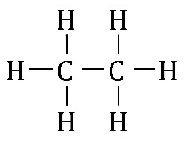  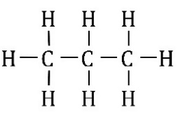  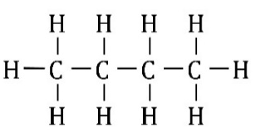
How does burning fossil fuels contribute to climate change? | Burning fossil fuels produces water and carbon dioxide (CO₂). CO₂ is a greenhouse gas that acts as an insulating blanket in the Earth’s atmosphere. It retains energy that the Earth has absorbed from the Sun and then emitted again as infrared radiation. This warms the planet and leads to climate change.
How is farm and food waste used to generate green energy? | Microbes can turn farm, food and landfill waste into ‘green gas’. This is done in closed containers called digesters, without air (anaerobic digestion). Green gas is put into the same national grid that fossil-based natural gas flows through. Green gas is cleaner and less problematic than buying natural gas and oil from countries like Russia.
What promises and progress have the UK and Ireland made concerning greenhouse emissions? | The UK and Ireland have promised that their greenhouse gas emissions will reach net zero by 2050, meaning any emissions will be balanced out by efforts to remove greenhouse gases already in the atmosphere. Electricity will have to come from renewable, carbon-neutral sources, instead of from oil and gas. UK renewable electricity generation has doubled since 2014. It currently stands at nearly half of the overall output.
What is the best way to reduce our reliance on fossil fuels? | The best way to reduce our reliance on fossil fuels is to use less energy. To do this we could turn down thermostats, work from home more, if possible, use public transport, walk more and drive slower if we need to drive.

