- These three molecules include an alkane, an alkene and an alcohol.

- State which molecules belong to which group.
Write your answer underneath each molecular structure.

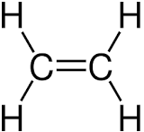 | 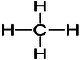 | 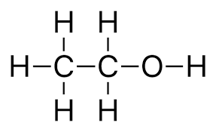
Answer: Alkene: ethene. | Answer: Alkane: methane. | Answer: Alcohol: ethanol.
- Name each of the substances in part a).
Write your answer in the same boxes.
Answer: See answers above.
- Indicate the alcohol functional group on one of the molecules shown.
Answer: See diagram of ethanol in which the O-H (hydroxyl) group is circled.
- Use the molecular structure of ethanol to write down the chemical formula for ethanol.
Answer: C₂H₅OH, or C₂H₆O.
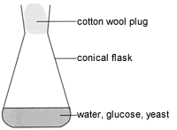
- Janice and Matt set up this equipment then waited for one week.
A chemical reaction takes place in which new substances are made.
- Complete the word equation for this reaction:

Glucose ethanol + carbon dioxide
- What is the name given to the type of reaction taking place?
Answer: Fermentation.
- Explain why yeast is used in the experiment.
Answer: Yeast contains an enzyme that makes the fermentation happen at a faster rate.

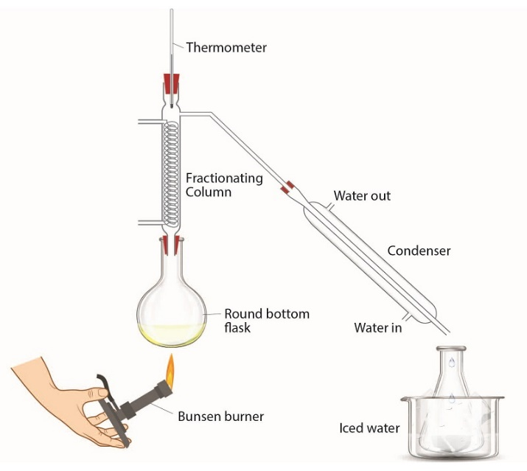
Janice and Matt then add the mixture from the conical flask to the round-bottom flask in a different experiment.
- What is the purpose of this new experiment?
Answer: To separate the ethanol from the aqueous solution.

- Explain how this experiment works.
Source: Royal Society of Chemistry
Answer: Ethanol has a lower boiling point than water, so is able to form a vapour that can be removed and condensed.
Source: Royal Society of Chemistry
Source: Royal Society of Chemistry

- What is the name of this technique or experiment?
Answer: Fractional distillation.

- Janice and Matt add a small sample of the ethanol they have made and add it to a crucible.
They add a lighted splint to the ethanol and notice that it catches fire.

Complete the equation to show what happens when ethanol burns:
C₂H₅OH + 3O₂ 2CO₂ + 3H₂O

- Ravi carries out an experiment with a mixture of ethanol dissolved in water.
He leaves the ethanol open to the air for two weeks.
He notices that a very slow chemical reaction takes place.
He removes a few drops of his new mixture and adds some universal indicator solution.
He notices that the indicator turns orange.
- What type of substance has formed?
Answer: A weak acid.
- What is the name of the new organic product formed?
Answer: Ethanoic acid.
- State the name of the chemical substance that reacts with ethanol in this reaction.
Answer: Oxygen.
- What type of reaction has taken place?
Answer: Oxidation.
- Complete the diagram to show the structure of the new organic product made.
