The sublimation of air freshener

This resource accompanies the article Sniffing out the science of smells in Education in Chemistry which provides further context for this topic: rsc.li/4acKLv1

The demonstration is part of the Nuffield practical collection, developed by the Nuffield Foundation and the Royal Society of Chemistry. Delve into a wide range of chemical concepts and processes with this collection of over 200 step-by-step practicals: rsc.li/3x7JxmH

Learning objectives
- Describe sublimation and deposition.
- Understand the difference between sublimation and deposition.
- Use the particle model to explain sublimation and deposition.

Introduction

During this teacher demonstration, learners will observe the process of sublimation as the solid air freshener is heated and changes directly to the gaseous state.

The demonstration

It is best if you do this experiment as a teacher demonstration.

It takes a while for anything to happen, so learners can work through questions 1–5 once you have set up the demonstration. Once learners have completed the questions, they can go over to the demonstration in small groups to make their observations. Learners can observe the demonstration periodically during the lesson to record changes over time.

Scaffolding

The student sheet is available with two different levels of support: scaffolded (one star in the header) and unscaffolded (two stars). There is a challenge question at the end of the unscaffolded student sheet.

Teaching notes

Sublimation is the vaporisation of a solid. The opposite process – the formation of a solid directly from a vapour – is called deposition. The heat from the water bath causes the solid air freshener to sublime. The cold beaker causes the vaporised air freshener to re-form the solid. If there is space in the fume cupboard, leave a few lumps of solid air freshener to sublime at room temperature (not in a hot water bath) to demonstrate the difference in rate of change.

Sublimation is caused by the absorption of heat, which provides enough energy for some molecules to overcome the attractive forces of their neighbours and escape into the gas phase. Learners will be less familiar with this process as normally we expect a solid to melt into a liquid before boiling or evaporating into a gas. However, sometimes conditions such as vapour pressure and temperature mean that the liquid phase is skipped.

If possible, use a coloured air freshener and notice that the material that collects on the cold beaker is white. The dye does not sublime because it is not chemically a part of the compound that does sublime. Vapour deposition is an important industrial process for separation and purification.

You can use other materials that sublime including iodine, naphthalene and dry ice (carbon dioxide), see below for more details.

Technician notes

Equipment required for a teacher demonstration
- Eye protection
- Access to fume cupboard
- Gloves (for those with sensitive skin)
- 100 cm³ Beakers x 2
- Stand, boss and clamp
- Shallow dish
- Thermometer, –10–110°C
- Kettle for hot water

Solid air freshener (HARMFUL), a few lumps. Gel-type air fresheners will not work.

Safety and hazards

Read our standard health and safety guidance, available from rsc.li/3vu3tj2, and carry out a risk assessment before running any live practical.
- Wear eye protection and gloves.
- Work in a fume cupboard.
- Air freshener – solid toilet bowl cleaners work best; if possible, use a coloured one.

If cheap air fresheners containing 1,4-dichlorobenzene (para-dichlorobenzene), $C_{6}H_{4}{Cl}_{2}$(s), are used, handle them with tongs in a fume cupboard. Para-dichlorobenzene is HARMFUL and DANGEROUS FOR THE ENVIRONMENT – see CLEAPSS Hazcard HC023.

Alternative materials

Please note the following when using another material to do this demonstration:
- Iodine (HARMFUL, DANGEROUS FOR THE ENVIRONMENT): use only a few crystals and do the activity in a fume cupboard – see CLEAPSS Hazcard HC054. See also Sublimation of iodine (Exhibition chemistry): rsc.li/3x2UnKB
- Naphthalene (HARMFUL, DANGEROUS FOR THE ENVIRONMENT): do the activity in a fume cupboard. Naphthalene mothballs must be heated to near 70°C to sublime – see CLEAPSS Hazcard HC046b.
- Dry ice sublimes at –78.5°C and above. Handle with tongs or thermal gloves. You will not be able to watch the solid re-form but it is great for observing the change from solid to gas – see CLEAPSS Hazcard HC020a.

Procedure
- Wear eye protection and work in a fume cupboard.
- Place a few lumps of air freshener in the bottom of one of the 100 cm³ beakers.
- Fill the other beaker three-quarters full of ice.
- Stand the beaker containing the air freshener in a shallow dish.
- Carefully, clamp the beaker containing the ice in position on top of the beaker of air freshener.

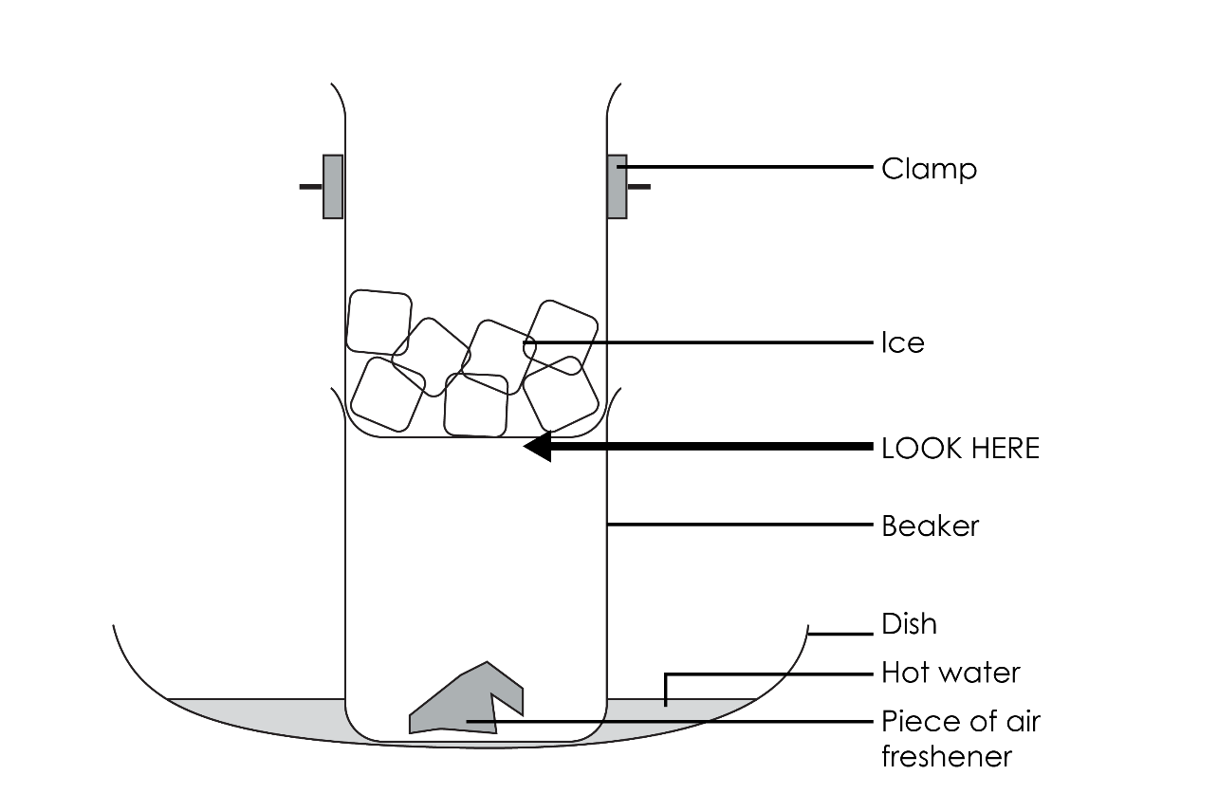
- One-third fill the shallow dish with warm water (hotter than 45°C).
- Observe what happens to the solid. Be patient as it can take a while.

Answers

Unscaffolded version (2 stars)

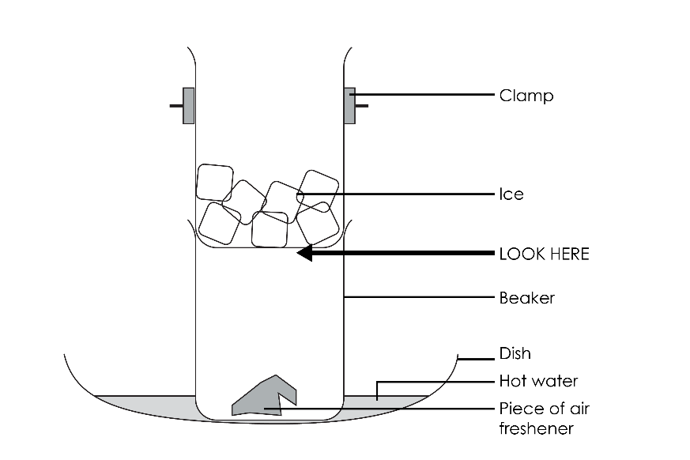
- The substances in some air fresheners can be harmful and should not be breathed in.
- By the hot water in the dish.
- To make a cold surface for the gaseous air freshener to hit and deposit on.
- The solid air freshener will shrink and become smaller. A white solid will appear of the bottom of the top beaker.

Observations
- Air freshener will reduce in size/shrink/get smaller.
- A white solid will form on the cold surface.
- Nothing will be seen in the main part of the beaker.

Conclusion

When the air freshener was heated, it changed from a solid to gas because the particles took in enough energy to break the forces between the particles so that they could freely escape to the gaseous phase. We call this process sublimation.

When the air freshener gas particles hit the cold surface, they turned back to a solid because they transferred so much kinetic energy to the cold surface they had to slow down and come together in the solid state. We call this process deposition.

Changes of state questions
- (a) melting

(b) freezing

(c) evaporation

(d) condensation

(e) sublimation

(f) deposition

- Sublimation and deposition.

Challenge question
- A cloud of ‘white smoke’ forms as solid carbon dioxide very quickly turns into carbon dioxide gas. The solid carbon dioxide block decreases or gets smaller in size. The surrounding temperature drops, or it feels colder as the carbon dioxide particles take in energy from the surrounding air. No liquid would be observed. The dry ice sublimes.
- Snow is a solid form of water in which the particles are packed close together and vibrate around a fixed point. When the sun appears, heat energy from the sun is very quickly transferred to the water particles in the solid state. As the snow particles at the surface take in the heat energy it is transferred to kinetic energy. The particles start to vibrate much faster until they have enough energy to change from the solid to the gaseous state. It happens so quickly, the liquid state is missed out and the snow particles sublime.

Scaffolded version (one star)

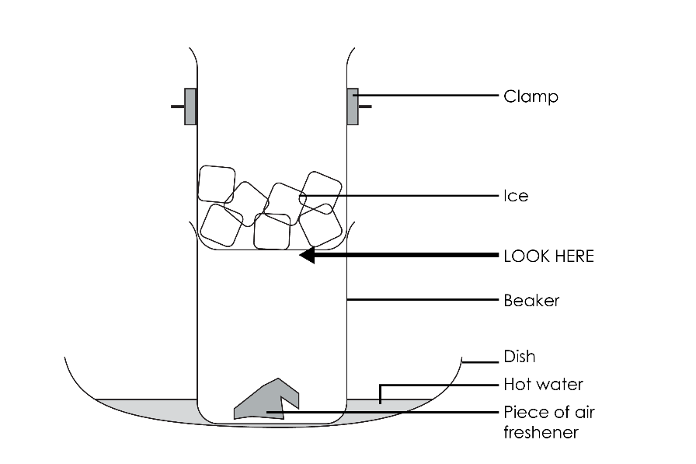
- The demonstration is carried out in the fume cupboard because some air fresheners produce harmful/dangerous substances when they are heated quickly, which are not good to breathe in.
- Hot water was used to slowly heat the air freshener.
- Ice was added to the top beaker to make a cold surface for the gaseous air freshener particles to hit.
- The solid air freshener will shrink and become smaller. A white solid will appear on the bottom of the top beaker.

Observations
- The pieces of air freshener will get smaller/shrink.
- A white solid will form on the cold surface.

Conclusion

When the air freshener was heated it changed from a solid to a gas because the particles took in lots of energy. We call this process sublimation.

When the gas particles hit the cold surface they turned back to a solid because they had lost a lot of energy. We call this process deposition.

Changes of state questions
- (a) melting

(b) freezing

(c) evaporation

(d) condensation

(e) sublimation

(f) deposition

- Sublimation and deposition.

