Shapes, surface areas and volumes in chemistry: answers
Education in Chemistry
November 2020
rsc.li/3ddLrUJ

Diagnostic exercises
- Name the following polyhedra:
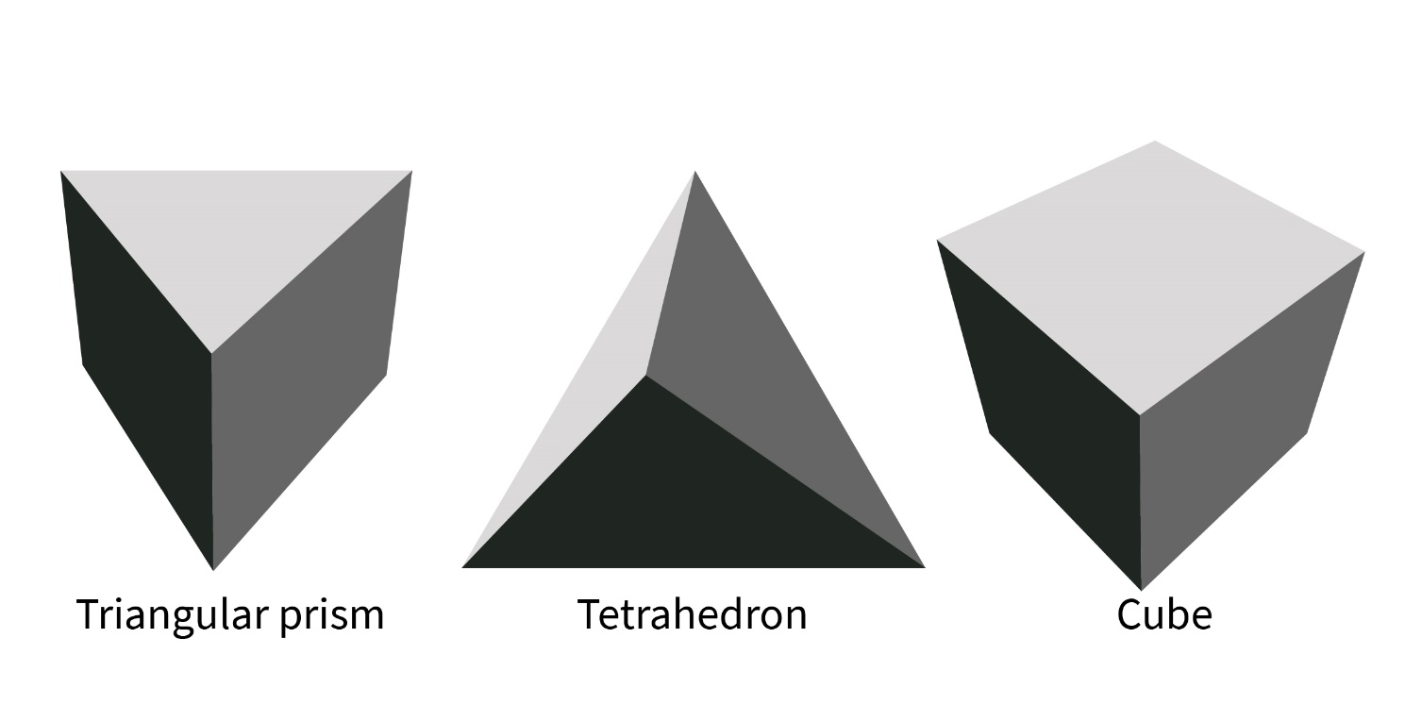
- What is the surface area of this cube?
1.5 cm
a. 2.25 cm²
b. 3.375 cm²
c. 13.5 cm²
d. 4.5 cm²

- Which of the following shapes is identical to Shape A?
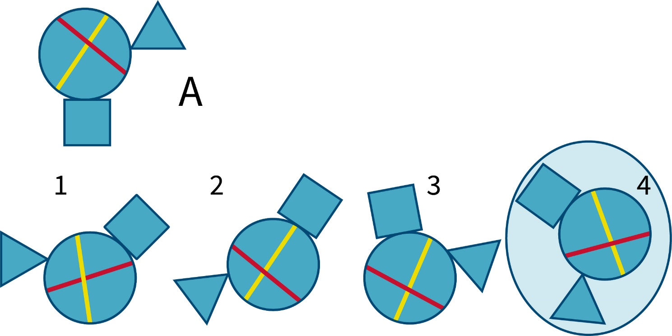
- Which cube cannot be based on the following net?
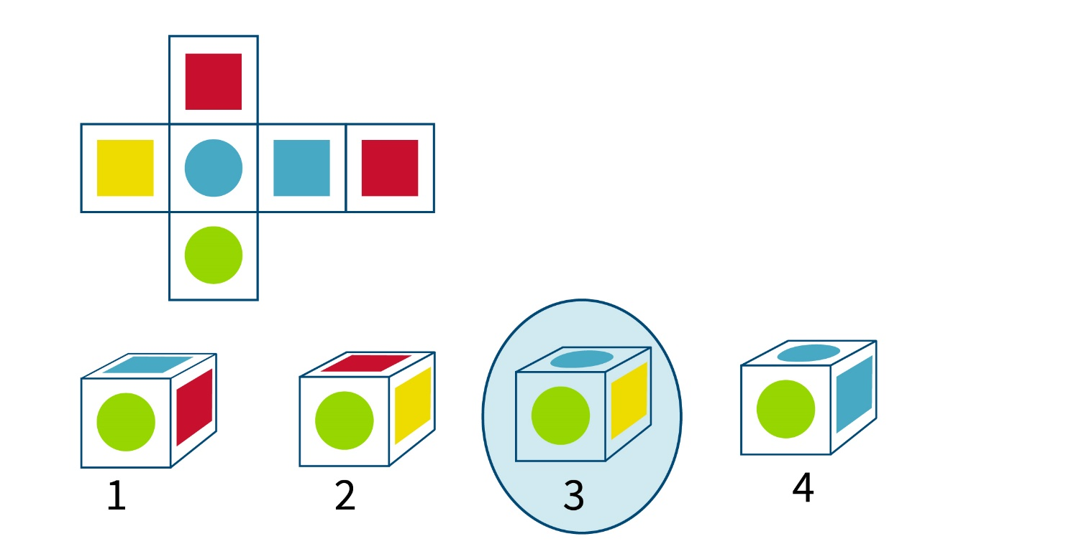

Maths problems
- What is the area of this triangle? 5.6 cm²
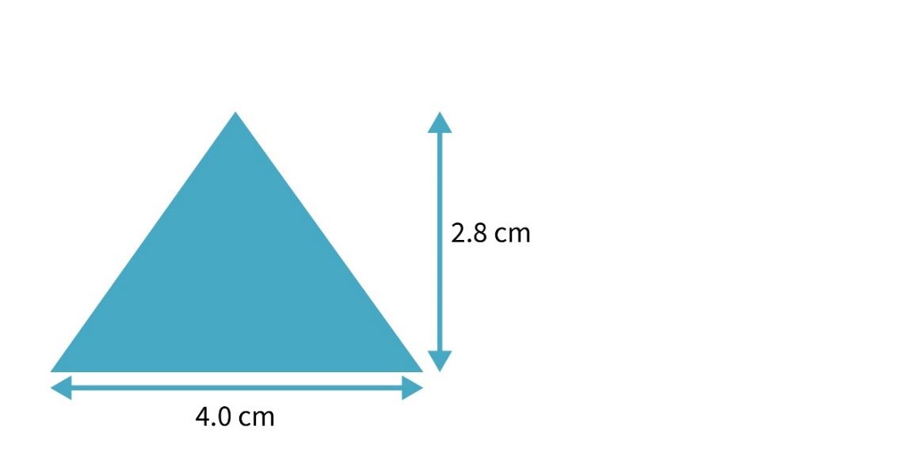
- What are the units of surface area if the lengths are given in centimetres? cm²
- What are the units of volume if the lengths are given in centimetres? cm³
- The surface area (SA) to volume (V) ratio is calculated as SA/V. What are the units? cm⁻¹
- A cube has sides of 10 cm in length.
  - What is the surface area? 600 cm²
  - What is the volume? 1000 cm³
  - What is the surface area to volume ratio? 0.6 cm⁻¹

- A cube has sides of 1 cm in length.
  - What is the surface area? 6 cm²
  - What is the volume? 1 cm³
  - What is the surface area to volume ratio? 6 cm⁻¹

- Describe what happens to the surface area to volume ratio as the size of the cube decreases by a factor of 10.
As the length of the side of a cube decrease by a factor of 10, the surface area to volume ratio increases by a factor of 10.

- Complete the following table:
Cube side length | Surface area (SA) | Volume (V) | SA/V
2 cm | 24 cm² | 8 cm³ | 3 cm⁻¹
4 cm | 96 cm² | 64 cm³ | 1.5 cm⁻¹
6 cm | 216 cm² | 216 cm³ | 1 cm⁻¹
8 cm | 384 cm² | 512 cm³ | 0.75 cm⁻¹
10 cm | 600 cm² | 1000 cm³ | 0.6 cm⁻¹

Algebra
1. A cube has sides of length l cm. What is the surface area of the cube expressed in terms of l? 6l² cm²
2. A cube has sides of length l cm. What is the volume of cube expressed in terms of l? l³ cm³
3. A cube has sides of length l cm. What is the surface area: volume ratio expressed in terms of l? $\frac{6}{l}$ cm³

Chemistry problems

Rates of reaction
Marble chips were reacted with dilute hydrochloric acid and the reaction was continuously monitored by measuring the volume of gas evolved. The experiment was repeated a second time using marble chips of a different size. The results of the experiments were plotted below.
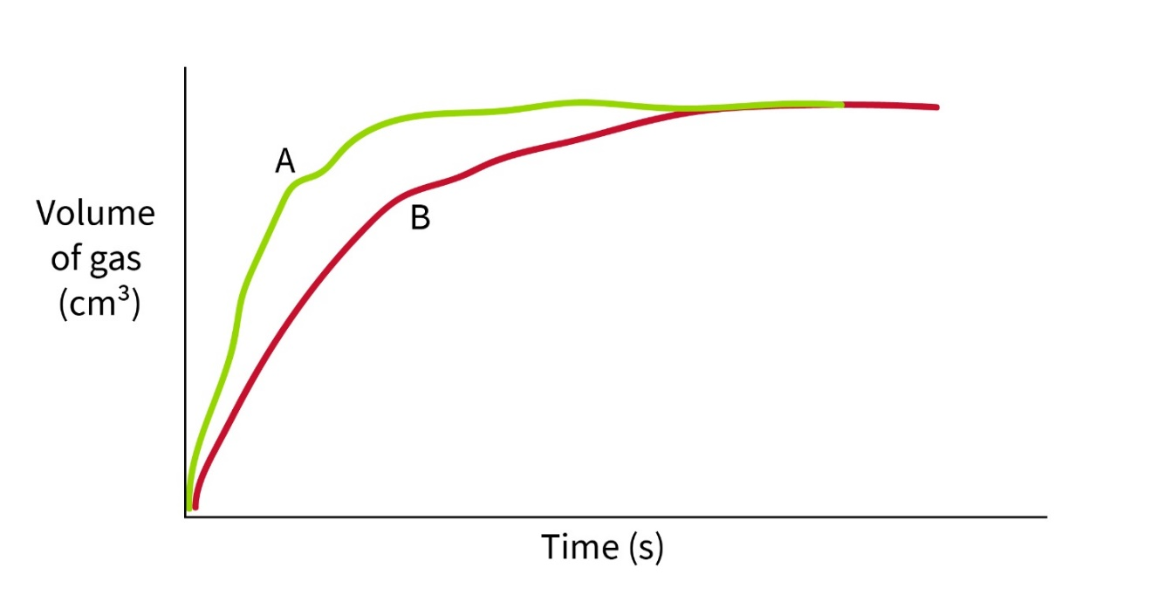
- Why does the plotted graph flatten out into a straight line?
One of the reactants has been used up so no more gas is released. The reaction has gone to completion.
- Which of the experiments (A or B) had the fastest rate of reaction. How can you tell?
A had the fastest reaction rate. The reaction rate is faster because (a) the initial rate of reaction (gradient) is steeper and (b) the reaction comes to completion (flattens out) sooner.
Alternative answers: A larger volume of gas is produced in the same time OR It takes less time to produce the same volume of gas.
- The marble chips in the first experiment can be modelled as cubes with sides of length 0.5 cm.
  - What is the surface area of a single marble chip? 1.5 cm²
  - What is the volume of a single marble chip? 0.125 cm³
  - The surface area (SA) to volume (V) ratio is calculated as SA/V. What is the surface area to volume ratio? 12 cm⁻¹
  - How is the rate of reaction related to the surface area to volume ratio? Why?
A bigger surface area to volume ratio leads to a faster rate of reaction because the acid can only react with marble exposed on the surface of the chip.
  - Were the marble chips used in B smaller or bigger than those used in the first experiment? How can you tell?
They were bigger, which gives a smaller surface area to volume ratio, so the rate of reaction is slower.

Isomerism
1. Which of the following molecules is not identical but is an isomer?
C
Cl
HO
H₃C
H
C
Cl
H
HO
CH₃
C
Cl
H₃C
HO
H
C
H
H₃C
HO
Cl

