Puzzling polymers
Education in Chemistry
May 2021
https://rsc.li/32kIM78
Use the clues and process of elimination to match unfamiliar chemical structures to their chemical or common names
Five polymers are named in the article, Plastic fantastic. Can you match the named polymers to their structural formula using these clues?
Clue 1: Rubber and polyvinylchloride (PVC) are addition polymers based around a carbon–carbon double bond.
Clue 2: Polyvinylchloride (PVC) contains the element chlorine.
Clue 3: Polyisoprene (rubber) had two carbon–carbon double bonds in its monomer structure (so will still have one in its repeating pattern structure).
Clue 4: There are two different types of cellulose, which is an important part of plant structure giving it rigidity. They are large molecules containing lots of carbon. They contain two ring formations.
Clue 5: Cellulose nitrate will have nitrogen in its formula.
Clue 6: Polyurethane is a condensation polymer based on a peptide -NH-CO- link.
Polymers to identify:
- Polyisoprene (rubber)
- Polyvinylchloride (PVC)
- Cellulose acetate
- Cellulose nitrate
- Polyurethane foam

 | Structural formula | Name of polymer
A | 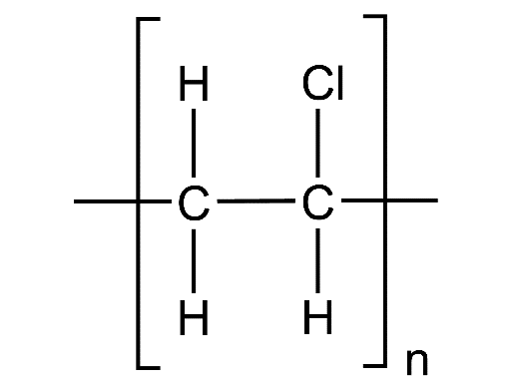
B | 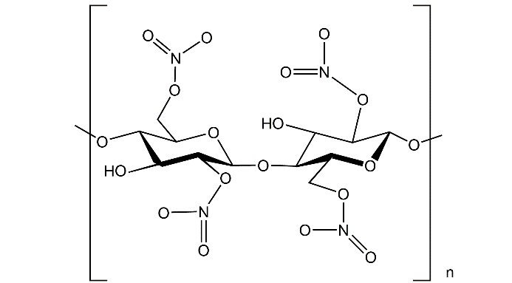
C | 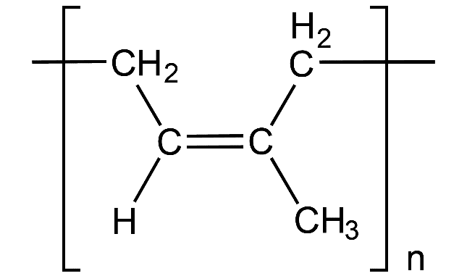
D
E | 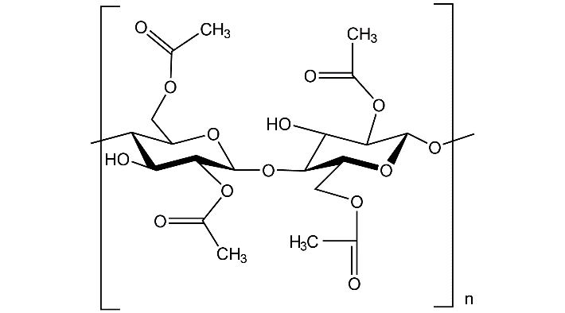

Answers

A: Polyvinylchloride (PVC)
B: Cellulose nitrate
C: Polyisoprene (rubber)
D: Polyurethane foam
E: Cellulose acetate

