Analysis

Mass spectrometry

The mass spectrometer

- The diagram below shows a simple mass spectrometer. Name the processes that occur at each of the points 1 - 5 highlighted;
(5 marks)
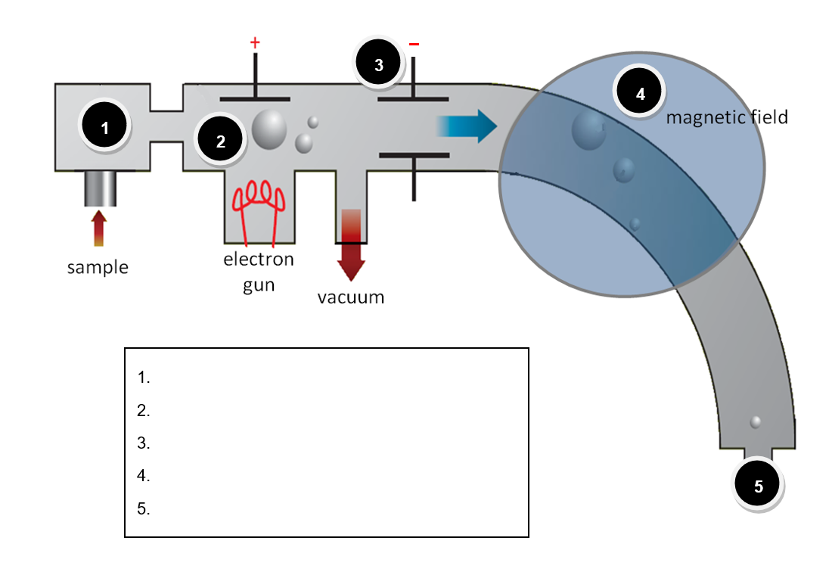
- For each of the statements below, indicate with the appropriate number, the stage in the mass spectrometer at which that process occurs. The first one has been done for you.
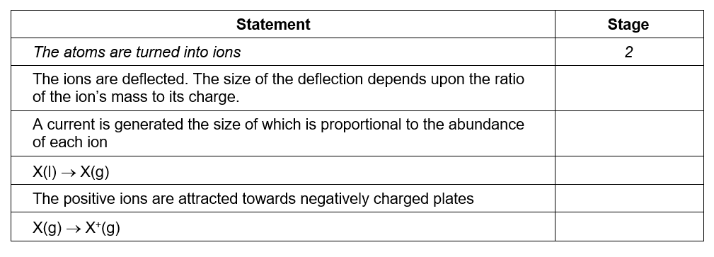
(5 marks)

Isotopic abundance

- The ratio of the different isotopes of certain elements can be used to identify objects from outer space. By comparing the isotope patterns with samples known to originate on earth the scientists can determine the origins of unknown objects.

The mass spectrum opposite is of a sample of chromium extracted from a rock recently found in the Nevada desert. Scientists believe it may be from a meteor.

Use the mass spectrum to determine the relative atomic mass of the chromium in the rock. Based on your result, make a recommendation as to the origin of the rock sample.
- marks)
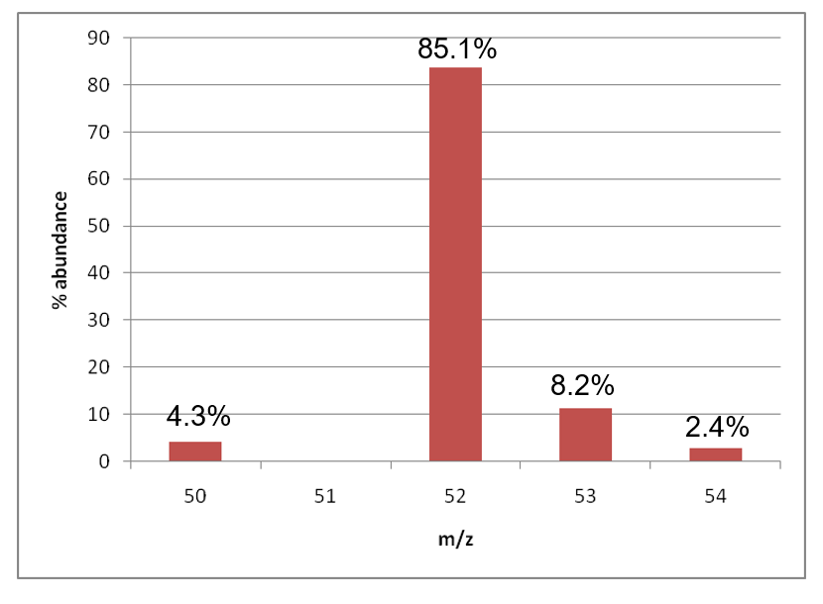
- The data below gives the m/z ratio and relative abundance of different isotopes of an element X. Determine the relative atomic mass of the element X to 1 d.p.
Suggest an identity for X.
- marks)

- The element magnesium (relative atomic mass 24.3) has three naturally occurring isotopes, ^{24.0}Mg, ^{25.0}Mg and ^{26.0}Mg. If the percentage of the heaviest isotope is 11.0%, what is the percentage of the lightest isotope present?
(3 marks)

Molecular mass spectrometry
Use the elemental analysis data together with the mass spectrum to propose a molecular formula for the unknowns A to C. Easy!
(3 marks for each)
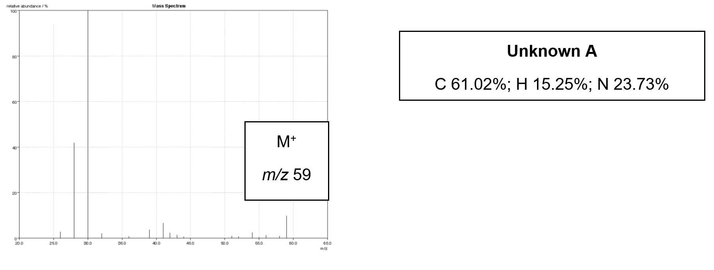
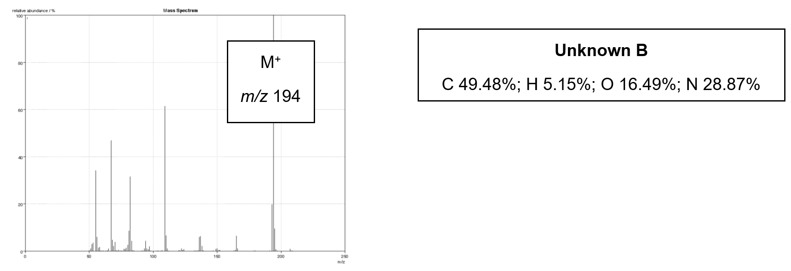
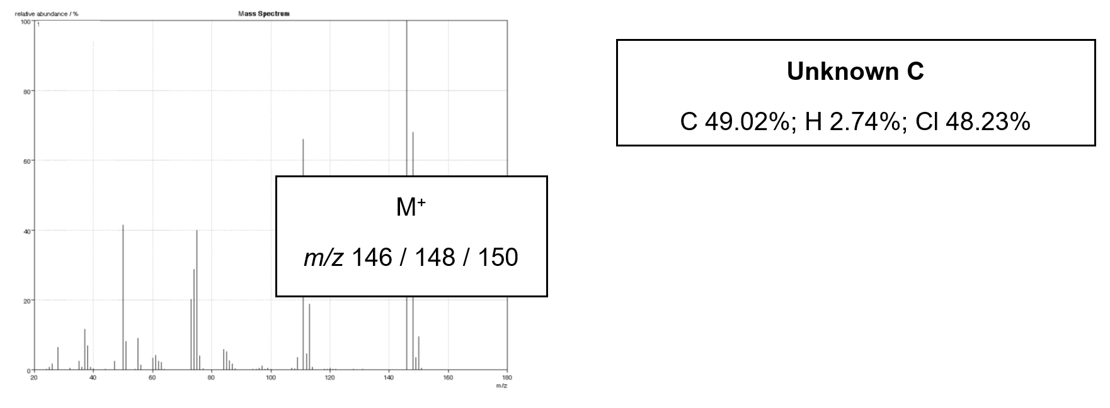
BONUS MARK Why does unknown C appear to have three molecular ions each differing in mass by 2?
(1 mark)

Infra-red spectroscopy
Help! The computer has gone crazy and mixed up all my spectra. Can you use the infra-red spectra together with the empirical formula to help me identify the compounds A - D below;
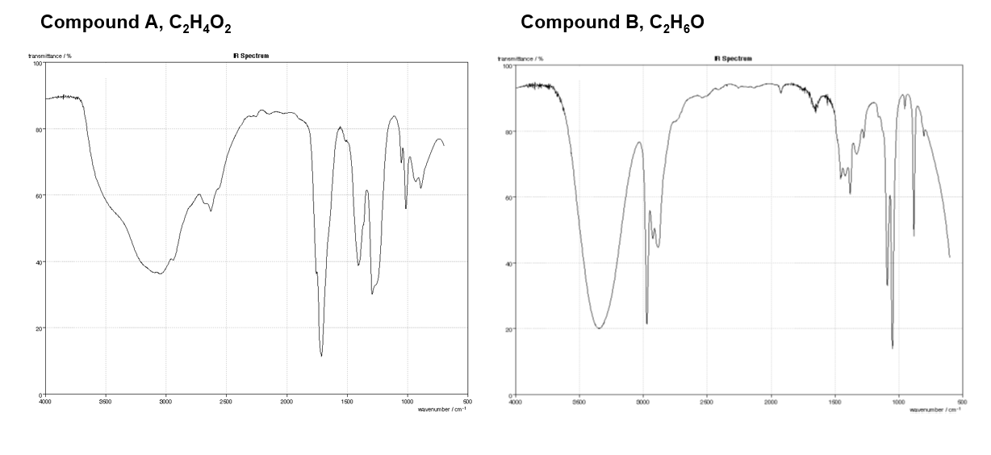
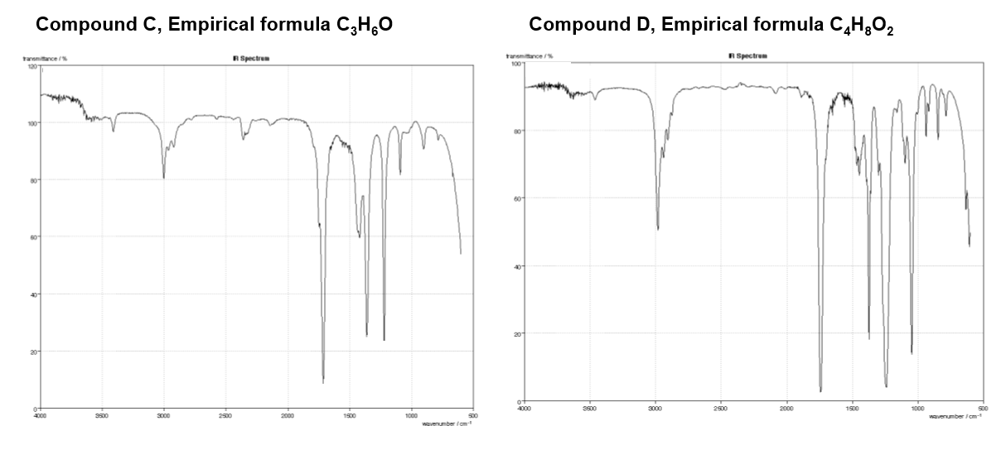

BONUS MARKS
There is more than one possible structure for compounds C and D. Can you suggest an alternative structure for each which is still compatible with the infra-red spectrum provided?

Analysis - Answers

Mass spectrometry

The mass spectrometer
1.
- vaporisation
- ionisation
- acceleration
- deflection
- detection
(5 marks)
2.
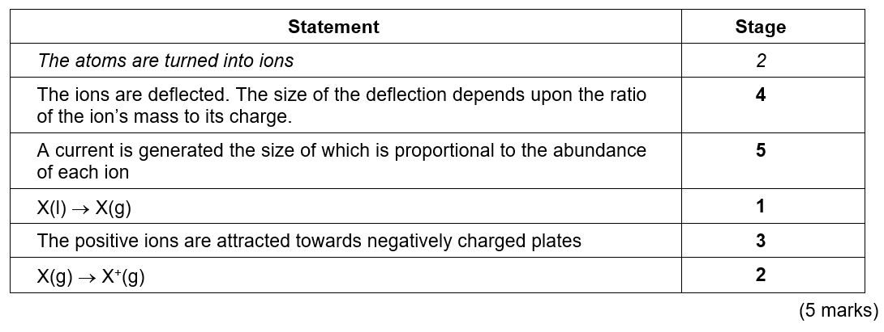

Isotopic abundance
1.
(4.3% × 50) + (85.1% × 52) + (8.2% × 53) + (2.4% × 54) = 52.0
100 %
(2 marks)
2.
(2.7 × 204) + (46.0 × 206) + (42.2 × 207) + (100 × 208) = 207.2
(2 marks)
(2.7 + 46.0 + 42.2 + 100.0)
(1 d.p. 1 mark)
Based on its atomic mass, X is likely to be Pb, lead (1 mark)
3.
If there is 11% of the heaviest isotope present we can say that the percentage of the lightest isotope present is ‘y’ and therefore the percentage of the remaining isotope present must be;
100% - 11% - y% = 89% - y
(1 mark)

Therefore substituting these numbers into our equation;
(26 × 11%) + (24 × y%) + [25 × (89 – y)%] = 24.3

100 %

286.0 + 24 y% + 2225 – 25 y% = 2430
2511 – y% = 2430
81 = y%
(1 mark each)
Therefore the percentage of the lightest isotope present is 81%

Molecular mass spectrometry
(1 mark for calculations, 1 mark for empirical formula, 1 mark for molecular formula of each unknown)

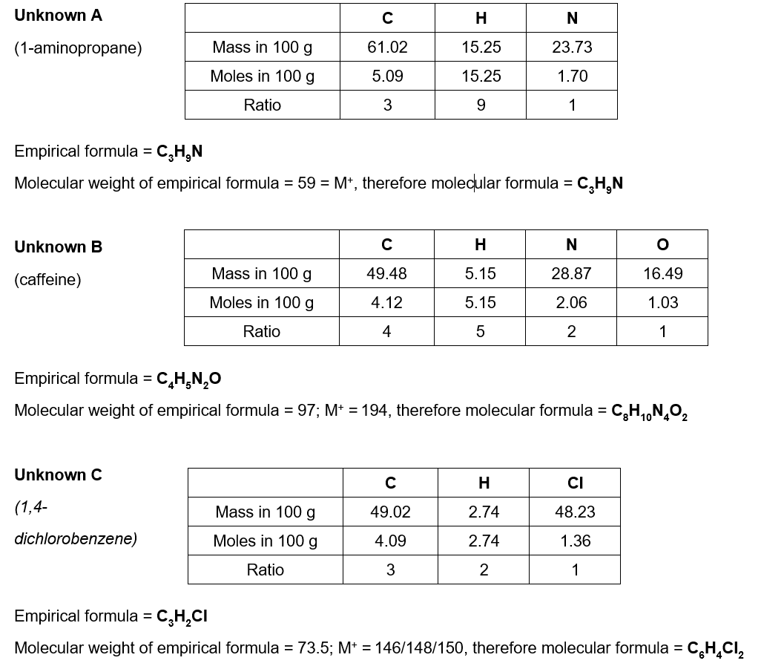

BONUS MARK – The mass spectrum of unknown C appears to have three molecular ion peaks owing to the common isotopes of Cl, ³⁵Cl and ³⁷Cl which are found naturally in a 3:1 ratio. As the unknown contains two chlorine atoms, this results in three possible combinations of these isotopes in the molecule.
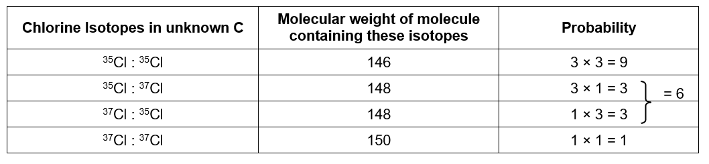

Infra-red spectroscopy
Compound A = ethanoic acid
(1 mark for molecule with C-H, O-H and C=O, 1 mark for correct structure)
Compound B = ethanol
(1 mark for molecule with C-H and O-H, 1 mark for correct structure)
Compound C = propanone
(1 mark for molecule with C-H and C=O, 1 mark for correct structure)
Compound D = ethyl ethanoate
(1 mark for molecule with C-H and C=O, 1 mark for correct structure)

Possible alternative structures for;
Compound C = propanal
(1 mark)
Compound D = methyl propanoate, propyl methanoate or iso-propyl methanoate
(1 mark)

