Bonding workshop
Covalent bonding and hydrocarbons
Contents
- Learning objectives
- Activity 1: hydrocarbons
- Activity 2: structure of hydrocarbons
- Activity 3: simple molecules
- Activity 4: alkanes
- Activity 5: reactions of alkanes
- Activity 6: alkenes
- Activity 7: reactions of alkenes
- Activity 8: functional groups
- Homework activity

Learning objectives
By the end of this session, you will be able to:
- Explain how a covalent bond is formed between two atoms.
- Construct models for at least three hydrocarbons.
- Draw the displayed structures for three alkanes and three alkenes.
- Work out the structures for at least two additional functional groups and draw their displayed formulas.
Acknowledgements
This resource was originally developed by Liverpool John Moores University to support outreach work delivered as part of the Chemistry for All Project.
To find out more about the project, and get more resources to help widen participation, visit our Outreach resources hub: rsc.li/3CJX7M3.
Unless explicitly stated, all images are © Royal Society of Chemistry.

Activity 1: hydrocarbons
Draw lines to match the terms in the first column with their definition.
Elements | * | * | a substance formed when two or more different chemical elements are chemically bonded together
Compound | * | * | a hydrocarbon containing only single bonds between the carbon atoms
Hydrocarbon | * | * | the simplest substances that cannot be broken down using chemical methods
Saturated hydrocarbon | * | * | a compound containing hydrogen and carbon atoms only
Unsaturated hydrocarbon | * | * | a hydrocarbon containing one or more double or triple bonds between the carbon atoms
Science communicator
Watch the video on slide 6 of the PowerPoint, also available from rsc.li/3CAOzIi, which introduces a science communicator. Fernando uses his scientific knowledge to uncover and translate complicated science for the public.
Activity 2: structure of hydrocarbons
- Fill in the number of subatomic particles for carbon and hydrogen. Complete the diagrams below to show the structure of each atom, using an X for the electrons.
- Carbon
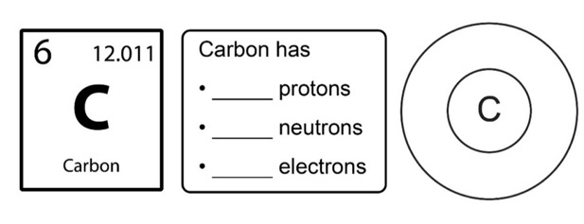

Composite: © Shutterstock and Royal Society of Chemistry
- Hydrogen
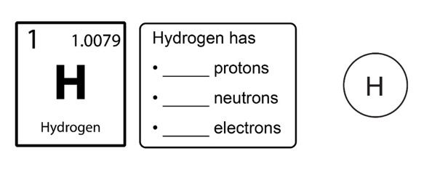

Composite: © Shutterstock and Royal Society of Chemistry

Carbon and other non-metallic atoms bond by sharing electrons.
This is known as covalent bonding. Electrons are shared between bonding atoms, so that all atoms gain the stability of a full outer shell.

- Complete the dot and cross diagram to show the bonding that occurs between carbon and hydrogen in methane. Use dots to show the electrons in carbon and crosses to show the electrons in hydrogen.
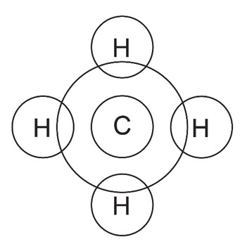
Activity 3: simple molecules
In molymod kits each ball represents an atom and each stick represents a bonding pair of electrons.
Molymod atoms
Colour of ball | Atom name | Chemical symbol | Number of bonds
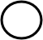 | hydrogen | H | 1
 | carbon | C | 4
 | oxygen | O | 2
 | nitrogen | N | 3
 | sulfur | S | 2
 | chlorine | Cl | 1
 | iodine | I | 1
 | aluminium | Al | 4

- As part of a group, build models of the following simple molecules. Complete the table below. The first row has been filled in for you.
Molecule | Molecular formula | Molymod  model built?  X/ | Displayed  formula
Example: hydrogen | H₂
chlorine | Cl₂
hydrogen chloride | HCl
water | H₂O
ammonia | NH₃
oxygen | O₂
carbon dioxide | CO₂

Activity 4: alkanes
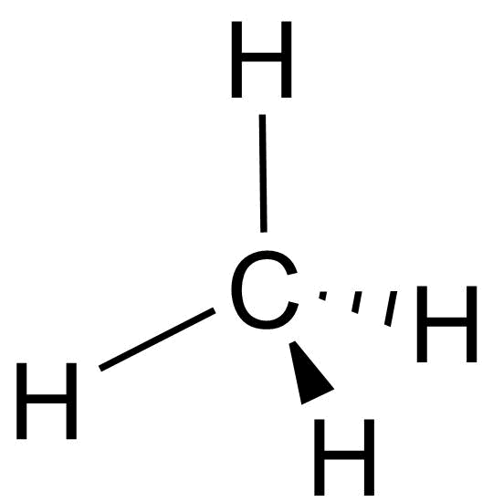
The simplest form of hydrocarbon is an alkane. Alkanes are saturated hydrocarbons, which means that they contain only single bonds between two carbon atoms. Each carbon atom makes four bonds by joining to other carbon atoms or hydrogen atoms. Hydrogen atoms form one bond each.

- Build models of the following alkanes. Complete the table below by drawing their displayed formulas. The first displayed formula has been drawn for you.
Molecule | Molecular formula | Molymod model built?  X/ | Displayed formula
methane | CH₄ |  | 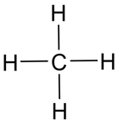
ethane | C₂H₆
propane | C₃H₈
butane | C₄H₁₀
- Describe how the number of hydrogen atoms changes as the number of carbon atoms in the chain increases.

- The general formula for alkanes is:

- Use the general formula for alkanes to predict the formula of the following molecules. Build them using the molymod kits to check your predictions.
Molecule | Molecular formula | Molymod model built?  X/ | Displayed formula
pentane
five carbon atoms
hexane
six carbon atoms
heptane
seven carbon atoms
octane
eight carbon atoms

Challenge: trends and patterns in alkanes
- Use the data provided in the table to answer the following questions.
Name | Formula | Melting point (ºC) | Boiling point (ºC)
methane | CH₄ | −182 | −161
ethane | CH₃CH₃ | −183 | −88
propane | CH₃CH₂CH₃ | −188 | −42
butane | CH₃(CH₂)₂CH₃ | −138 | 0
pentane | CH₃(CH₂)₃CH₃ | −130 | 36
hexane | CH₃(CH₂)₄CH₃ | −95 | 69
heptane | CH₃(CH₂)₅CH₃ | −90 | 99
octane | CH₃(CH₂)₆CH₃ | −57 | 126
nonane | CH₃(CH₂)₇CH₃ | −53 | 151
decane | CH₃(CH₂)₈CH₃ | −29 | 174
- Which alkane has the lowest boiling point?

- Name three alkanes which are liquids at room temperature.

- What do you notice about the trends in boiling point and melting point?

- Explain this trend using the term intermolecular forces.

Project leader of enhanced experimentation
Stuart’s video job profile, available on slide 22 and from rsc.li/3GQvi87, shows his role as a project leader of enhanced experimentation in oil and gas at Shell. He uses robots, computer modelling and data to research and develop new ways to use crude oil and gas.

Activity 5: reactions of alkanes
Fuels react with oxygen to release energy. Complete combustion happens in a plentiful supply of oxygen. Incomplete combustion occurs when the supply of oxygen is limited.
In general, for complete combustion:
alkane + oxygen → carbon dioxide + water
For example,
methane + oxygen → carbon dioxide + water
CH₄ (g) + 2O₂ (g) → CO₂ (g) + 2H₂O (g)
In general, for incomplete combustion:
alkane + oxygen → carbon monoxide + carbon + water
For example,
methane + oxygen → carbon monoxide + carbon + water
3CH₄ (g) + 4O₂ (g) → 2CO (g) + C (s) + 6H₂O (g)

Demonstration of a Bunsen burner flame
The gas used in Bunsen burners is methane. Watch the demonstration and observe what happens when the air hole of a Bunsen burner is opened and closed.
- Delete words on the diagrams below to describe what happened.
(a) Air hole open/closed (b) Air hole open/closed
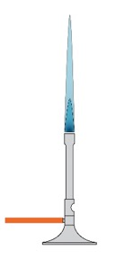
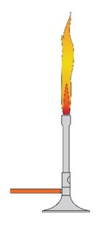

Complete/incomplete combustion Complete/incomplete combustion
Demonstration of a controlled explosion of methane
- Describe your observations.

- Explain what happened.

Demonstration of methane bubbles
- Describe what happened in the demonstration.

- Why did the methane bubbles float up to the ceiling?

Activity 6: alkenes
Another family of organic compounds are the alkenes. They are also hydrocarbons as they only contain hydrogen and carbon atoms. However, they are unsaturated compounds, which means that they contain at least one double bond between two carbon atoms.
- (a) Label the double bond in this displayed formula of an alkene.
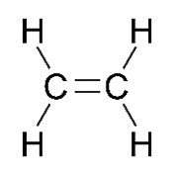

- Using your molymod kit, build each of the alkenes named in the table below and draw their displayed formulas.
Molecule | Molecular  formula | Molymod  model built?  X/ | Displayed formula
ethene | C₂H₄
propene | C₃H₆
butene | C₄H₈

- Why does a molecule called methene not exist?

- Describe how the number of hydrogen atoms changes as the number of carbon atoms in the chain increases.

- The general formula for alkenes is:

School science technician
Read Sandrine’s job profile, available on slide 48 and from rsc.li/3ZpDhAv. She is a school science technician and uses her knowledge and skills to design, prepare and test practicals for chemistry lessons and extracurricular activities.

- Use the general formula for alkenes to predict the formula of each of the alkenes in the table below. Build each using the molymod kit to see if you are correct.
Molecule | Molecular  formula | Molymod  model built?  X/ | Displayed formula
pentene
five carbon atoms
hexene
six carbon atoms
heptene
seven carbon atoms
octene
eight carbon atoms
- Does it matter where the double bond is in the molecule? Why?

Activity 7: reactions of alkenes
The double bond of the alkene allows us to distinguish them from alkanes because they undergo an addition reaction with a halogen.
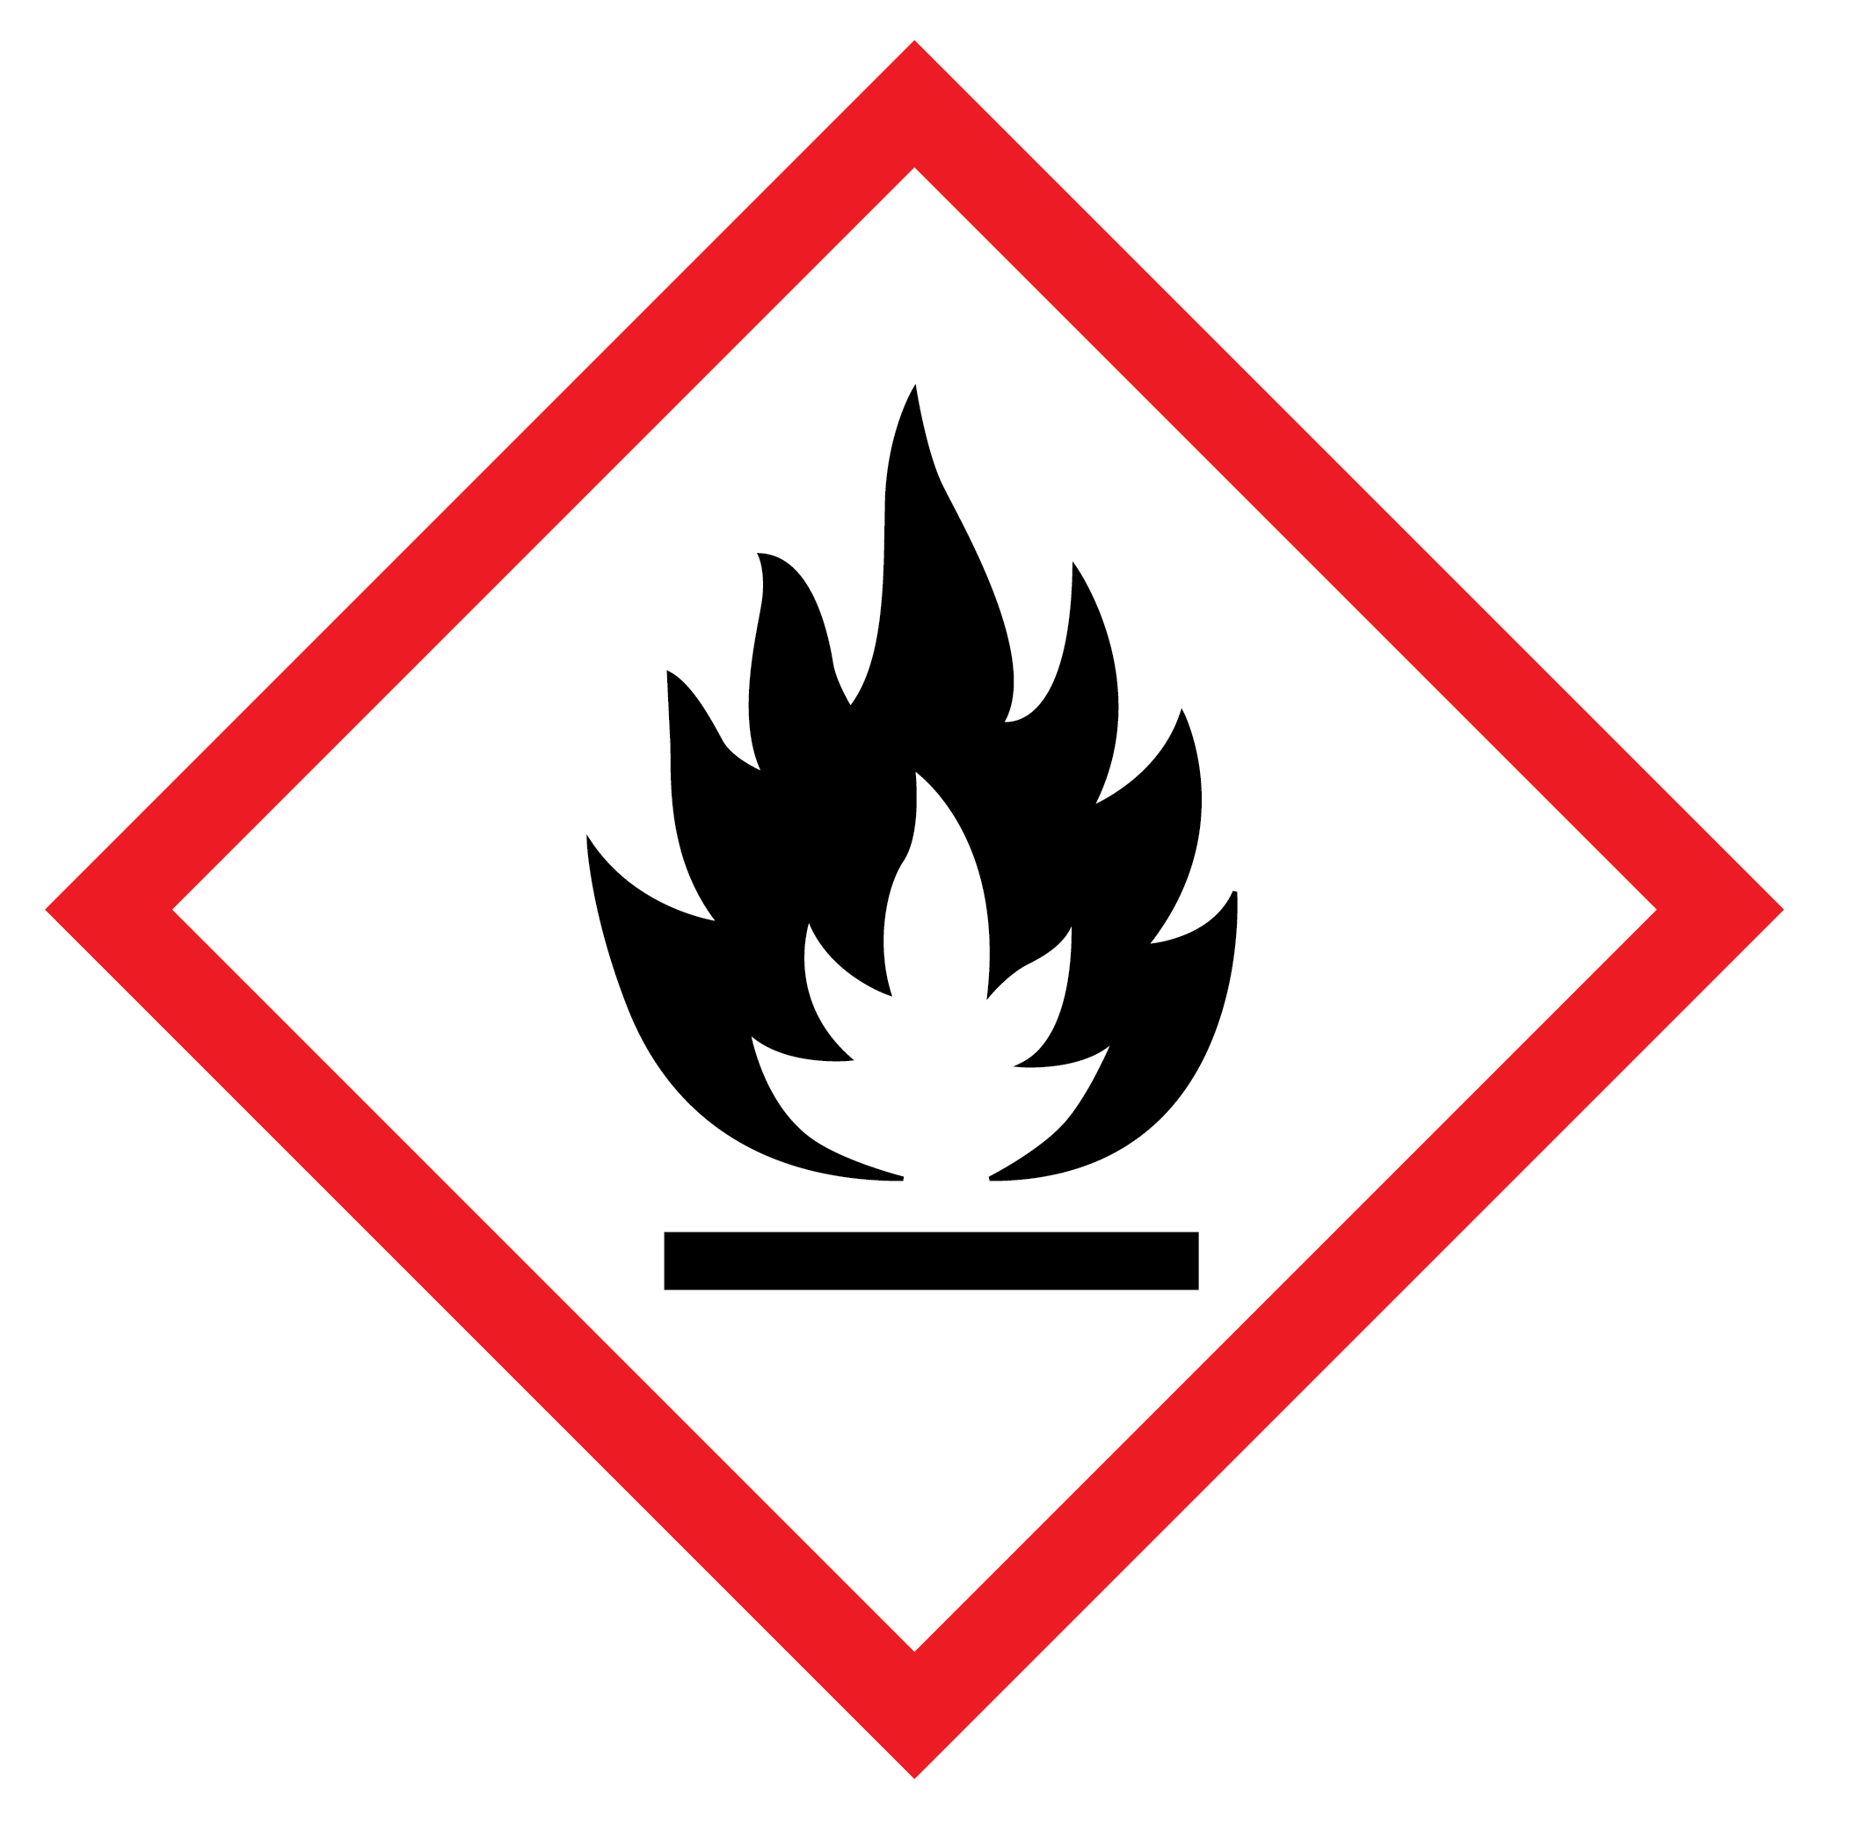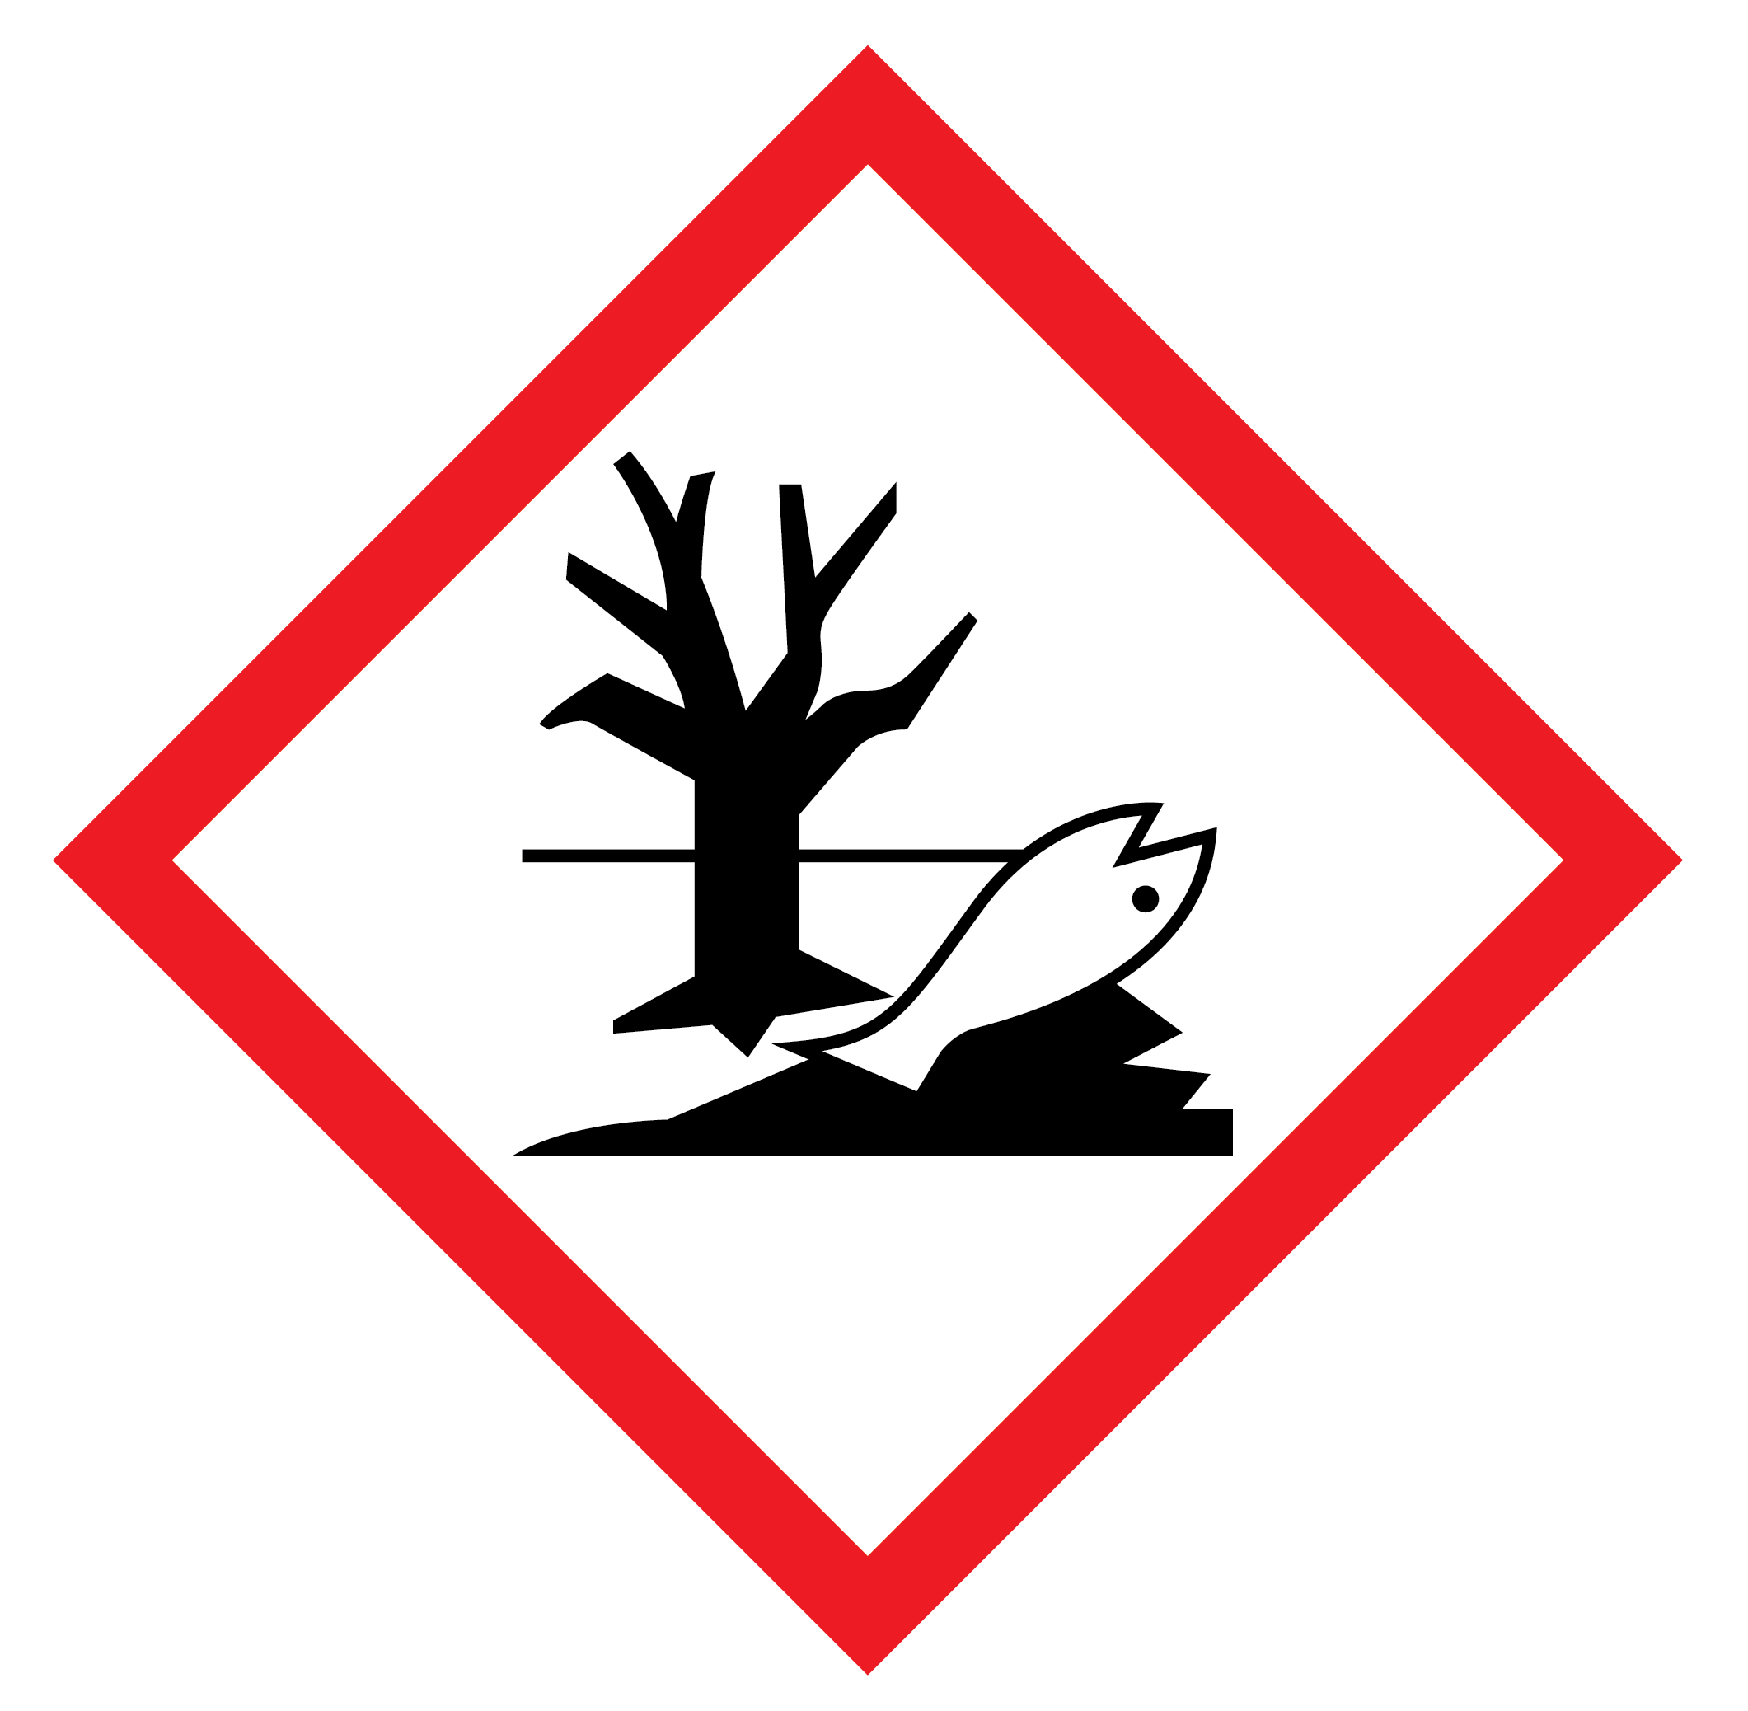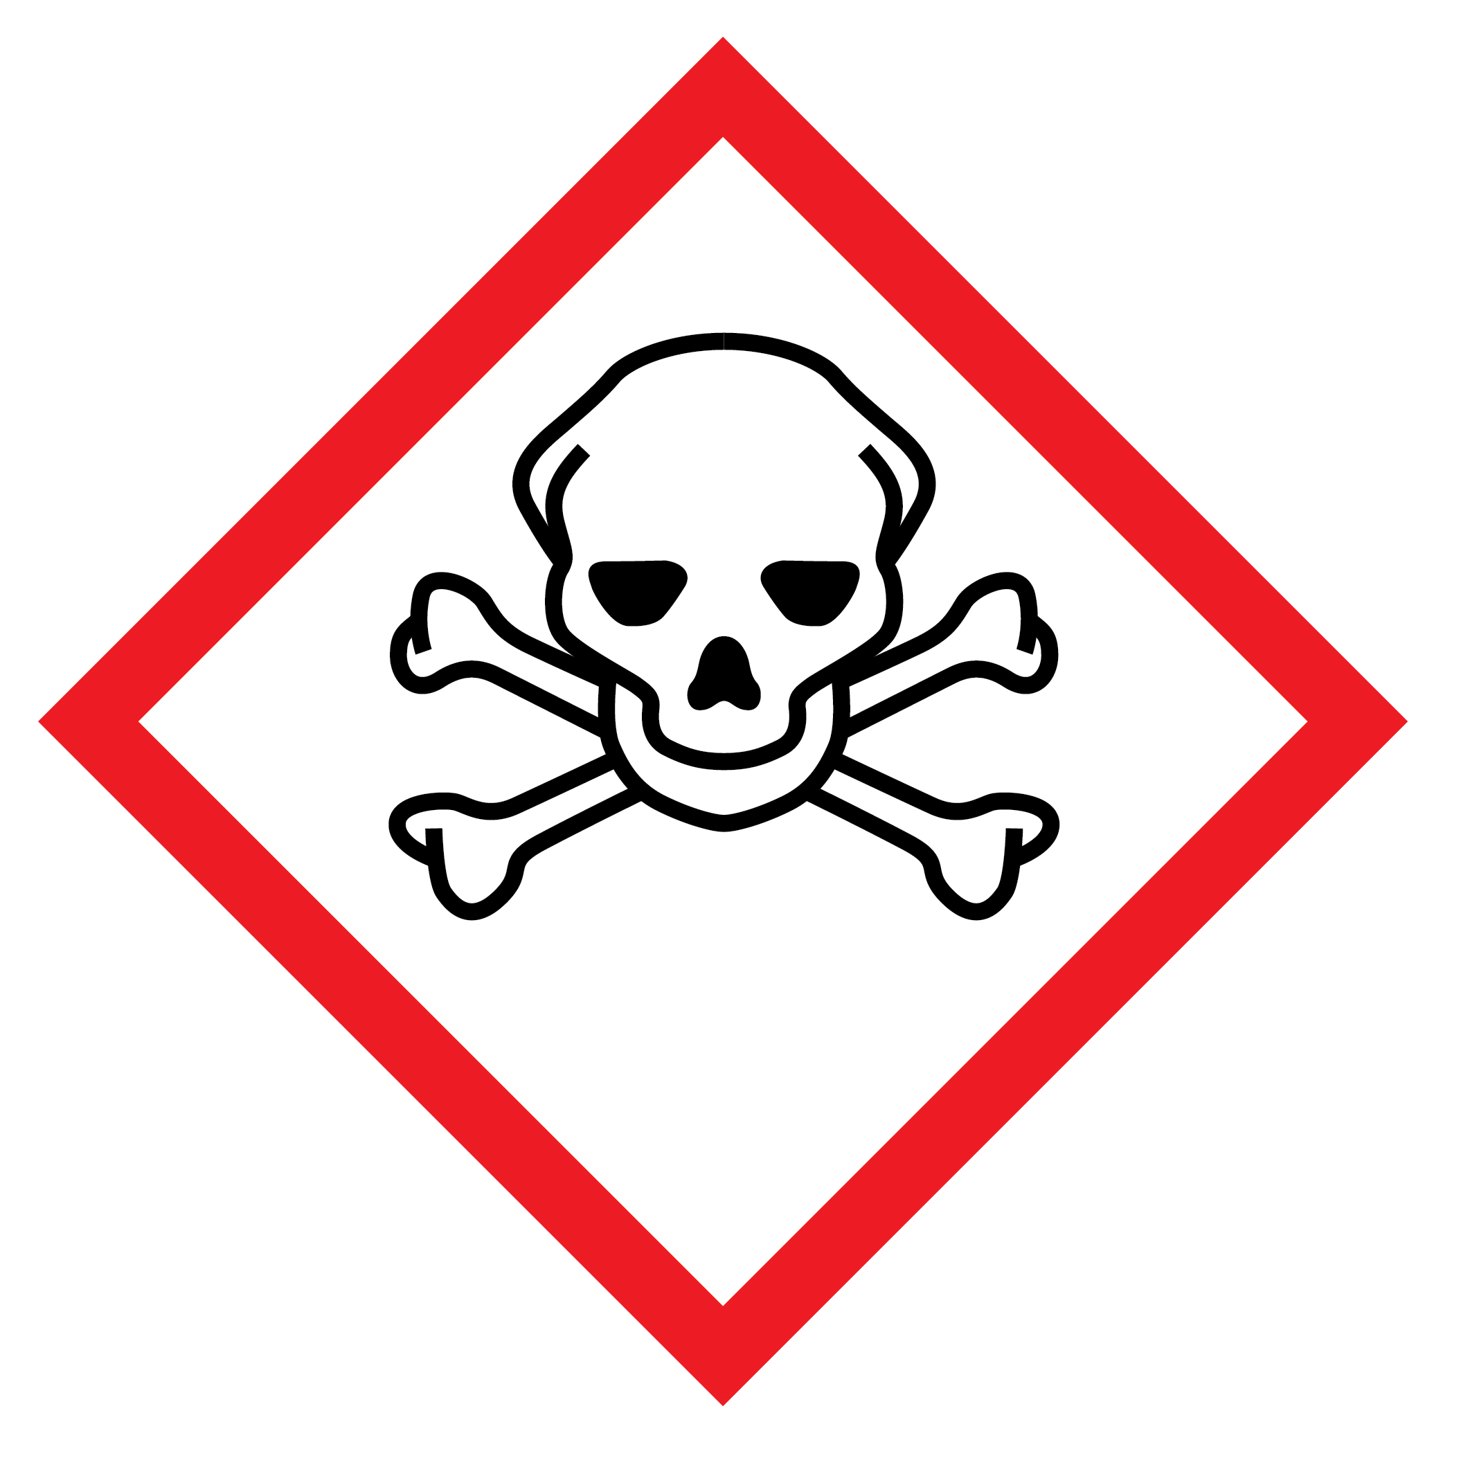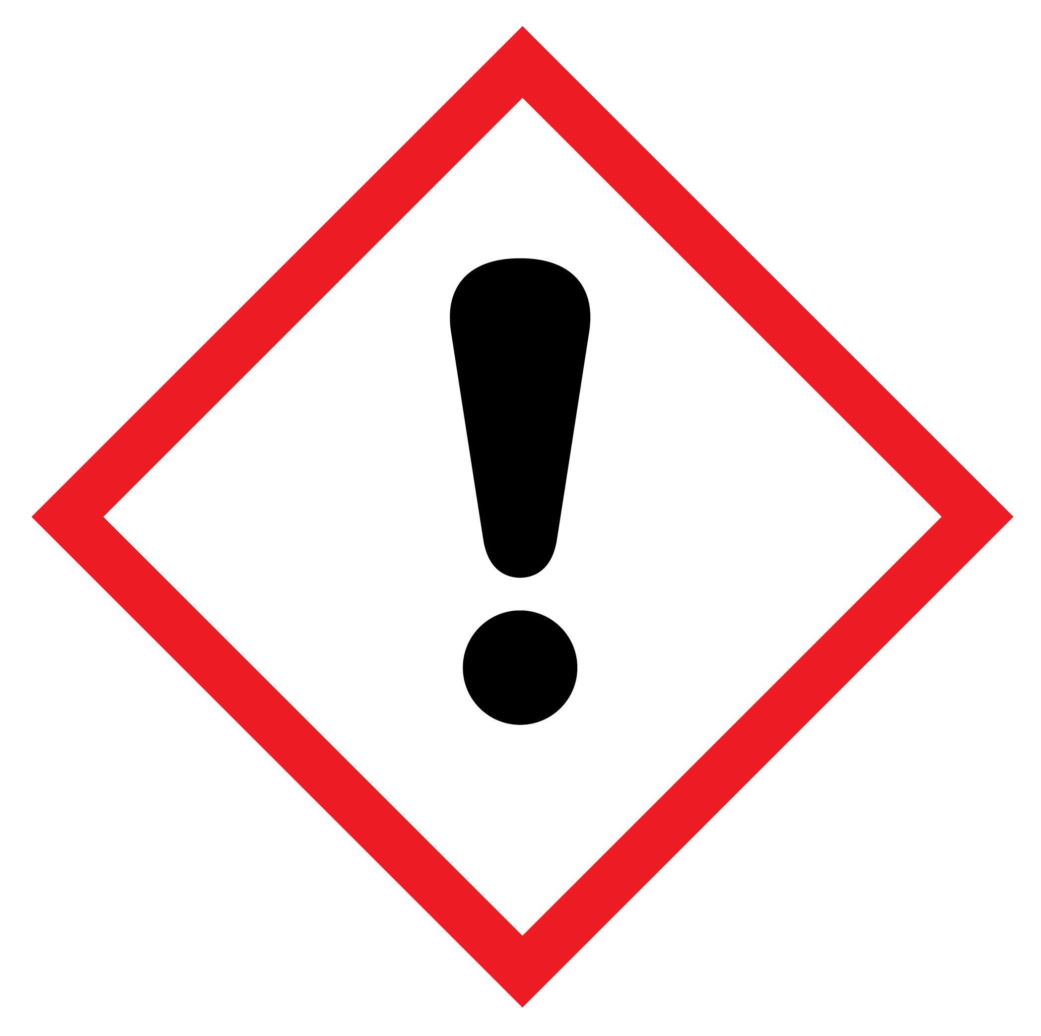
© Shutterstock
Safety and hazards
Wear safety glasses
To do:
- You have two test tubes which contain bromine water, Br₂ (aq).
- Remove the bung of the first test tube. Quickly add one drop of an alkane (hexane) and replace the bung immediately. Take care not to spill the test tube as bromine water and hexane are hazardous.
- Agitate the test tube by waggling it gently between your fingers.
- Note your observations in the table below.
- Repeat steps (a) to (c) with an alkene (hexene) using the second tube of bromine water.

Alkane or alkene | Appearance of bromine water (Br₂ (aq)) before adding the alkane/alkene | Appearance of bromine water (Br₂ (aq)) after adding the alkane/alkene
hexane
hexene

To answer:
Look at the reaction of bromine water and ethene.
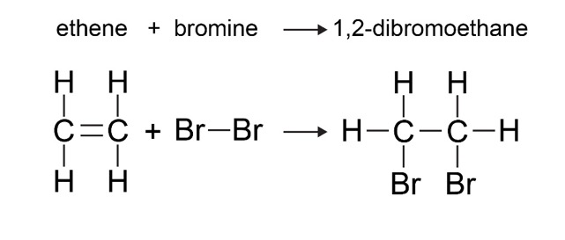
- Use this reaction to explain your observations.

Activity 8: functional groups
- Build the following organic molecules using your molymod kit and try to identify the functional group (what makes it different from an alkane?).
Functional group | Example compound name and formula | Molymod  model built?  X/ | Displayed formula
alkene | butene  C₄H₈
alcohol | ethanol  CH₃CH₂OH
carboxylic acid | ethanoic acid  CH₃COOH
aldehyde | propanal  CH₃CH₂CHO
ketone | propanone  CH₃COCH₃
- Circle the functional group in each displayed formula you have drawn.

Homework activity
Fill in the gaps
- Combustion takes place when a fuel burns in oxygen.
When there is a plentiful supply of oxygen, ________________________ combustion takes place.
The general equation for this reaction is:
fuel + oxygen → ________________________ + water
When the oxygen supply is limited, ________________________ combustion takes place.
The general equation for this reaction is:
fuel + oxygen → carbon monoxide + ________________________ + water
- Can you give the name and molecular formula for each of the molecules below?
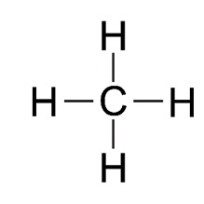
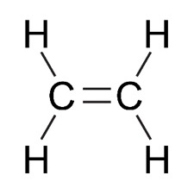
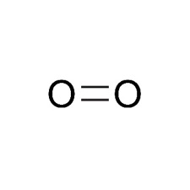

Name: _______________ Name: _______________ Name: _______________
Formula: _____________ Formula: _____________ Formula: _____________

