Chemistry in medicine
Education in Chemistry
March 2019
rsc.li/2HJTI5e
Understanding biological processes on a molecular level is essential in medicine. The questions below provide examples of where chemistry is needed to solve a medical problem
Intermolecular forces
In medicinal chemistry the lipophilicity (or hydrophobicity) of a drug is quantified by its ‘logP’ value. To do this, the drug is added to a mixture of octanol and water, mixed thoroughly, then the octanol and water layers separated and analysed for the amount of drug in each layer. The concentration of drug in the octanol layer divided by the concentration of drug in the water layer is the value P and, because medicinal chemists are generally only interested in order of magnitudes, the logarithm of P is calculated. For newly-discovered drugs, the logP value should be typically less than 5.
1. What piece of apparatus could be used to mix and then separate the octanol and water layers?
2. Explain why octanol and water are immiscible.
3. If the concentration of drug in the water phase is 10⁻⁴ M, what is the concentration in the octanol phase if logP = 5?
Acids and bases
B + H⁺ ⇌ BH⁺
Equation 1 – Equilibrium for a weak base
Buccal administration is where a drug is held in the cheek and absorbed across the cell membranes into the blood. It can be used in post-operative pain relief in animals. The pKa of the pain-relief medication buprenorphine is 8.3.
The Henderson–Hasselbalch equation (below) can be used to estimate the ratio of charged to uncharged form of a drug.
$$pK_{a}=pH-\log_{10}\left(\frac{B}{BH^{+}}\right)$$
4. Calculate the percentage of buprenoprphine in the charged form at pH 7.4, 7.1 and 6.8.
5. The pH of human saliva is 5.4–7.5, while the pH of dog saliva is ~8 and that of cat saliva is ~9. How might the pH of saliva affect the absorption of buprenorphine in dogs and cats compared with humans?

Oxidation–reduction
Lactate is formed from pyruvate in muscles when there is insufficient oxygen as in the reaction below.
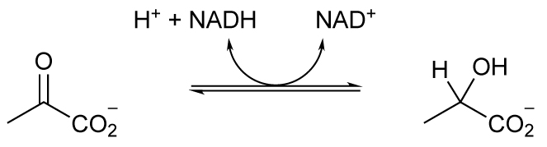
Equation 2 – conversion of pyruvate to lactate
6. Is pyruvate being oxidised or reduced?
7. The co-enzyme NADH is required and NAD⁺ is regenerated. Is NADH being oxidised or reduced?
Redox reactions are not restricted to cellular respiration. Many drugs undergo redox reactions in the liver including alcohol: ethanol is converted to ethanal and then to ethanoic acid. Since the pKa of ethanoic acid is 4.8, it exists in the charged form, ethanoate, at pH 7.4 and therefore it is readily removed in the urine and not reabsorbed back into the blood. This occurs because the blood is filtered in the kidney and the small molecules such as ethanoate pass through into the nephron and then on into the urine. If the molecules are non-polar they can diffuse through the cell membranes back into the blood but if they are charged they remain in the nephron and pass into the urine.
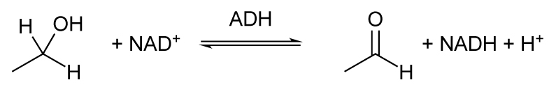
Equation 3 – conversion of ethanol to ethanal by alcohol dehydrogenase (ADH)
8. In the reaction scheme above, which molecules are being oxidised and which are being reduced?
9. How would a decrease in the pH of the urine affect the proportion of ethanoic acid compared with ethanoate?

Answers
1. Separating funnel
2. The 8 carbon chain is non-polar and dominates the intermolecular forces compared with the hydrophilicity of the hydroxyl group.
3. 10 M
working:
$\log\left(P\right)=log\left(\frac{concentration in octanol}{concentration in water}\right)=5$
$$\frac{concentration in octanol}{concentration in water}={10}^{5}$$
concentration in octanol = 10⁵ x 10⁻⁴= 10 M
4.
Buprenorphine, pain relief medication, pKa = 8.3 | $$\frac{B}{BH^{+}}$$ | % BH⁺
pH = 7.4 | 0.126 | 89%
pH = 7.1 | 0.063 | 94%
pH = 6.8 | 0.032 | 97%

5. In cat saliva, pH ~9, the ratio of [B]: [BH⁺] is 5:1 so the uncharged form predominates and so absorption is enhanced.
In dog saliva, pH ~ 8, the ratio [B]: [BH⁺] is 1:2 so there is relatively less of the uncharged form than in cats and so absorption is reduced.
At the top of the range of pH for humans, pH 7.5, the ratio [B]: [BH⁺] is 1:6 and at the lowest end of the range, pH 5.4, the ratio [B] : [BH⁺] is 1:800 which means there would be very little absorption.
6. Pyruvate is being reduced
7. NADH is being reduced
8. Alcohol is being oxidised and NAD+ is being reduced.
9. The equilibrium is: ethanoic acid ⇌ ethanoate + H+
A decrease in pH means an increase in [H+] and the equilibrium shifts to the left to produce more ethanoic acid which is uncharged and will therefore cross from the urine back into the blood therefore decreasing the amount in the urine.

