Unsaturation test with potassium manganate(VII) – teacher notes

In this experiment, students use a solution of potassium manganate(VII) in propanone to detect whether an organic compound is unsaturated.

The propanone solution is made up and stored in a plastic pipette, and mixes easily with non-polar organic compounds such as cyclohexane, cyclohexene and limonene.

Unsaturated compounds will turn the solution a brownish colour as the manganese(VII) is reduced to manganese(IV).

Timing

20 minutes

Equipment

Apparatus

- Eye protection
- Plastic pipettes
- Plastic Petri dish
- Beaker, 10 cm³
- Scissors

Chemicals

- Propanone
- Potassium manganate(VII) crystals
- Cyclohexane
- Cyclohexene
- Limonene

Procedure

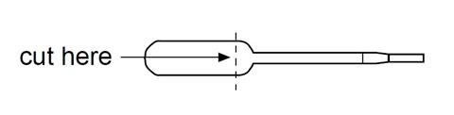
- Cut the end off a plastic pipette as shown below and place the cup in a glass beaker or test tube.
- Carefully add a few crystals of potassium manganate(VII) to the cup.
- Add propanone to the cup until it is about half-full. You will notice that the potassium manganate(VII) dissolves to give a purple solution. Is it surprising that potassium manganate(VII) dissolves in an organic solvent?
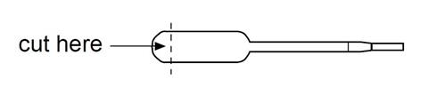
- Cut the ends off three pipettes to make small reaction vessels as shown below and place them in the lid of a plastic Petri dish.
- Using a plastic pipette, add four drops of the potassium manganate(VII) in propanone solution to each of the reaction vessels.
- Put three drops of each of the organic liquids under test in the reaction vessel and observe any changes over the next few minutes.
- Mop up the liquid with tissue paper when you have finished.

Health, safety and technical notes

- Read our standard health and safety guidance (https://rsc.li/3yKPgKL).
- Wear eye protection throughout.
- Avoid sources of ignition.
- Propanone is HIGHLY FLAMMABLE. See CLEAPSS Hazcard HC085A.
- Potassium manganate(VII) is an OXIDISER and IRRITANT, and stains glass, plastic, clothing and skin. Avoid direct contact and store in the dark. See CLEAPSS Hazcard HC081.
- Cyclohexane is HIGHLY FLAMMABLE, a skin/respiratory IRRITANT and very TOXIC to aquatic life. See CLEAPSS Hazcard HC045b.
- Cyclohexene is a HIGHLY FLAMMABLE liquid and vapour. It is HARMFUL if ingested or in contact with the skin and is very TOXIC to aquatic life. See CLEAPSS Hazcard HC045c.
- Limonene is FLAMMABLE as liquid and vapour. It is TOXIC to aquatic life and is an IRRITANT and SENSITISER to skin. See CLEAPSS Hazcard HC045c.

