Ammonium nitrate explosions: answers
Education in Chemistry
November 2020
rsc.li/2TdpNqC
The decomposition of ammonium nitrate at temperatures above 260ºC leads to a ‘runaway’ explosive reaction. Many aspects of this ‘runaway’ reaction can be explained by concepts such as enthalpy change and by taking a closer look at the structure and bonding of ammonium nitrate.

Task 1 – Structure and bonding in ammonium nitrate
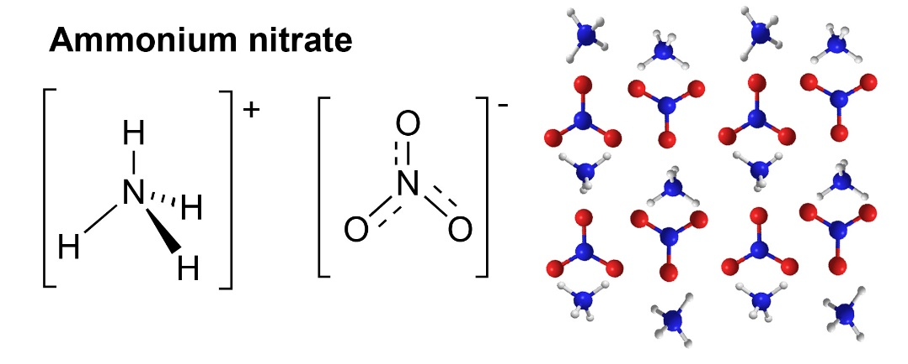
The structure and geometry of ammonium nitrate are shown in the diagrams below.
- Ammonium nitrate is composed of two polyatomic ions – identify the different type(s) of bonding within its structure.
Covalent bonding within NH₃ molecule
Coordinate bond between N and H⁺ ion
Ionic bonding between NH₄⁺and NO₃⁻ in the lattice
- Using the VSEPR theory and the diagrams above, state and explain the geometries of the NH₄⁺ and NO₃⁻ ions shown.
NH₄⁺ has four bond pairs which repel equally to give a tetrahedral geometry and a bond angle of 109.5°.
NO₃⁻ has three double bond pairs which repel equally to give a trigonal planar geometry and a bond angle of 120°.

Task 2 – Decomposition or explosion?
Pure ammonium nitrate does not explode easily and can be handled safely. It decomposes at 230ºC producing nitrous oxide gas (N₂O) and water vapour.
- Give a balanced equation for the decomposition reaction.
NH₄NO₃ (s) → N₂O(g) + 2H₂O(g)
Above 260ºC, if confined and when contaminated, ammonium nitrate will explode forming toxic gases such as NO₂, responsible for the ‘orange brown fireball’ described in the article.
The following equation represents one of the reactions contributing to the explosion:
4NH₄NO₃(s) → 3N₂(g) + 2NO₂(g) + 8H₂O(g)
- Given that the molar gas volume is 24.5 dm³ at 298K and 1atm calculate the total volume of gas produced from 80 kg of NH₄NO₃(s) under these conditions.
4 moles NH₄NO₃(s) → 13 moles of gas
1 mole NH₄NO₃(s) → 13/4 moles of gas
80kg NH₄NO₃(s) = 1000 moles NH₄NO₃(s) → 3250 moles of gas
Volume of gas = 3250 x 24.5 dm³ = 79,625 dm³
- Use your value to calculate the total volume of gas at the same pressure and 300ºC.
Scale this up to calculate the vast volume of gas produced from 2750 tonnes of NH₄NO₃(s) in the Beirut explosion.
80kg NH₄NO₃(s) → 79,625 dm³ of gas at 298 K
V₁/T₁ = V₂/T₂; 300ºC = 573 K
79,625/298 = V₂/573; V₂ = 153,104.4 dm³
2750 tonnes → 153,104.4/80 x 2750 x 1000 dm³ of gas = 5,262,965.3x10³ dm³ of gas

Task 3 – Calculating the enthalpy of reaction, ΔH_{R}, and using kinetic theory to explain why this is a ‘runaway’ reaction
The data below will be used in Tasks 3 - 5
Compound | ΔH⁰f / KJmol⁻¹ | S⁰/JK⁻¹mol⁻¹
NH₄NO₃ (s) | -365.6 | +15.1
N₂(g) | 0 | +153.3
NO₂(g) | +33.2 | +240.1
H₂O(g) | -241.8 | +188.8

Once decomposition begins a ‘runaway’ reaction occurs. In a runaway reaction an exothermic reaction goes out of control. The heat evolved raises the temperature of the reacting mixture leading to an increase in reaction rate, which causes a further increase in temperature and a further increase in reaction rate until an explosion occurs.
- Use the standard enthalpies of formation, ΔH⁰f, given in KJmol⁻¹ to calculate the enthalpy change for the reaction and confirm that it is exothermic
4NH₄NO₃(s) → 3N₂(g) + 2NO₂(g) + 8H₂O(g)
ΔH_{R} = sum of (ΔH⁰f products) - sum of (ΔH⁰f reactants)
ΔH_{R} = -1934.4 + 66.4. + 1462.4 = - 405.6 KJmol⁻¹
- Select which of the energy profile templates below (A or B) correctly represents the enthalpy change you have calculated and label it showing reactants, products, ΔH_{R} and E_{act}.
Energy profile diagram B, showing reactant, NH₄NO_{3 ,}on LHS and products 3N₂(g),2NO₂(g) and 8H₂O(g) on RHS. E_{act} shown as the difference in energy between reactants and peak of profile.

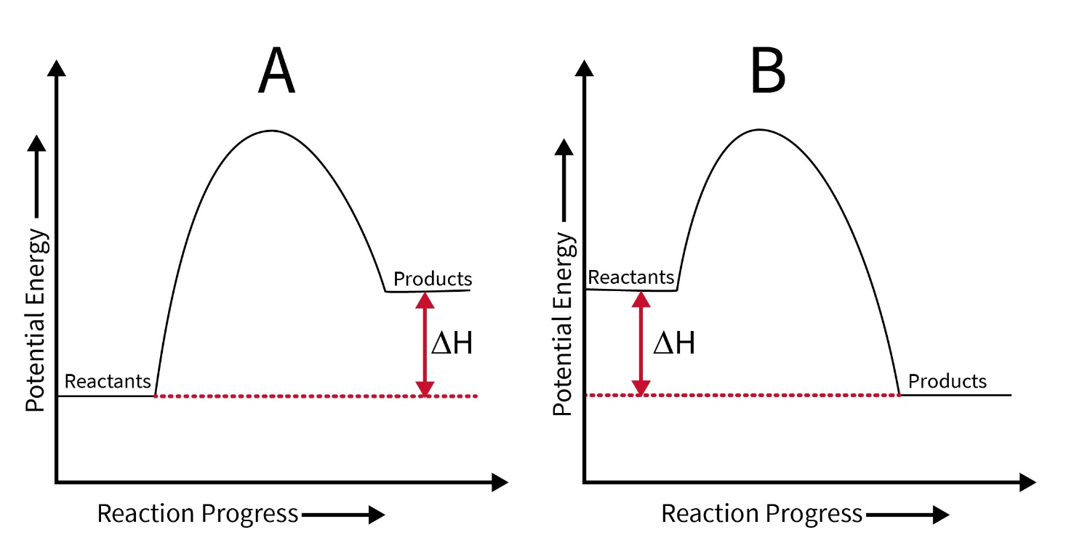

- Use kinetic theory to explain why an increase in temperature causes an increase in reaction rate.
For a successful collision molecules need E > or = E_{act}. As temperature increases kinetic energy of molecules increases and more molecules have E > or = E_{act} resulting in more successful collisions per unit time.

Task 4 – Calculating the entropy change, ΔS, for the reaction
The changes in state during the decomposition reaction below suggest there will be a significant increase in the disorder, entropy, for the reaction – ie ΔS will be highly positive.
- Use the standard entropies, S⁰, given in JK⁻¹mol⁻¹ to confirm this is the case.
4NH₄NO₃(s) → 3N₂(g) + 2NO₂(g) + 8H₂O(g)
ΔS = sum of (S⁰ of products) - sum of (S⁰ of reactants) = 459.9 + 1510.4 + 480.2 - 60.4 = +2390.1JK⁻¹mol⁻¹

Task 5 – Assessing the spontaneity of the reaction
To assess the spontaneity of a reaction both enthalpy and entropy changes need to be considered together in Gibb’s Equation.
Using your enthalpy and entropy changes from Tasks 3 and 4 and Gibbs equation below:
- Comment on whether the decomposition reaction is likely to be spontaneous at all temperatures.
Since ΔH = -ve and ΔS = +ve, both the terms ΔH and TΔS will be -ve at all temperatures above 0K; therefore ΔG = -ve indicating a spontaneous reaction.
- Using temperatures of 300⁰C and 500⁰C in a model calculation comment on whether the decomposition is likely to become more favourable as the temperature increases.
At 300K: ΔG = -405.6 - 573 x (2390.1/1000) = -1775.1KJmol⁻¹
At 500K: ΔG = -405.6 - 773 x (2390.1/1000) = -2253.1KJmol⁻¹
ΔG becomes more -ve as T increases; therefore decomposition reaction becomes more favourable.

Reminders about Gibbs equation:
ΔG = ΔH -TΔS

For a reaction to be spontaneous ΔG must be negative.
Take care with units!
ΔG and ΔH in KJmol⁻¹, ΔS in JK⁻¹mol⁻¹ and T is in K.

