Ionic bonding: Johnstone’s triangle

This resource is from the **Johnstone’s triangle** series which can be viewed at: [rsc.li/3Ak1lN6](https://rsc.li/3Ak1lN6). It will help learners understand the different ways you need to think in chemistry, building their mental models and understanding.

Learning objectives

1. Describe an ionic compound based on observations.
2. Use symbolic models to represent an ionic compound.
3. Explain how the bonding in an ionic compound relates to the properties you can observe.

How to use Johnstone’s triangle

Use Johnstone’s triangle to develop learners’ thinking about scientific concepts at three different conceptual levels:

* 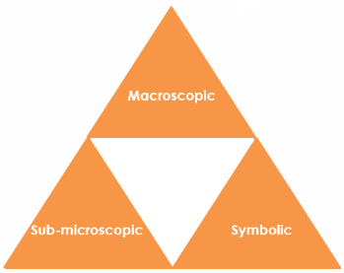Macroscopic – what we can see. Think about the properties we can observe, measure and record.
* Symbolic – representations. Think about how we represent chemical ideas including symbols and diagrams.
* Sub-microscopic – smaller than we can see. Think about the particle or atomic level.

For learners to gain a deeper awareness of a topic, they need to understand it at all three levels.

When introducing a topic, do not try to introduce all of the levels of thinking at once. This will overload working memory. Instead complete the triangle over a series of lessons, beginning with the macroscopic level and introducing other levels, in turn, once secure.

All of the levels are interrelated, for example, learners need visual representation of the sub-microscopic in order to develop mental models of the particle or atomic level.

Find further reading about Johnstone’s triangle and how to use it in your teaching at [rsc.li/3yyOg1W](https://rsc.li/3yyOg1W).

Scaffolding

It is important to share the structure of the triangle with learners prior to use. Tell them why you want them to use the triangle and how it will help them to develop their understanding. Use an ‘I try, we try, you try’ approach when you are introducing Johnstone’s triangle for the first time.

More resources

To further develop learner’s thinking in all areas of Johnstone’s triangle, try our **Developing understanding** worksheets ([rsc.li/4dTT7cn](https://rsc.li/4dTT7cn)). These include icons in the margin referring to the conceptual level of thinking needed to answer the question.

Teacher demonstration

Use this demonstration of the conductivity of solid salt and salt solution to encourage learners to observe and describe the macroscopic properties of salt.

Equipment

* Table salt
* Distilled water
* Petri dish
* Electrical circuit comprising:
* Power bank
* Wires or leads
* Electrodes
* Small bulb
* Ammeter (optional)

Circuit diagram

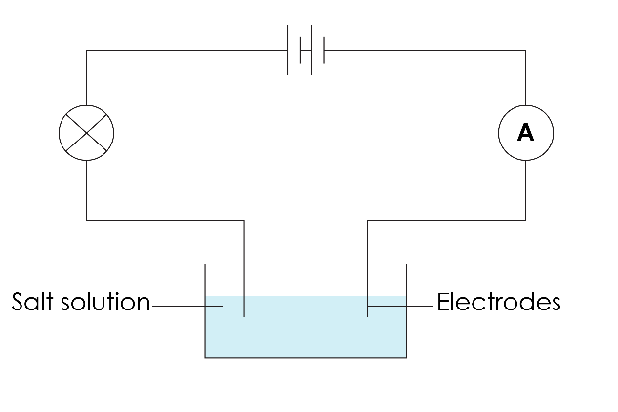

Method

1. Add one tablespoon of salt to a large Petri dish. Pass the salt around so that learners can look at it closely and observe the size, shape and colour of the salt crystals.
2. Set up a simple series circuit containing a light bulb and an ammeter (optional). There should be a break in the circuit with two electrodes (carbon rods will work but you can also use the ends of the leads or a pair of crocodile clips as the electrodes).
3. Firstly, touch the electrodes together to show that the light bulb will glow when the circuit is completed. Learners should be watching to see if the bulb glows during the demonstration.
4. Next, touch the electrodes to the solid salt in the Petri dish. The electrodes must not touch each other. The salt should be heaped so that there are grains touching between the electrodes (no break in the circuit). The light bulb will not glow.
5. Add distilled water to the Petri dish and stir until the salt dissolves. Next, touch the electrodes to the salt solution. The light bulb will glow.
6. You can opt to demonstrate the effect that distilled water has on the flow of electricity without any salt, as a ‘control’ variable. Distilled water should not conduct electricity, however, if there are any impurities the light bulb may dimly glow. The light bulb will glow brighter with the salt solution. Be mindful of whether there is any salt on the electrodes and use fresh electrodes if this is the case.

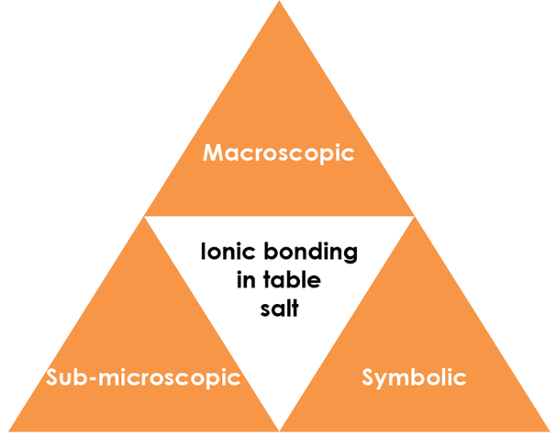

**chloride ion**

**sodium ion**

Macroscopic – what we can see

Describe table salt:

**White, crystalline solid formed of small cubic grains.**

Task: Watch the teacher demonstration. What are the properties of salt you have observed?

* **Solid salt does not conduct electricity.**
* **Salt dissolves in water.**
* **Salt solution conducts electricity.**

Symbolic – representations

Write the chemical formula for table salt.

Draw a dot and cross diagram for a sodium ion and a chloride ion. 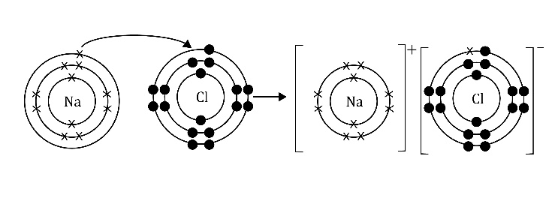

Label a sodium ion and a chloride ion on the ionic lattice diagram:  
Note: labels can be either way round.

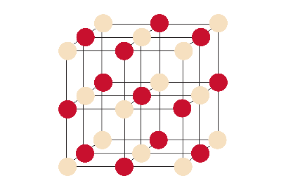

Sub-microscopic – smaller than we can see

Explain the electrical conductivity of salt. (You might find it helpful to refer to the symbolic diagrams.)

**Salt is made up of charged ions. Electricity is the flow of charged particles therefore molten salt and salt solutions can conduct electricity as these ions are free to move.**

**Solid salt has a giant ionic lattice structure. The cubic shape of salt grains mimics this structure at a larger scale. The ions are not free to move in solid salt and so cannot flow.**