Particle diagrams

Learning objectives
- Recall, draw and describe the particle model for solids, liquids and gases where particles are represented by circles/spheres.
- Use particle diagrams to represent chemical reactions and physical changes.
- Evaluate the use of particle diagrams.

Introduction

Particle diagrams are often used to show the arrangement of atoms and molecules in substances. It is important that we understand all the information given in these diagrams and their limitations.

Instructions
- Stick the structure strip in the margin of your exercise book/paper.
- Follow the prompts to write a summary of particle diagrams. You can use a textbook, revision guide or website to help you. Write in full sentences, rephrasing the question within your answer and using appropriate keywords.
- Answer the follow-up question below to apply your knowledge of particle diagrams to a new context.

Keywords

Use these key words in your responses:

• solid • liquid • gas • substance • particle • atom • molecule • mixture • regular
• irregular • arrangement

Follow-up question

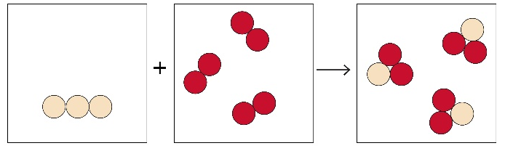
Substance X
Substance Z
Substance Y

The diagram shows a chemical reaction. Explain how the diagram shows this is a chemical reaction and what the diagram shows about the types and states of the substances involved. Suggest a symbol equation with state symbols that would fit the diagram.
Structure strip Particle diagrams | Structure strip Particle diagrams | Structure strip Particle diagrams | Structure strip Particle diagrams | Structure strip Particle diagrams
Draw diagrams of the arrangement of particles for each of the following states:  - solid  - liquid  - gas  Describe and explain the key features of your diagrams. | Draw diagrams of the arrangement of particles for each of the following states:  - solid  - liquid  - gas  Describe and explain the key features of your diagrams. | Draw diagrams of the arrangement of particles for each of the following states:  - solid  - liquid  - gas  Describe and explain the key features of your diagrams. | Draw diagrams of the arrangement of particles for each of the following states:  - solid  - liquid  - gas  Describe and explain the key features of your diagrams. | Draw diagrams of the arrangement of particles for each of the following states:  - solid  - liquid  - gas  Describe and explain the key features of your diagrams.
Explain why representing atoms and molecules as circles/spheres is useful for representing state changes. | Explain why representing atoms and molecules as circles/spheres is useful for representing state changes. | Explain why representing atoms and molecules as circles/spheres is useful for representing state changes. | Explain why representing atoms and molecules as circles/spheres is useful for representing state changes. | Explain why representing atoms and molecules as circles/spheres is useful for representing state changes.
Using circles for the individual atoms, show what happens when sulfur, S, reacts with oxygen, $O_{2}$, to make sulfur dioxide, ${SO}_{2}$. Explain your diagram. | Using circles for the individual atoms, show what happens when sulfur, S, reacts with oxygen, $O_{2}$, to make sulfur dioxide, ${SO}_{2}$. Explain your diagram. | Using circles for the individual atoms, show what happens when sulfur, S, reacts with oxygen, $O_{2}$, to make sulfur dioxide, ${SO}_{2}$. Explain your diagram. | Using circles for the individual atoms, show what happens when sulfur, S, reacts with oxygen, $O_{2}$, to make sulfur dioxide, ${SO}_{2}$. Explain your diagram. | Using circles for the individual atoms, show what happens when sulfur, S, reacts with oxygen, $O_{2}$, to make sulfur dioxide, ${SO}_{2}$. Explain your diagram.
Using circles for the individual atoms, show what happens when iron, Fe, mixes with sulfur, S, but does not react. Explain your diagram. | Using circles for the individual atoms, show what happens when iron, Fe, mixes with sulfur, S, but does not react. Explain your diagram. | Using circles for the individual atoms, show what happens when iron, Fe, mixes with sulfur, S, but does not react. Explain your diagram. | Using circles for the individual atoms, show what happens when iron, Fe, mixes with sulfur, S, but does not react. Explain your diagram. | Using circles for the individual atoms, show what happens when iron, Fe, mixes with sulfur, S, but does not react. Explain your diagram.
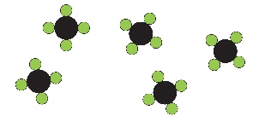Evaluate the pros and cons of this diagram which shows molecules of methane, ${CH}_{4}$, as a gas. | 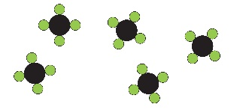Evaluate the pros and cons of this diagram which shows molecules of methane, ${CH}_{4}$, as a gas. | Evaluate the pros and cons of this diagram which shows molecules of methane, ${CH}_{4}$, as a gas. | Evaluate the pros and cons of this diagram which shows molecules of methane, ${CH}_{4}$, as a gas. | Evaluate the pros and cons of this diagram which shows molecules of methane, ${CH}_{4}$, as a gas.

