**Cracking: knowledge check**

1. The table compares the supply of crude oil fractions from fractional distillation and the demand.

|  |  |  |
| --- | --- | --- |
| **Fraction** | **Percentage supplied**  **from crude oil**  **()** | **Percentage demand**  **()** |
| gases | 3 | 6 |
| petrol | 10 | 27 |
| kerosene | 11 | 19 |
| bitumen | 12 | 4 |
| diesel | 15 | 23 |
| fuel oil | 49 | 21 |

Use the data in the table to answer the questions.

* 1. For which fractions is the demand higher than supply?
  2. For which fractions is supply higher than demand?

1. Decide whether each of the following statements is true or false and write your answer in the box provided.

For each statement you think is false, write out the correct version.

* 1. The process of cracking is used to break larger hydrocarbon molecules into smaller ones. **True False**
  2. Smaller hydrocarbon molecules are generally less useful than larger hydrocarbon molecules. **True False**
  3. Saturated hydrocarbons contain at least one double covalent bond between carbon atoms. **True False**
  4. Alkenes are saturated compounds. **True False**
  5. Alkane molecules only contain single covalent bonds between carbon atoms. **True False**
  6. Alkanes and alkenes are part of the same homologous series.

**True False**

1. Complete the gaps in the sentences.

The process of cracking is used to help match the supply of crude oil fractions with their __________________.

The smaller, saturated __________________ produced in cracking are used as __________________ such as petrol, kerosene and __________________.

The unsaturated __________________ produced are used in the petrochemical industry to make other products including medicines, dyes and __________________.

1. Fill in the gaps to complete the sentences describing the two methods of cracking.

During the process of cracking some of the __________________ bonds in the molecules are broken to produce __________________ alkanes and alkenes.

Catalytic cracking involves heating the hydrocarbons to a temperature of __________________ to vaporise them. The vapours are passed over a __________________ of zeolite to __________________ the reaction.

Steam cracking involves heating the hydrocarbons to a temperature of __________________ to vaporise them.

The vaporised hydrocarbons are mixed with __________________ and cracking occurs.

**Cracking: test myself**

1. What type of reaction is cracking?
2. State the general molecular formula of an alkene.
3. This is the displayed structural formula of ethene.

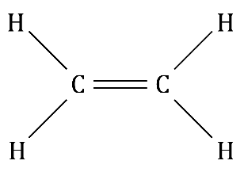

How many pairs of electrons are shared in the double covalent bond?

1. This equation represents the cracking of decane, C10H22.

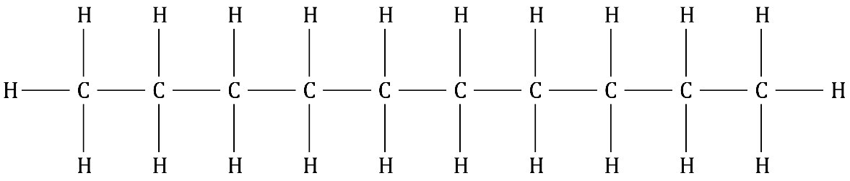

C10H22  decane

**Heat**

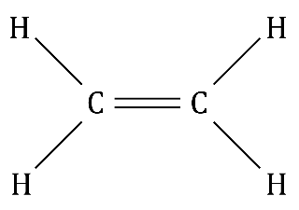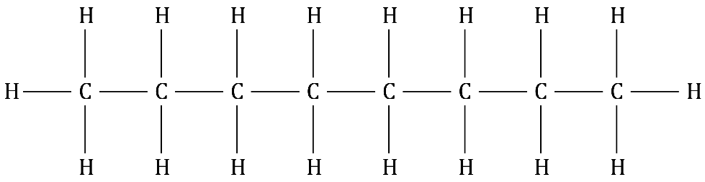

+

C8H18  octane C2H4  ethene

Identify the unsaturated product.

1. Complete the equation representing the cracking of undecane, C11H24, to produce nonane, C9H20 and an unsaturated compound.

C11H24 → __________________ + __________________

1. The cracking of dodecane, C12H26, produces one molecule of propene, one molecule of ethene and a third alkane product.

State the molecular formula of the alkane product formed.

1. The cracking of the alkane C16H34 produces an alkane with 12 carbon atoms in each molecule and a second unsaturated product.

Complete the equation for the reaction.

C16H34 → __________________ + __________________

1. Suggest two reasons why catalytic cracking is usually preferred to steam cracking.

Reason 1: ___________________________________________________________________

Reason 2: ___________________________________________________________________

**Cracking: feeling confident?**

1. Ethane or ethene?

Complete the table comparing the saturated compound ethane and the unsaturated compound ethene.

|  |  |  |  |  |  |
| --- | --- | --- | --- | --- | --- |
| **Compound** | **Homologous**  **series** | **Molecular formula** | **Displayed structural formula** | **Number of single covalent bonds** | **Number of double covalent bonds** |
| ethane |  |  |  |  |  |
| ethene |  |  |  |  |  |

1. Alkanes that contain between 10 and 16 carbon atoms are the feedstock for steam cracking.

By varying the temperature at which cracking is carried out, chemists can control the chain length of the alkanes and alkenes produced.

The table provides information about the alkanes and alkenes produced at two different temperatures during steam cracking.

|  |  |  |  |
| --- | --- | --- | --- |
| **Temperature** | **Point at which the carbon chain breaks** | **Alkanes produced** | **Alkenes produced** |
| higher temperature | near the end of the alkane chain | higher proportion of longer alkanes containing 10 to 14 carbons | higher proportion of smaller alkenes, ethene and propene |
| lower temperature | near the middle of the alkane chain | higher proportion of medium-sized alkanes such as C8H18 | higher proportion of larger alkenes, such as C8H16 |

Use the information provided in the table to write an equation representing the cracking of C14H30 at each of the two temperatures.

*[Hint: You can use the information in the table to decide on the products formed in each process, but the equations must be balanced.]*

**C2H4 C3H6 C7H14 C8H16**

**C13H28 C12H26 C8H18 C9H20 C6H14**

* 1. Higher temperature

C14H30 → __________________ + __________________

* 1. Lower temperature

C14H30 → __________________ + __________________

**Cracking: what do I understand?**

Think about your answers and confidence level for each mini-topic. Decide whether you understand it well, are unsure or need more help. Tick the appropriate column.

|  |  |  |  |
| --- | --- | --- | --- |
| **Mini-topic** | **I understand  this well** | **I think I understand this** | **I need more  help** |
| I can compare the supply and demand of fractions produced from the fractional distillation of crude oil. |  |  |  |
| I can describe the reasons for cracking. |  |  |  |
| I can describe the production of smaller alkane molecules and alkene molecules from cracking. |  |  |  |
| I can write equations to represent cracking. |  |  |  |
| I can compare catalytic and steam cracking. |  |  |  |
| **Feeling confident? topics** | **I understand  this well** | **I think I understand this** | **I need more  help** |
| I can describe the difference between ethane and ethene. |  |  |  |
| I can predict products formed during steam cracking. |  |  |  |