Ionic bonding: Johnstone’s triangle

This resource is from the **Johnstone’s triangle** series which can be viewed at: [rsc.li/3Ak1lN6](https://rsc.li/3Ak1lN6). Use this resource alongside our **Developing understanding** worksheets which can be downloaded from: [rsc.li/3yyOg1W](https://rsc.li/3yyOg1W)

Learning objectives

1. Describe an ionic compound based on observations.
2. Use symbolic models to represent an ionic compound.
3. Explain how the bonding in an ionic compound relates to the properties you can observe.

How to use Johnstone’s triangle

Use Johnstone’s triangle to develop learners’ thinking about scientific concepts at three different conceptual levels:

* 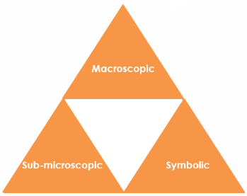Macroscopic – what we can see
* Symbolic – what we use to represent what we’ve seen
* Sub-microscopic – smaller than we can see

For learners to gain a deeper awareness of a topic, they need to understand it at all three levels.

Read more about how to use Johnstone’s triangle in your teaching with these *Education in Chemistry* articles:

* Develop deeper understanding with models: [rsc.li/4dBHvLr](https://rsc.li/4dBHvLr)
* Improve students’ understanding with Johnstone’s triangle: [rsc.li/4dCT8lg](https://rsc.li/4dCT8lg)

Scaffolding

It is important to share the structure of the triangle with learners prior to use. Tell them why you want them to use the triangle and how it will help them to develop their understanding. Ask learners to complete the Johnstone’s triangle worksheet independently, in small groups or as a whole class activity.

Use an ‘I try, we try, you try’ approach when you are introducing Johnstone’s triangle for the first time, as detailed in the article *Develop deeper understanding with models*, link above. Use the scaffolded version (two stars in header) with learners who need more support.

Next steps

Get learners to use the completed Johnstone’s triangle as a support document to refer back to when they move on to complete the associated **Developing understanding** worksheet ([rsc.li/3yyOg1W](https://rsc.li/3yyOg1W)).

These worksheets contain icons in the margin referring to the conceptual level of thinking needed to answer the question.

Teacher demonstration

Use this demonstration of the conductivity of solid salt and salt solution to encourage learners to observe and describe the macroscopic properties of salt.

Equipment

* Table salt
* Distilled water
* Petri dish
* Electrical circuit comprising:
* Power bank
* Wires or leads
* Electrodes
* Small bulb
* Ammeter (optional)

Circuit diagram

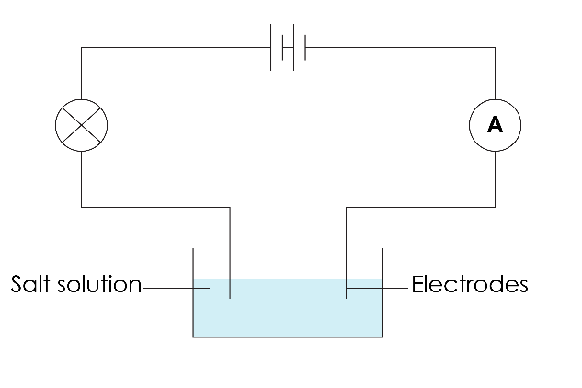

Method

1. Add one tablespoon of salt to a large Petri dish. Pass the salt around so that learners can look at it closely and observe the size, shape and colour of the salt crystals.
2. Set up a simple series circuit containing a light bulb and an ammeter (optional). There should be a break in the circuit with two electrodes (carbon rods will work but you can also use the ends of the leads or a pair of crocodile clips as the electrodes).
3. Firstly, touch the electrodes together to show that the light bulb will glow when the circuit is completed. Learners should be watching to see if the bulb glows during the demonstration.
4. Next, touch the electrodes to the solid salt in the Petri dish. The electrodes must not touch. The salt should be heaped so that there are grains touching between the electrodes (no break in the circuit). The light bulb will not glow.
5. Add distilled water to the Petri dish and stir until the salt dissolves. Next, touch the electrodes to the salt solution. The light bulb will glow.
6. You can opt to demonstrate the effect that distilled water has on the flow of electricity without any salt, as a ‘control’ variable. Distilled water should not conduct electricity, however, if there are any impurities the light bulb may dimly glow. The light bulb will glow brighter with the salt solution. Be mindful of whether there is any salt on the electrodes and use fresh electrodes if this is the case.

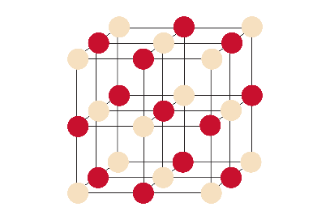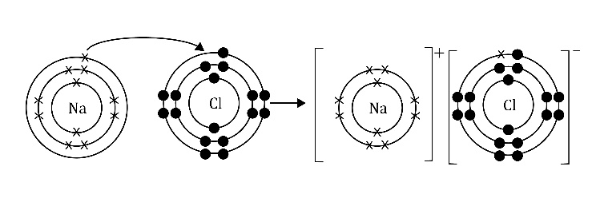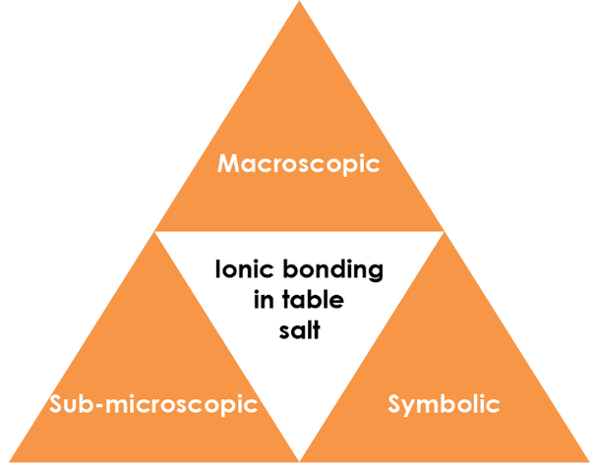

Symbolic - How do we represent it?

Write a word and symbol equation to represent the formation of table salt from its elements.

**sodium + chlorine sodium chloride**

Draw a dot and cross diagram to represent the formation of table salt from its constituent ions.

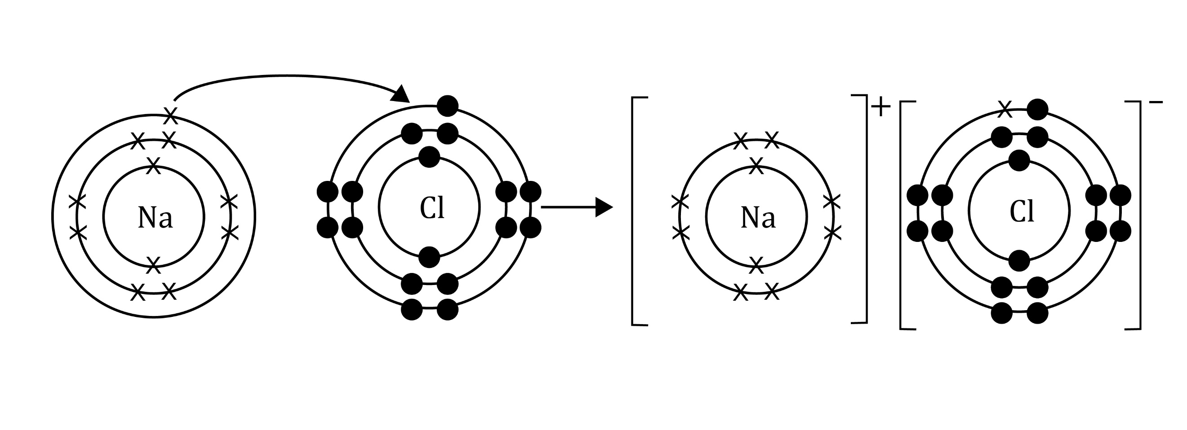

Identify the metal and non-metal ions.

**Metal: sodium, non-metal: chloride**

Macroscopic - What do you observe?

Describe table salt:

**White, crystalline solid formed of small cubic grains.**

Task: Watch the teacher demonstration. What are the properties of salt that you have observed?

* **Solid salt does not conduct electricity.**
* **Salt dissolves in water.**
* **Salt solution conducts electricity.**

Sub-microscopic - What is happening that we can’t see?

Explain the electrical conductivity of salt using diagrams.

**Salt contains charged ions due to the transfer of electrons. Electricity is the flow of charged particles therefore molten salt and salt solutions can conduct electricity.**

**Solid salt has a giant crystal lattice. The cubic shape of salt grains mimics this structure at a larger scale. The ions are not free to move in solid salt, so the ions do not flow.**