Ionic structure

Introduction

These questions are designed to help you to develop your mental models (pictures in your head) of ions. Being able to think about ions in different ways will help to develop your understanding of ionic structures. Use the icon in the margin to find out which level of understanding the question is developing. You can refer back to your **Ionic bonding in table salt: Johnstone’s triangle** worksheet to support you.

|  |  |
| --- | --- |
| An icon used to indicate the Macroscopic part of Johnstone's triangle. | **Macroscopic:** what we can see. Think about the properties that you can observe, measure and record. |
| An icon used to indicate the Sub-microscopic part of Johnstone's triangle. | **Sub-microscopic:** smaller than we can see. Think about what is happening at a particle or atomic level. |
| An icon used to indicate the Symbolic part of Johnstone's triangle. | **Symbolic:** how we represent what is happening. Think about the models you use to represent what you cannot see including diagrams and symbols. |

Questions

1. Sodium chloride is an ionic compound. Select the diagram that shows the structure of sodium chloride.

|  |  |  |
| --- | --- | --- |
| Diagram A consists of 16 identical circles arranged in four rows of four. Each circle is touching four of its neighbours. | Diagram B consists of 16 circles which are the same size. They are arranged in four rows of four. Each circle is touching four of its neighbours. They alternate in colour between white and grey so that no two circles of the same colour are next to each other. | Diagram C consists of two circles of the same size touching each other. One is white and one is grey. |
| A | B | C |
| Diagram D consists of three shapes made up of two circles of the same size touching each other. One of the circles in each shape is grey, the other is white. The three shapes are oriented in different directions and are separate from each other. | Diagram E is a 3D model containing two different sized spheres arranged in an alternating lattice. The spheres are tightly packed in a cube which is 5 rows high, 5 rows deep and 5 rows wide. |  |
| D | E |  |

1. A sodium atom has 11 electrons. The diagram below shows an electron configuration diagram of a sodium atom.

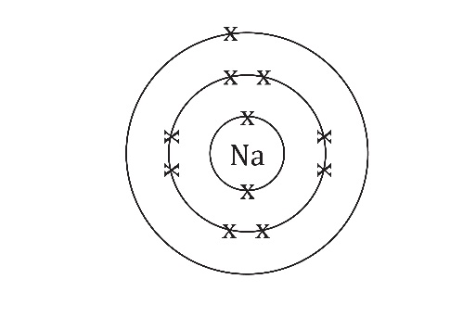

1. Complete the electron configuration diagram for a sodium ion ().

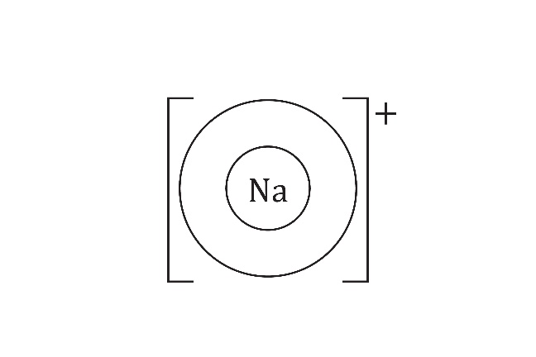

1. Draw the electron configuration diagrams for the following ions:
2. lithium ion ()  
   (A lithium atom has 3 electrons.)
3. chloride ion ()  
   (A chlorine atom has 17 electrons.)
4. fluoride ion ()  
   (A fluorine atom has 9 electrons.)
5. Complete the following sentences using the words **larger** or **smaller**.
6. A sodium ion is _______________ than a chloride ion.
7. A chloride ion is _______________ that a fluoride ion.
8. A lithium ion is _______________ than a fluoride ion.
9. In diagrams of ionic lattices, ions are shown as spheres. Different ions are shown with different colours or shading. Ions are not really different colours but it helps to show the structure of the lattice more clearly.  
     
   The diagram below shows the structure of lithium fluoride. On the diagram, label:
10. a lithium ion
11. a fluoride ion

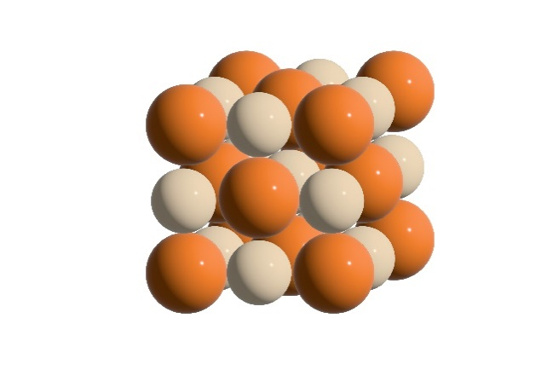

1. The diagram below shows two models of the structure of caesium chloride.

Two diagrams. 

The diagram on the left is a 3D model containing two different coloured spheres (red and orange) arranged in a cube. The red spheres are arranged 3 rows high, 3 rows deep and 3 rows wide. Between these, and offset so that they fill the gaps between, are the orange spheres. These are arranged 2 rows high, 2 rows deep and 2 rows high. The orange spheres are labelled 'caesium ion'.

The diagram on the right is a 3D ball and stick model. This is made up of a frame of cubes outlined by thin black lines which is 2 by 2 by 2. At the corner of each cube in the frame there is a red dot. The red dots make up a lattice of red dots which is 3 by 3 by 3. At the centre of each cube is an orange dot. The orange dot is labelled 'caesium ion'. Two dashed lines drawn from opposite corners in one of the cubes show that the orange dot is centred in the middle of the cubes that make up the frame.

Space-filling model Ball-and-stick model

1. Suggest why the ions in the caesium chloride lattice are arranged differently to the ions in lithium fluoride (in question 2(d)).

__________________________________________________________________________________

__________________________________________________________________________________

__________________________________________________________________________________

__________________________________________________________________________________

1. Give one advantage and one disadvantage for the space-filling model and the ball-and-stick model.

__________________________________________________________________________________

__________________________________________________________________________________

__________________________________________________________________________________

__________________________________________________________________________________

__________________________________________________________________________________

__________________________________________________________________________________

__________________________________________________________________________________

__________________________________________________________________________________

__________________________________________________________________________________

__________________________________________________________________________________

__________________________________________________________________________________

__________________________________________________________________________________