Ionic structure and bonding

Introduction

These questions are designed to help you to develop your mental models (pictures in your head) of ions. Being able to think about ions in different ways will help to develop your understanding of ionic structures. Use the icon in the margin to find out which level of understanding the question is developing.

|  |  |
| --- | --- |
| An icon used to indicate the Macroscopic part of Johnstone's triangle. | **Macroscopic:** what we can see. Think about the properties that we can observe, measure and record. |
| An icon used to indicate the Sub-microscopic part of Johnstone's triangle. | **Sub-microscopic:** smaller than we can see. Think about the particle or atomic level. |
| An icon used to indicate the Symbolic part of Johnstone's triangle. | **Symbolic:** representations. Think about how we represent chemical ideas including symbols and diagrams. |

Questions

1. Sodium chloride is an ionic compound. It is in the solid state at room temperature.

|  |  |  |
| --- | --- | --- |
| Diagram A consists of 16 identical circles arranged in four rows of four. Each circle is touching four of its neighbours. All circles are the same colour. | Diagram B consists of 16 identical circles arranged in four rows of four. Each circle is touching four of its neighbours. The colour of the circles alternates - one circle is dark orange and the next is light orange. | Diagram C shows six circles in a white box. the circles are in pairs one dark orange and one light orange circle. There is space between and around each pair. |
| A | B | C |

1. Select the diagram that shows the structure of sodium chloride at room temperature.
2. Complete the sentence.

This is the best representation of the structure of sodium chloride because…   
__________________________________________________________________________________

__________________________________________________________________________________

__________________________________________________________________________________

1. Sodium chloride is made up of white crystals. The structure of sodium chloride can also be represented by the diagram below.

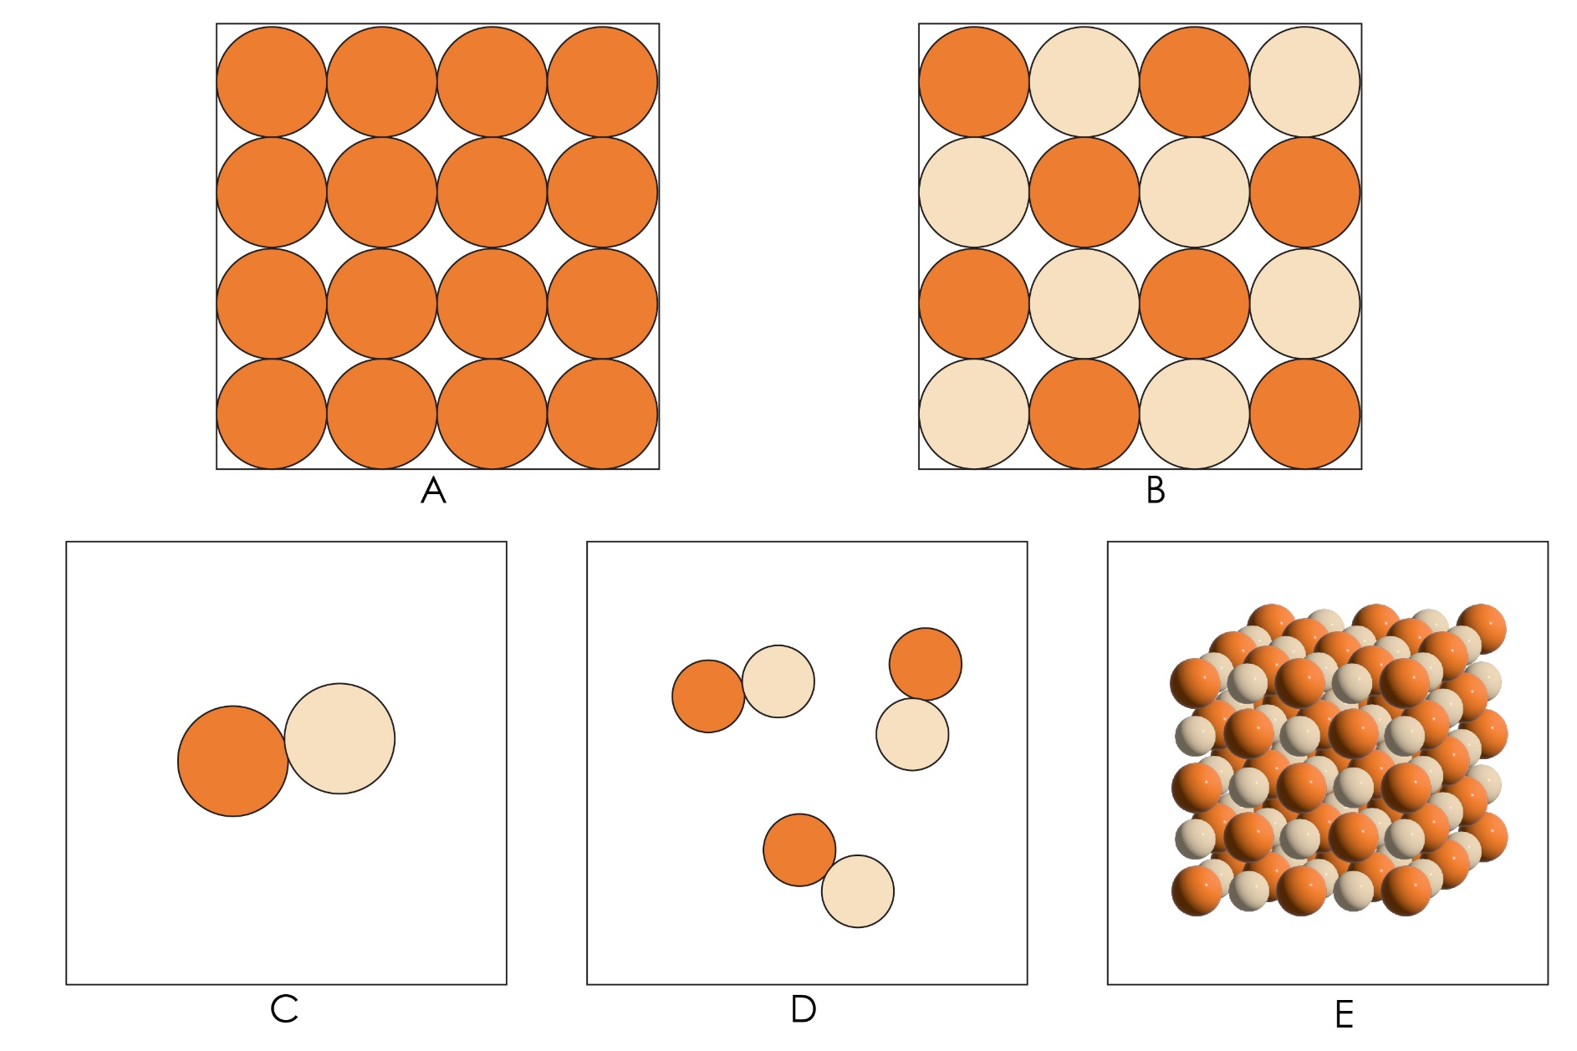

1. Describe what this diagram shows.

__________________________________________________________________________________

__________________________________________________________________________________

1. Explain why this diagram is a better representation of sodium chloride than the representation you chose in question 1(a).

__________________________________________________________________________________

__________________________________________________________________________________

1. A sodium atom has 11 electrons. The diagram below shows an electron configuration diagram of a sodium atom.

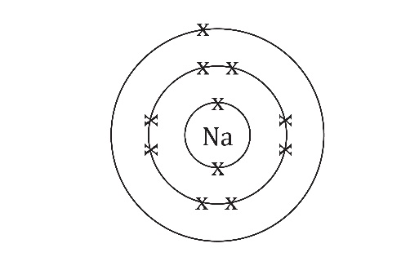

1. Complete the electron configuration diagram for a sodium ion ().

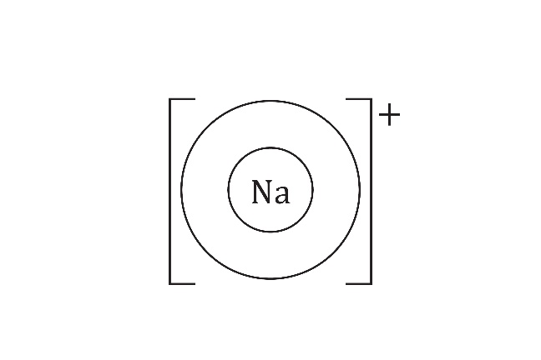

1. Draw the electron configuration diagrams for the following ions:
2. lithium ion ()  
   (A lithium atom has 3 electrons.)
3. chloride ion ()  
   (A chlorine atom has 17 electrons.)
4. fluoride ion ()  
   (A fluorine atom has 9 electrons.)
5. Complete the following sentences using the words **larger** or **smaller**.
6. A sodium ion is _______________ than a chloride ion.
7. A chloride ion is _______________ that a fluoride ion.
8. A lithium ion is _______________ than a fluoride ion.
9. In diagrams of ionic lattices, ions are shown as spheres. Different ions are shown with different colours or shading. Ions are not really different colours but it helps to show the structure of the lattice more clearly.  
     
   The diagram below shows the structure of lithium fluoride. On the diagram, label:
10. a lithium ion
11. a fluoride ion

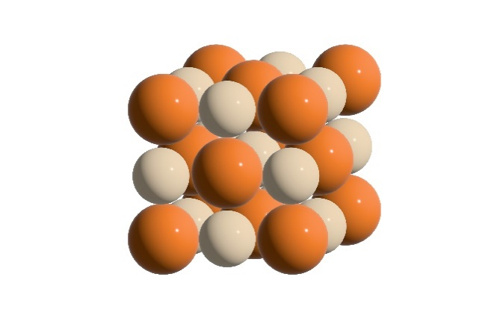

1. The diagram below shows two models of the structure of caesium chloride.

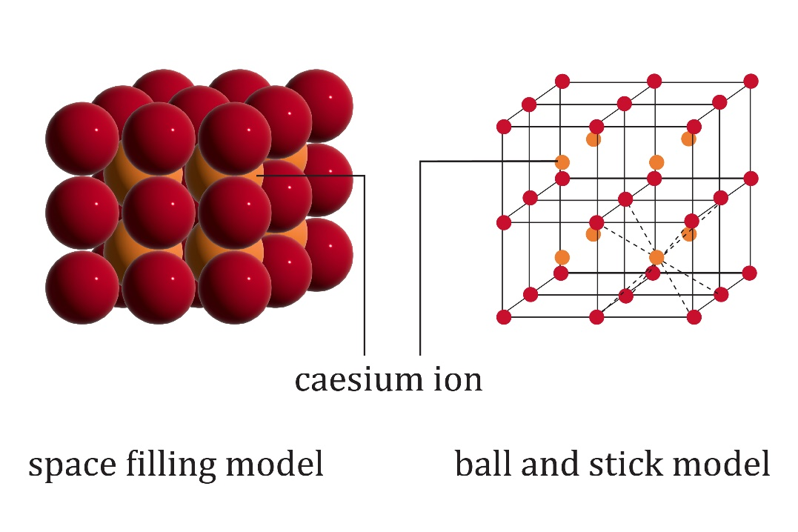

Space-filling model Ball-and-stick model

1. Suggest why the ions in the caesium chloride lattice are arranged differently to the ions in lithium fluoride in question 3(d).

__________________________________________________________________________________

__________________________________________________________________________________

__________________________________________________________________________________

__________________________________________________________________________________

1. Give one advantage and one disadvantage for the space-filling model and the ball-and-stick model.

Space filling model

Advantage: _____________________________________________________________________

__________________________________________________________________________________

__________________________________________________________________________________

__________________________________________________________________________________

Disadvantage: ___________________________________________________________________

__________________________________________________________________________________

__________________________________________________________________________________

__________________________________________________________________________________

Ball-and-stick model

Advantage: _____________________________________________________________________

__________________________________________________________________________________

__________________________________________________________________________________

__________________________________________________________________________________

Disadvantage: ___________________________________________________________________

__________________________________________________________________________________

__________________________________________________________________________________

__________________________________________________________________________________