Addition polymerisation: knowledge check

1. The diagram represents a reaction in which a small section of polymer is formed.

Add labels to the diagram to identify the **monomer**, **polymer**, **single C-C covalent bond** and **double C=C covalent bond**. Identify and label the monomer used and the polymer formed.

__________________

Name: __________________ __________________

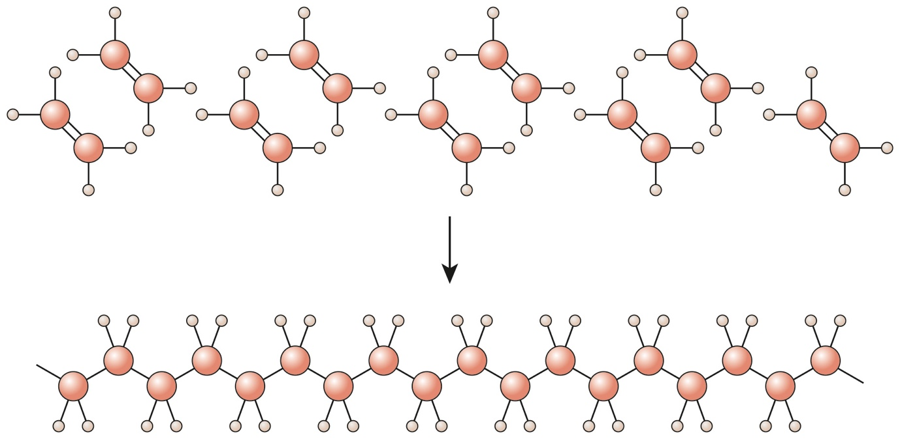

__________________ __________________

Name: __________________

1. Decide whether each of the following statements is true or false and add your answer in the box provided. For any statements that are false, write the correct version in the space provided.
   1. During polymerisation, a large molecule is broken up   
      into smaller molecules. **True False**
   2. Alkanes are used to make addition polymers. **True False**
   3. Only one product is formed during addition   
      polymerisation. **True False**
   4. The polymer formed from ethene is poly(ethene). **True False**
   5. The monomer used to make poly(propene) is propane. **True False**
2. Alkenes can be used to make addition polymers. The equation shows ethene molecules joining up to form poly(ethene).

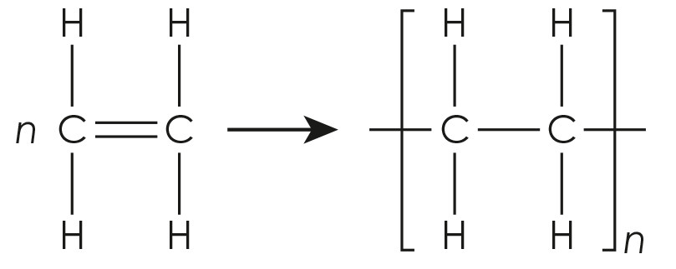

Add the correct word or words to complete the sentences describing this equation.

The name of the monomer used in this addition polymerisation reaction is __________________ .

The name of the polymer formed is __________________ .

The __________________ in the monomer molecules allows them to join together to form an addition polymer.

Addition polymers have the prefix __________________, followed by the name of the __________________ in brackets.

As addition polymer molecules are so __________________, they are represented by drawing the part of the polymer that is repeated many times. This is known as the __________________ .

Addition polymerisation: test myself

**Answer questions 2.1 and 2.2 by circling the correct answer(s). There may be more than one correct answer in each question.**

1. Which of these molecules is a monomer for an addition polymer?

|  |  |
| --- | --- |
| **A**  There is a displayed formula in box A with two capital letters C in the middle connected by a single line. Each C also has three lines connecting it to three capital letters H. | **B**  There is a displayed formula in box B with two capital letters C in the middle connected by a single line. Each C also has two lines connecting it to two capital letters H and one line connecting it to a chlorine atom denoted by a capital letter C and lower case l. |
| **C**  There is a displayed formula in box C with two capital letters C in the middle connected by a two lines. Each C also has one line connecting it to one capital letter H and one chlorine atom denoted by a capital letter C and lower case l. | **D**  There is a displayed formula in box D with one capital letter C in the middle connected by single lines to three capital letters H and oby a single line to a chlorine atom denoted by a capital letter C and lower case l. |

1. Which **three** of these molecules are suitable monomers to make an addition polymer?

butene

propane

pentene

butane

ethane

ethene

methene

1. What is the name of the monomer used to make poly(chloroethene)?
2. Name the polymer made from the monomer tetrafluoroethene.
3. Draw the repeating unit for poly(propene).
4. The diagram shows the repeating unit of an addition polymer:

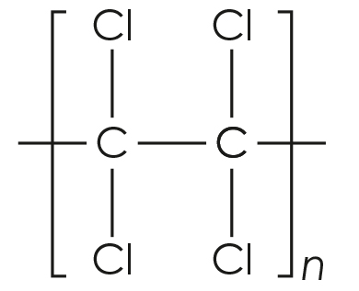

Draw the displayed formula of the monomer being represented by this repeating unit.

1. The diagram shows a section of a polymer.

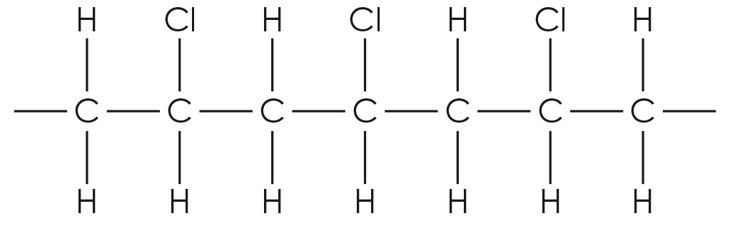

Draw the repeating unit of this polymer.

Addition polymerisation: feeling confident?

1. Complete the table with the missing images for the monomers or repeating units.

|  |  |
| --- | --- |
| **Monomer** | **Repeating unit of polymer** |
| There is an image showing two carbon atoms in the middle joined by two lines. Each C is also joined to two fluorine atoms shown by a capital letter F by single lines. |  |
|  | There is a diagram of a displayed structure shown inside square brackets with a lower case italic n after the brackets. Inside the brackets there are two capital letters C joined by a single line. The first C has a line going out of the bracket to the left, a single line pointing down to a capital H and a single line pointing up to a benzene ring shown by capital C subscript 6 capital H subscript 5. The second C is joined to two letters H by single lines and  has one single line going out of the bracket to the right. |
| There is an image showing two carbon atoms in the middle joined by two lines. The first C is also joined to one H by a single line pointing up and a chlorine atom shown by a capital C and lower case l by a single line pointing down.  The second C is joined to one chlorine atom by a single line pointing up and a H by a single line pointing down. |  |

1. Poly(ethenetetrafluoroethene) is made from the two monomers shown:

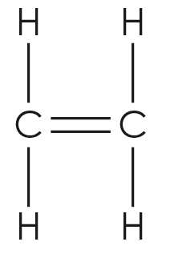 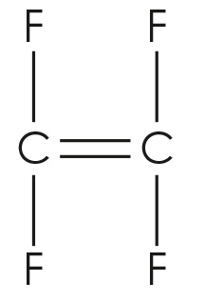

The two monomers join in the polymer chain in an alternating pattern.

* 1. Name the two monomers.
  2. Draw a diagram to represent a section of the polymer chain that contains two molecules of each monomer and is eight carbon atoms long.

Addition polymerisation: what do I understand?

Think about your answers and confidence level for each mini-topic. Decide whether you understand it well, are unsure or need more help. Tick the appropriate column.

|  |  |  |  |
| --- | --- | --- | --- |
| **Mini-topic** | **I understand  this well** | **I think I understand this** | **I need more  help** |
| I can understand the meanings of the terms monomer, polymer and polymerisation. |  |  |  |
| I can explain how addition polymers are formed. |  |  |  |
| I know how to name addition polymers. |  |  |  |
| I can interpret equations used to represent the process of addition polymerisation. |  |  |  |
| I can identify repeating units. |  |  |  |
| I can deduce the identity of monomers from repeating units and vice-versa. |  |  |  |
| **Feeling confident? topic** | **I understand  this well** | **I think I understand this** | **I need more  help** |
| I can draw the structure of monomers from repeating units and vice-versa. |  |  |  |
| I can draw a section of a polymer chain formed from two monomers. |  |  |  |