**Carboxylic acids: teacher guidance**

This resource forms part of the **Review my learning** series from the *Royal Society of Chemistry*. The worksheets assess learner’s understanding of content from common 11–14 and 14–16 curriculums. They can be used to identify knowledge gaps and misconceptions once that part of the curriculum has been taught.

The Carboxylic acid worksheets cover the following topics:

* carboxylic acids as a homologous series
* the general formula and functional group of carboxylic acids
* the molecular and displayed formulas of the first four carboxylic acids
* the reactions of carboxylic acids with metals, bases and carbonates
* the reactions of carboxylic acids with alcohols to produce esters
* the displayed formula of ethyl ethanoate.

If learners successfully answer questions on these topics, they can attempt the extension question. This requires learners to answer questions on strong and weak acids and name an ester.

**Scaffolding**

Level 1 (*) is a scaffolded worksheet which supports learners in a variety of ways, such as selecting words from a word bank, providing answer options to choose from or completed examples. Level 2 (**) is a partially scaffolded worksheet with a reduced level of support, such as partially completed sentences or a wider range of answer options to select from. Level 3 (***) is an unscaffolded worksheet in which most of the tasks involve answering questions with a minimum of prompts.

**Metacognition**

The ‘What do I understand?’ page is common to all levels of worksheet and can be used both to identify areas needing whole class attention and as an indicator for learners to help guide their revision.

Below you will find model answers for each level and guidance on learners’ misconceptions. Learners can use the model answers to self- or peer assess.

**When to use**

The worksheets can be used in a variety of ways:

* To assess learners’ knowledge at the beginning or end of a period of teaching. Match the level of the worksheet to the support needs of the learners.
* To assess knowledge during a period of teaching once learners have completed the relevant topic.
* As part of revision.
* As a refresher exercise for teachers or non-subject specialists.

There is also scope to increase the level of worksheets used as learners progress through their curriculum.

**Further support**

For more resources to support teaching of this topic and address any misconceptions identified, go to [**rsc.li/4a9oo9U**](https://rsc.li/4a9oo9U). For more assessment questions on this topic use our Knowledge check and In context worksheets on Carboxylic acids from [rsc.li/3o4cneK](https://rsc.li/3o4cneK).

Answers

Carboxylic acids: knowledge check

1. **Level 1, 2 and 3**

**carboxylic acid functional group**

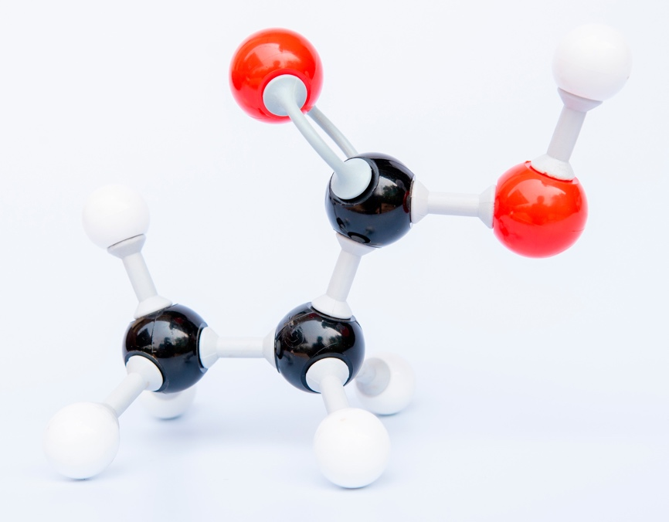

**double covalent bond**

**hydrogen atom**

**carbon atom**

**oxygen atom**

**single covalent bond**

**Guidance:** Learners need to know the colour coding on molecular models. Learners may think organic molecules are two dimensional, which may confuse identification of the functional group.

1. **Level 1, 2 and 3**

|  |  |  |
| --- | --- | --- |
| **Molecular model** | **Name** | **Molecular formula** |
| There is an image of a molecular model. The model has one black sphere in the middle. This is connected to one white sphere by a single bond and a single bond to a red sphere which is also connected to one white sphere by a single bond. The black sphere is also connected to a red sphere with a double bond. | methanoic acid |  |
| There is a photograph of a molecular model. The model has two black spheres in the middle. The first black sphere has three white spheres connected to it by single bond and has a single bond to the second black sphere. The second black sphere is connected to two red spheres. One red sphere is connected by a double bond. The other red sphere is connected to the second black sphere by a single bond and also to a white sphere by a single bond. | ethanoic acid |  |
| There is a photograph of a molecular model. The model has three black spheres in the middle. The first black sphere has three white spheres connected to it by single bonds and has a single bond to the second black sphere. The second black sphere is connected to two white spheres by single bonds and to the third black sphere by a single bond. The third black sphere is connected to two red spheres. One red sphere is connected by a double bond. The other red sphere is connected to the third black sphere by a single bond and also to a white sphere by a single bond. | propanoic acid |  |
| There is a photograph of a molecular model. The model has four black spheres in the middle. The first black sphere has three white spheres connected to it by single bonds and has a single bond to the second black sphere. The second black sphere is connected to two white spheres by single bonds and to the third black sphere by a single bond. The third black sphere is connected to two white spheres by single bonds and to the third black sphere by a single bond. The fourth black sphere is connected to two red spheres. One red sphere is connected by a double bond. The other red sphere is connected to the third black sphere by a single bond and also to a white sphere by a single bond. | butanoic acid |  |

**Guidance:** See guidance for question 1.1. Also, many learners will confuse the spelling of the carboxylic acid names, e.g. ‘ethaneoic’ and many variations.

1. **Level 1**
   1. True
   2. False
   3. False
   4. False
   5. True

**Level 2**

* 1. False – Carboxylic acids **partially** ionise in water.
  2. False – Carboxylic acids are **weak** acids.
  3. True
  4. False – The functional group of carboxylic acids is .
  5. True

**Level 3**

* 1. False – Carboxylic acids **partially** ionise in water.
  2. True
  3. False – Solutions of carboxylic acids in water have a pH **below** 7.
  4. False – The functional group of carboxylic acids is .
  5. True
  6. False – The molecular formula for pentanoic acid is .
  7. False – Ethanoic acid is a **weaker** acid than hydrochloric acid.

**Guidance:** Like alcohols, carboxylic acids also contain an group, which many will find confusing. A common misconception is not including the ‘C’ in the groupwhen counting the number of carbon atoms to give the suffix of the name.

1. **Level 1, 2 and 3**

Carboxylic acids react with:

* metals to form **a salt** and **hydrogen gas**
* bases to form **a salt** and **water**
* carbonates to form **a salt**, **water** and **carbon dioxide gas**.

**Guidance**:Some learners are confused by the idea of ‘lower’ when describing pH, assuming that substances with a lower pH are weaker. Many learners have problems differentiating between weak and strong acids and concentrated and dilute acids. Learners may need to revisit typical acid properties from 11-14 studies.

Carboxylic acids: test myself

1. **Level 1**

**Level 2 and 3**

**and**

**Guidance**: Learners need to be able to recognise the functional groups when written in molecular formula or structural formula.

1. **Level 1, 2 and 3**

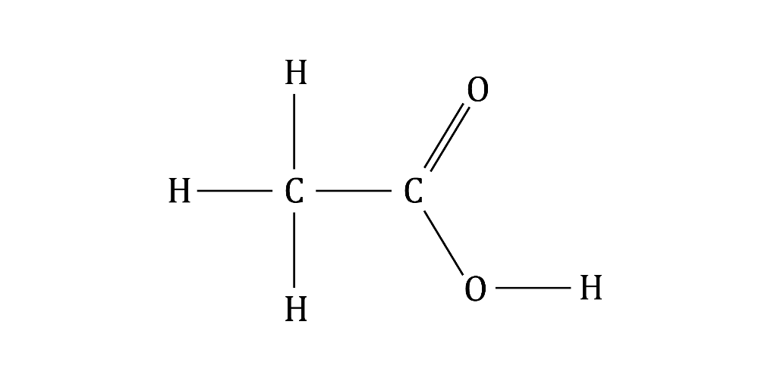

**Guidance**: Displayed formulas need to show every bond. Learners may forget to draw the bond between the O and H or may include an extra – group in the formula because they have not included the ‘C’ in the –COOH group when working out the number of carbon atoms from the name.

1. **Level 1, 2 and 3**

hydrogen ions

**Guidance**: There is an associated misconception here that learners assume that compounds containing only C–H bonds also form hydrogen ions.

1. **Level 1, 2 and 3**
   1. ethanoic acid + **magnesium** → magnesium ethanoate + **hydrogen**
   2. ethanoic acid + magnesium oxide → **magnesium ethanoate** + **water**
   3. ethanoic acid + **magnesium carbonate** → **magnesium ethanoate** + **water** + carbon dioxide

**Guidance**: This question follows on from question 1.4.

1. **Level 1, 2 and 3**

B, **carboxylic acid + alcohol → ester + water**

**Guidance**: Learners need to remember that water is also produced in this reaction.

1. **Level 1, 2 and 3**

The ester functional group is –COO–.

**Guidance**: Learners may not recognise that the ester functional group is found in the middle of the molecule.

1. **Level 1, 2 and 3**

The ester is ethyl ethanoate.

**Guidance**:Learners may find it helpful to remember that the first part of the ester name is derived from the alcohol, with ‘–yl’ added and the second part of the name is derived from the carboxylic acid with ‘–oate’ added. But this will still present problems with ‘eth–’ and ‘ethan–’ and when to use which.

1. **Level 1, 2 and 3**

**Guidance**: Learners probably studied this in the alcohol topic. They need to recall that [O] represents an oxidising agent.

Misconceptions associated with balancing equations include:

* adding numbers in the middle of a formula to make an equation balance
* changing the subscripts
* having unequal numbers of types of atom on each side.

Carboxylic acids: feeling confident?

1. **Level 1**
   1. is a hydrogen ion.
   2. Diagram B
   3. ethanoic acid
   4. Diagram B

**Level 2**

* 1. is a hydrogen ion.
  2. Diagram B

Diagram A represents ethanoic acid and diagram B represents hydrochloric acid.

Ethanoic acid is a weak acid. Weak acids do not ionise fully. Diagram A shows only one of the HA molecules has ionised. Diagram B shows that all of the HA molecules have ionised and that there are lots of ions present. This represents a strong acid. Hydrochloric acid is a strong acid.

**Level 3**

* 1. is a hydrogen ion.
  2. Diagram B
  3. Diagram A represents ethanoic acid and diagram B represents hydrochloric acid.

Ethanoic acid is a weak acid. Weak acids do not ionise fully. Diagram A shows only one of the HA molecules has ionised. Diagram B shows that all of the HA molecules have ionised and that there are lots of ions present. This represents a strong acid. Hydrochloric acid is a strong acid.

**Guidance**: Learners need to link the degree of ionisation of an acid with its strength. The greater the degree of ionisation, the stronger the acid. They may not realise that the rate of reaction between an acid and magnesium depends on the strength of the hydrogen ion concentration.

1. **Level 1, 2 and 3**
   1. The carboxylic acid is **ethanoic acid**.
   2. The alcohol is **propanol**.
   3. The ester is **propyl ethanoate**.

**Guidance**: Misconceptions include:

* confusing the suffixes ‘prop–’ and ‘ethan–’
* confusing the alcohol with the carboxylic acid
* various spellings of ethanoate and propyl.

**Carboxylic acids: what do I understand?**

Think about your answers and confidence level for each mini-topic. Decide whether you understand it well, are unsure or need more help. Tick the appropriate column.

|  |  |
| --- | --- |
| **Mini-topic** | **Assessed via:** |
| I can identify the functional group and general formula of carboxylic acids. | 1.1, 1.3 |
| I can write the molecular formulae and draw the displayed formulae of the first four carboxylic acids. | 1.2, 2.1, 2.2 |
| I know that carboxylic acids are weak acids. | 1.3, 1.4, 2.3 |
| I can describe the reactions of carboxylic acids with metals, bases and carbonates. | 1.4, 2.4 |
| I can describe the reactions of carboxylic acids with alcohols to produce esters and identify the functional group of an ester. | 2.5, 2.6 |
| I can name an ester and identify the displayed formula of ethyl ethanoate. | 2.7 |
| I can write an equation for the reaction between ethanol and an oxidising agent. | 2.8 |
| **Feeling confident? topics** | **Assessed via:** |
| I can describe the difference between strong and weak acids. | 3.1 |
| I can name esters. | 3.2 |