States of matter

Introduction

These questions are designed to help you to develop your mental models (pictures in your head) of the arrangement and movement of particles. Being able to visualise the arrangement and movement of particles in your head will help you to develop your understanding of the properties of different states of matter.

|  |  |
| --- | --- |
| An icon used to indicate the Macroscopic part of Johnstone's triangle. | **Macroscopic:** what we can see. Think about the properties that we can observe, measure and record. |
| An icon used to indicate the Sub-microscopic part of Johnstone's triangle. | **Sub-microscopic:** smaller than we can see. Think about the particle or atomic level. |
| An icon used to indicate the Symbolic part of Johnstone's triangle. | **Symbolic:** representations. Think about how we represent chemical ideas including symbols and diagrams. |

Questions

1. Substances in the solid, liquid or gas state have different properties. The substances below are all at room temperature.

|  |  |  |
| --- | --- | --- |
| A close up photo of an iron nail isolated on a white background. | A green helium filler balloon with a ribbon isolated on a white background. | Droplets of a metallic silver liquid being poured onto a shiny white surface. |
| **iron nail** | **helium filled balloon** | **mercury** |

1. Give the state of each substance at room temperature.

* iron: ______________________________________________
* helium: ______________________________________________
* mercury: ______________________________________________

1. Draw one line from each state of matter to a key property.

|  |  |  |
| --- | --- | --- |
| **solid state** |  | fills shape of container |
|  |  |  |
| **liquid state** |  | has a fixed shape |
|  |  |  |
| **gas state** |  | is able to flow |

1. Draw the arrangement of particles of the following substances at room temperature.

|  |  |  |
| --- | --- | --- |
|  |  |  |
| **iron** | **mercury** | **helium** |

1. Describe the **movement** of particles in each substance.
2. iron

__________________________________________________________________________________

__________________________________________________________________________________

1. mercury

__________________________________________________________________________________

__________________________________________________________________________________

1. helium

__________________________________________________________________________________

__________________________________________________________________________________

1. Describe how the particle model explains why
2. an iron nail has a fixed shape

__________________________________________________________________________________

__________________________________________________________________________________

1. mercury can flow

__________________________________________________________________________________

__________________________________________________________________________________

1. helium fills the shape of the balloon

__________________________________________________________________________________

__________________________________________________________________________________

1. The particle model can be represented in different ways.

|  |  |  |  |
| --- | --- | --- | --- |
| **A** | **B** | **C** | **D** |
| A box containing 25 identical mid green circles arranged in five rows of five. Each circle is touching but not overlapping its nearest neighbours on either side and in the rows above and below. | A glass mug, partially filled with colourful glass marbles, all of which are the same size. | A 3D plastic model consisting of 27 black spheres arranged in three 3x3 squares, stacked on top of each other to form a cube. The black spheres are not touching each other but are connected by straight black rods. | A screenshot of a screen animation showing many bright blue dots randomly arranged on a black background within a metal cylinder. |
| 2D diagram | marbles in a glass | 3D physical model | animation |

Select the particle model representation that best helps to explain the following. Give reasons for your answer.

1. Substances in the liquid state can flow.

__________________________________________________________________________________

__________________________________________________________________________________

__________________________________________________________________________________

1. Substances in the solid state have a fixed shape.

__________________________________________________________________________________

__________________________________________________________________________________

__________________________________________________________________________________

1. Substances in the gas state fill the shape of a container.

__________________________________________________________________________________

__________________________________________________________________________________

__________________________________________________________________________________

1. Liquids cannot be compressed. Gases can be compressed.
2. Mercury is in the liquid state at room temperature. Use the particle model to explain why substances in the liquid state cannot be compressed.

__________________________________________________________________________________

__________________________________________________________________________________

__________________________________________________________________________________

1. Neon is in the gas state at room temperature. Add labels to the particle diagram for neon.

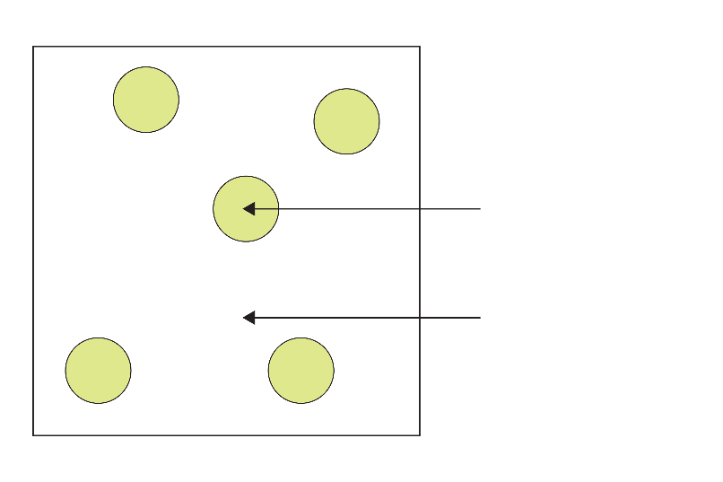

1. Use your diagram to explain why neon can be compressed.

__________________________________________________________________________________

__________________________________________________________________________________

__________________________________________________________________________________

Acknowledgements

Question 2 shows a screenshot from an online animation created by PhET at the University of Colorado. You can access the States of Matter simulation online at: <https://phet.colorado.edu/sims/html/states-of-matter-basics/latest/states-of-matter-basics_en.html>

Image sources

Question 1: **iron nail** © Shutterstock / Panupong786; **helium filled balloon** © Shutterstock / Soho A Studio; **mercury** © Shutterstock / MarcelClemens

Question 2: **A** © Royal Society of Chemistry; **B** © Shutterstock / RousePhotography; **C** © Shutterstock / 3d-sparrow; **D** © PhET / University of Colorado

Question 3 © Royal Society of Chemistry