The atomic structure of lithium: Johnstone’s triangle

This resource is from the **Johnstone’s triangle** series which can be viewed at: [rsc.li/43jMfSn](https://rsc.li/43jMfSn) It will help learners to understand the different ways you need to think in chemistry, building their mental models and understanding.

Learning objectives

1. Describe macroscopic properties of a substance.
2. Describe the arrangement of subatomic particles within an atom.
3. Calculate the number of protons, neutrons and electrons present for a given element.

How to use Johnstone’s triangle

Use Johnstone’s triangle to develop learners’ thinking about scientific concepts at three different conceptual levels:

* 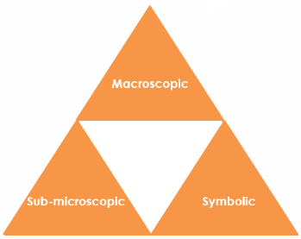Macroscopic – what we can see. Think about the properties you can observe, measure and record.
* Sub-microscopic – smaller than we can see. Think about the particle or atomic level.
* Symbolic – representations. Think about how we represent chemical ideas including symbols and diagrams.

For learners to gain a deeper awareness of a topic, they need to understand it at all three levels.

When introducing a topic, do not try to introduce all three levels of thinking at once. This will overload working memory. Instead complete the triangle over a series of lessons, beginning with the macroscopic level and introducing other levels, in turn, once understanding is secure.

The three levels are interrelated. For example, learners need visual representation of the sub-microscopic to develop mental models of the particle or atomic level.

Find further reading about Johnstone’s triangle and how to use it in your teaching at [rsc.li/3FQU8GX](https://rsc.li/3FQU8GX)

Scaffolding

It is important to share the structure of the triangle with learners prior to use. Tell them why you want them to use the triangle and how it will help them to develop their understanding. Use an ‘I try, we try, you try’ approach when you are introducing Johnstone’s triangle for the first time.

More resources

To further develop learner’s thinking in all areas of Johnstone’s triangle and make connections between the levels, try our **Developing understanding** worksheets [rsc.li/4krDQmW](https://rsc.li/4krDQmW). These include icons in the margin referring to the conceptual level of thinking needed to answer the question.

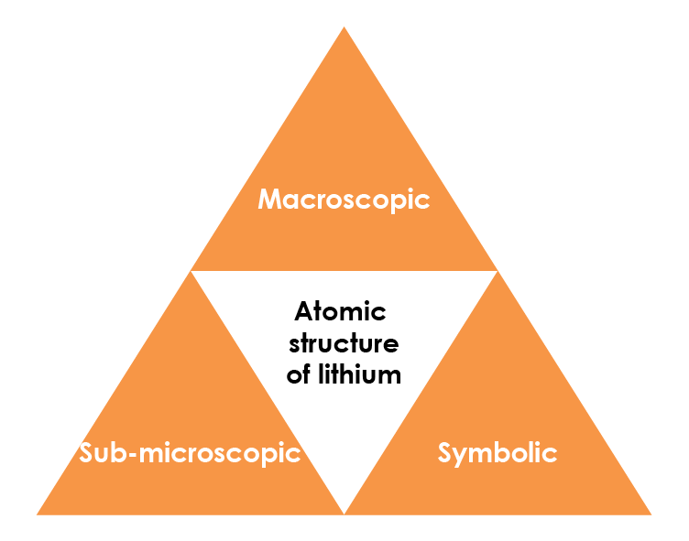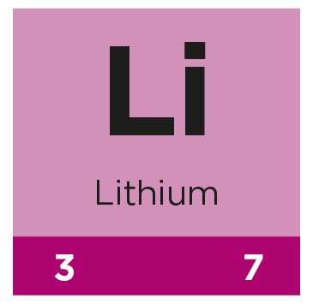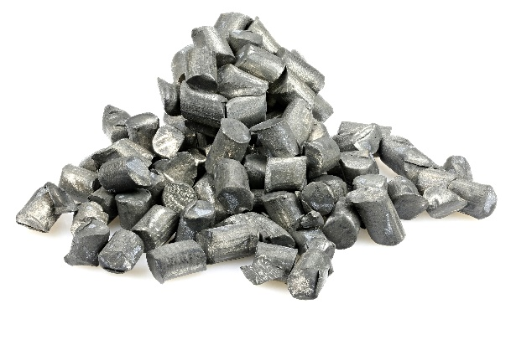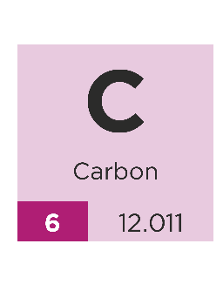

Symbolic – representations

Lithium is shown in the periodic table as:

The atomic number gives the number of protons and electrons. State the number of:

|  |  |
| --- | --- |
| **Protons** | **3 (three)** |
| **Electrons** | **3 (three)** |

The number of neutrons is found from:

= mass number – atomic number

Calculate the number of neutrons:

|  |  |
| --- | --- |
| **Neutrons** | **4(four)** |

Sub-microscopic – smaller than we can see

A lithium atom can be represented as:

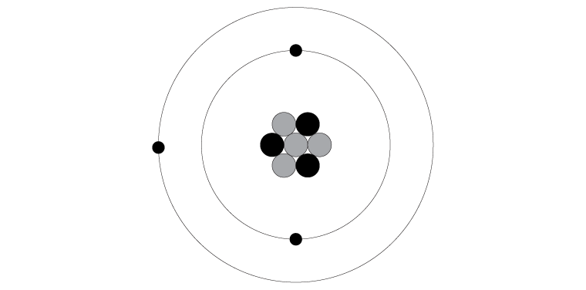

Describe where in an atom of lithium each type of subatomic particle is found:

Proton: **Found in the nucleus**_____________________________

Neutron: **Found in the nucleus**_____________________________

Electron: **Located outside the nucleus**_______________________

Suggest a connection between the number of protons and number of electrons:

**Number of protons = number of electrons**

Macroscopic – what we can see

The image shows lithium metal. It is made from lithium atoms. Using the image and your prior knowledge, list some macroscopic properties of lithium:

Learners might come up with a range of ideas e.g.

**• shiny • metallic**

**• conductive • grey**

**• grey**