**Solubility: knowledge check**

1. The diagram shows a solid dissolving in a liquid.

Label the diagram to identify the solute, solvent and solution and suggest examples of each.

__________________ __________________ __________________

eg __________________ eg __________________ eg glucose solution

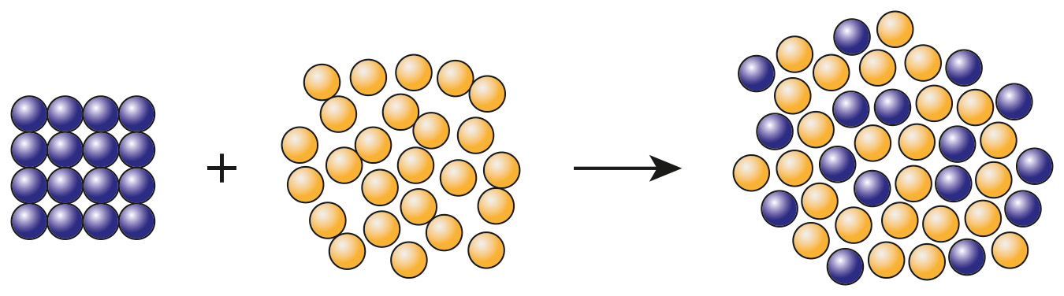

1. Add the correct term for each of the definitions included in the table.

|  |  |
| --- | --- |
| A substance that will dissolve in a solvent. |  |
| A substance that will not dissolve in a solvent. |  |
| A solution that contains a high amount of solute dissolved in it. |  |
| A solution that contains a relatively low amount of solute dissolved in it. |  |
| A solution that has the maximum mass of solute dissolved in it. |  |

1. Choose the correct term from those provided to complete each of the following sentences. Not all of the terms provided will be used.

**g dm-3 dm3/g 100 1000 9.00 2.25**

**saturated dilute lower higher**

* 1. The concentration of a solution can be measured in __________________
  2. 1 dm3 is the same volume as __________________ cm3.
  3. If a solution has a concentration of 4.50 g dm-3, 500 cm3 of that solution will contain __________________ g of solute.
  4. A solution that contains the maximum mass of solute possible is a __________________ solution.
  5. Most substances are more soluble at __________________ temperatures.

1. When sodium hydroxide solution is added to some metal cation solutions, a metal hydroxide precipitate is formed.

Complete the following sentences to explain why these precipitates are useful.

The metal hydroxide precipitate formed is a/an __________________ solid.

The __________________ of the precipitate formed can be used to identify the cations present.

For example, if sodium hydroxide solution is added to copper(II) sulfate __________________, a precipitate of __________________ copper(II) hydroxide forms.

If sodium hydroxide solution is added to iron(II) sulfate solution, a grey/green precipitate of __________________ (II) hydroxide is produced.

**Solubility: test myself**

1. What is the correct unit for concentration if the mass of the solute and the volume of solvent are given?
2. What method is used to separate an insoluble substance from a mixture of the substance and water?
3. What method is used to separate water from a salt solution?
4. A solution of sodium hydroxide has a concentration of 10 g dm-3. What mass of sodium hydroxide is present in 100 cm3 of the solution?
5. What is the concentration, in g dm-3, of a solution of sodium carbonate made by dissolving 2.5 g of sodium carbonate in 500 cm3 of water?
6. Sodium chloride, NaCl, solution reacts with acidified silver nitrate solution, AgNO3, to form a precipitate of silver chloride, AgCl, and sodium nitrate, NaNO3, solution. Complete the equation by adding the correct formulas and correct state symbols for all substances.

→

1. The concentration of a solution, in g dm-3, can be calculated using the equation:

The mass of solute dissolved in four different solutions is shown in the table.

|  |  |
| --- | --- |
| **Solution** | **Description** |
| **A** | contains 0.5 g solute in 100 cm3 solution |
| **B** | contains 5.0 g solute in 20 cm3 solution |
| **C** | contains 1.2 g solute in 30 cm3 solution |
| **D** | contains 1.6 g solute in 40 cm3 solution |

Use the equation provided, and the information provided in the table, to work out which of the four solutions, **A**, **B**, **C** or **D**, has the highest concentration.

*(Hint: Remember, 1 dm3 is 1000 cm3, so think about how to convert the volumes from cm3 to dm3 before you calculate the concentration.)*

|  |  |
| --- | --- |
| **Solution A** | **Solution B** |
| **Solution C** | **Solution D** |

The solution with the highest concentration is solution __________________.

**Solubility: feeling confident?**

1. The solubility curve shows how the solubilities of the two salts, potassium nitrate, KNO3, and sodium chloride, NaCl, vary with temperature.

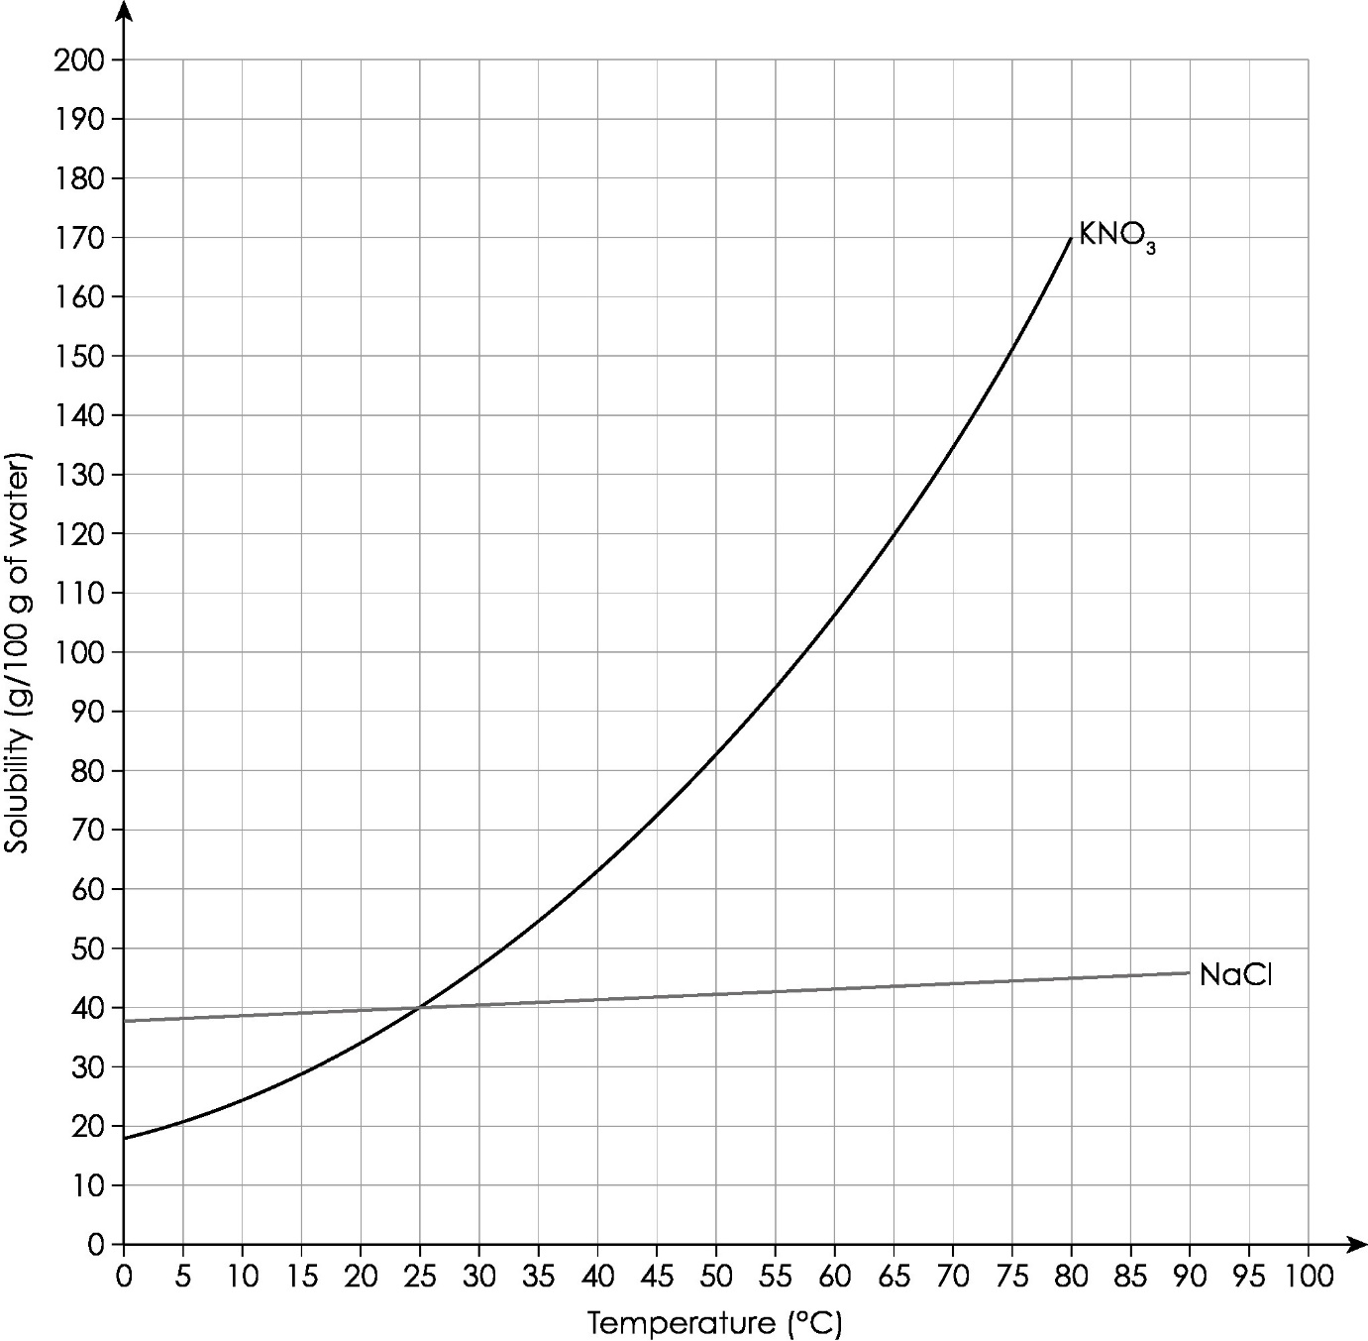

Write three conclusions you can make comparing the solubilities of the two salts using the solubility curve. Think about the similarities and differences in the solubilities of the two salts as temperature increases.

1. If a saturated solution of potassium nitrate in 100 g water is cooled from 80°C to 10°C, what mass of solute crystallises out? Show your working.

**Solubility: what do I understand?**

Think about your answers and confidence level for each mini-topic. Decide whether you understand it well, are unsure or need more help. Tick the appropriate column.

|  |  |  |  |
| --- | --- | --- | --- |
| **Mini-topic** | **I understand  this well** | **I think I understand this** | **I need more  help** |
| I can use the correct words to describe solubility and solutions. |  |  |  |
| I know the difference between dilute and concentrated solutions. |  |  |  |
| I can measure the concentration of solutions in g dm-3. |  |  |  |
| I can calculate the mass of solute in different volumes of solution. |  |  |  |
| I know how to define the term saturated solution. |  |  |  |
| I can describe precipitate formation. |  |  |  |
| I can select the correct method of separation based on solubilities (filtration, distillation, crystallisation). |  |  |  |
| **Feeling confident? topics** | **I understand  this well** | **I think I understand this** | **I need more  help** |
| I can understand solubility curves. |  |  |  |
| I know how to use solubility curves to calculate the mass of a solute that crystallises out when a saturated solution cools. |  |  |  |