­­Fighting fashion waste

*Original article by Tosin Thompson. Adapted by Nina Notman.*

Chemical approach could slash environmental harm caused by fast fashion

A new recycling method transforms polyester and spandex into reusable monomers while leaving cotton and nylon intact. The method could offer a way to decrease the environmental impact of textile waste.

Fast fashion trends have caused a surge in textile production with around 100 billion items of clothing now manufactured annually. The short lifespan of low-cost clothing items has a serious impact on the environment. ‘Fast fashion [contributes] to an estimated 92 million tons of textile waste globally annually,’ says Erha Andini from the University of Delaware, US.

Currently, less than 1% of textile waste is recycled, with most ending up in landfills or being incinerated. This is because although mechanical and chemical textile recycling technologies exist, most clothing items contain complex mixtures of fibres that are very hard to separate and sort.

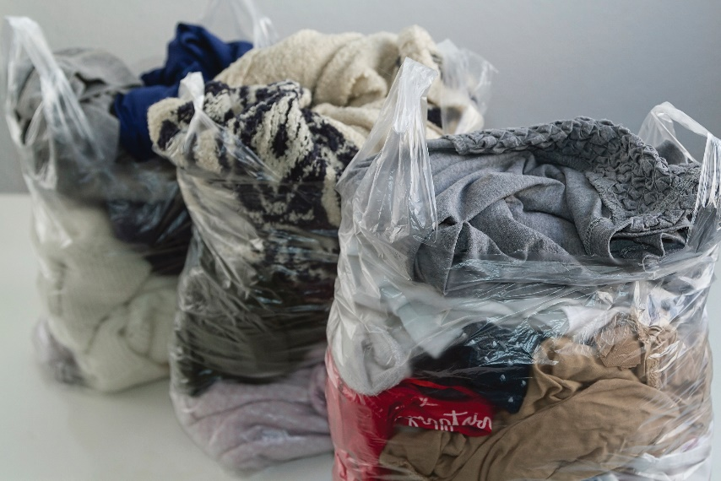

*Source: © Bangepul92/Shutterstock*

*Fast fashion with a high price*

Mixing it up

Now, Erha and her colleagues have developed a simple and fast chemical recycling method can be applied to the most common types of mixed textiles.

The team tried the method on polycotton first. They placed the fibre in ethylene glycol, added a catalyst and heated the mixture for around 15 minutes in the microwave. The polyester broke down into a monomer that can be polymerised again to re-make polyester, while the cotton remained largely unchanged.

Next, the team demonstrated its approach on a complex mixture of polyester, cotton, spandex and nylon. The polyester and spandex both broke down into useful monomers, while intact cotton and nylon were separated out. The nylon was then dissolved in acid in order to separate it from the cotton.

The team suggests that a refined version of their process could enable the recycling of up to 88% of global textiles. But they admit that challenges lie ahead, including dealing with the impact of dyes and finishes on the viability of the recycling process and ensuring it is economically viable.

This is adapted from the article ‘Glycolysis method breaks down mixed textiles for recycling’ in *Chemistry* *World.* Read the full article at [rsc.li/4ei9HUA](https://rsc.li/4ei9HUA).