Amino acids, peptides and proteins

Learning objectives
- Review the naming and structures of common amino acids.
- Draw the structural formulas for dipeptides and tripeptides formed during protein synthesis and the component amino acids formed during hydrolysis.
- Investigate how thin layer chromatography (TLC) can be used to separate amino acids in a mixture.
- Calculate Rf values to identify individual amino acids.

Introduction

Alternatives to meat products, such as tofu and jackfruit, have been popular since the 1960s. Tofu is a product made from soybeans. More recently, food developers and technologists have used a naturally occurring protein, haem, to make plant-based meat alternatives look and taste more like actual meat. It is important for food scientists and technologists to understand the chemistry behind food processing.

The following tasks first guide you through the chemistry behind building protein molecules from their amino acid monomers in condensation reactions. The process of hydrolysis, which breaks peptide bonds within protein chains to reform amino acids, is then considered. Finally, the separation and identification of amino acids using Rf values in chromatography is investigated.

Questions
- Amino acids are the building blocks of proteins and contain an amino (NH₂) group, carboxylic acid (COOH) group and a specific R group attached to a central C atom. Two amino acids found in soybeans are shown below; in the simplest amino acid, glycine, the R group is an H atom.
- Give the systematic (IUPAC) names of glycine and alanine.
- Using your knowledge of structure and bonding (including the fact that there is an internal transfer of a hydrogen ion from the COOH group to the NH₂ group to form a zwitterion) state and explain one physical property these two molecules will have in common and one which will be different.

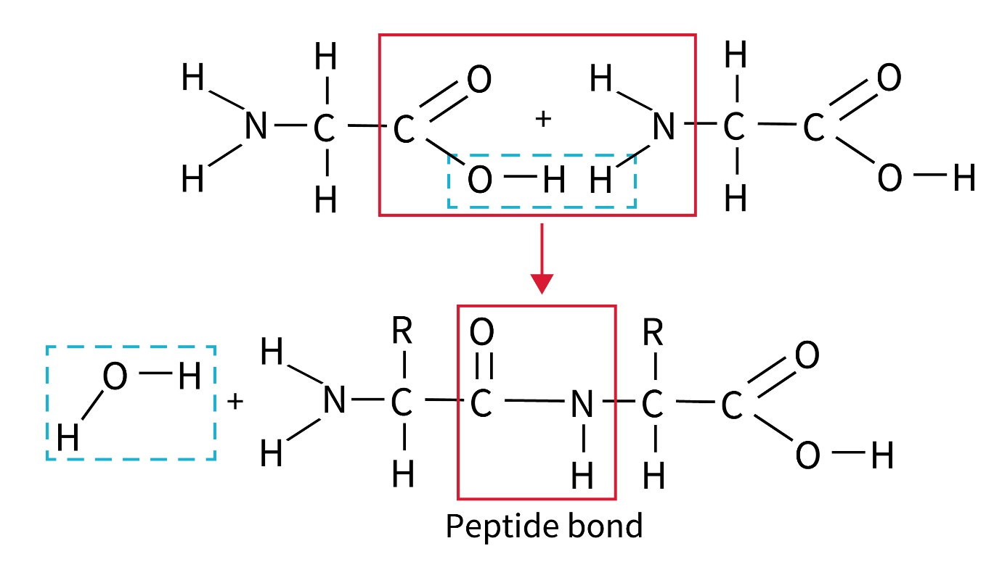
- Amino acids link by a condensation reaction (addition - elimination) in which the OH group is lost from the carboxylic acid (COOH) group of one molecule and a hydrogen atom from the amino (NH₂) group of a neighbouring molecule. This reaction forms a H₂O molecule and links the amino acids via a peptide bond.

Two amino acids joining form a dipeptide, three a tripeptide and several form a polypeptide. A protein contains one or more polypeptides using the 20 different amino acids.
- Give the displayed formulas of the dipeptide(s) formed by the condensation of a glycine and alanine molecule.
- The R group in the amino acid serine is CH₂OH. Serine is also present in soybeans. Draw three possible tripeptides formed in the condensation reaction between two molecules of serine and one molecule of glycine.
- State how many molecules of H₂O are formed as by-products.

- A hydrolysis reaction (splitting by reaction with water) is the opposite of a condensation reaction and breaks the C-N bond within the peptide link, reforming the component amino acid molecules. Hydrolysis is enzyme-catalysed in the digestion of proteins and can also be carried out by heating with 6M hydrochloric acid.
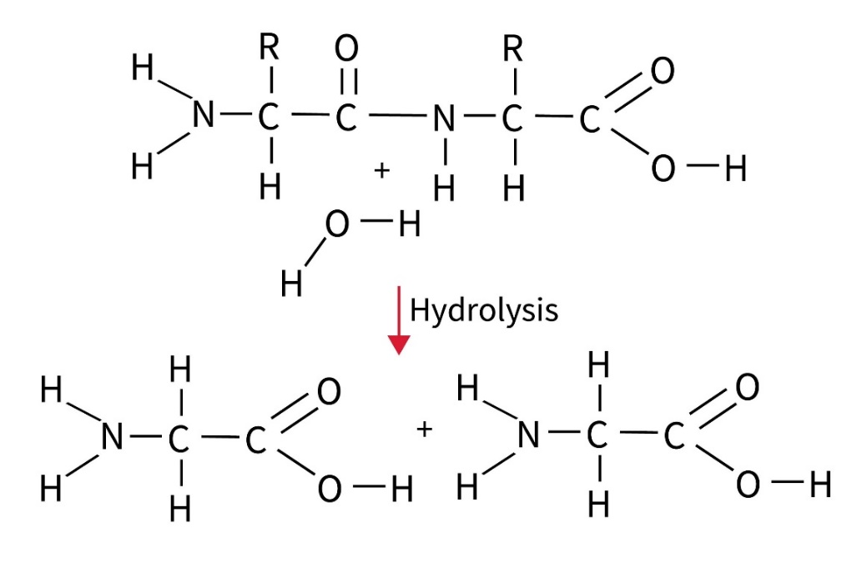
- Draw the displayed formulas of the amino acids formed when the tripeptide molecule below is heated strongly with 6M hydrochloric acid.

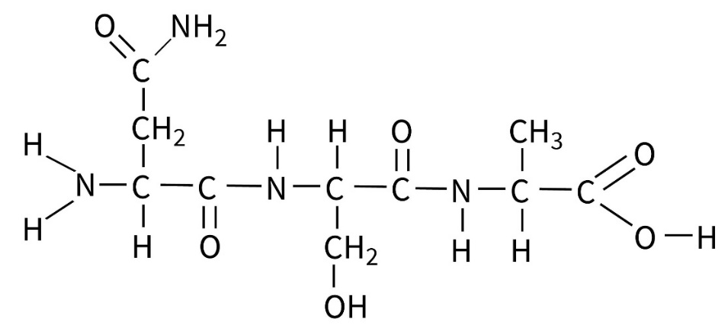
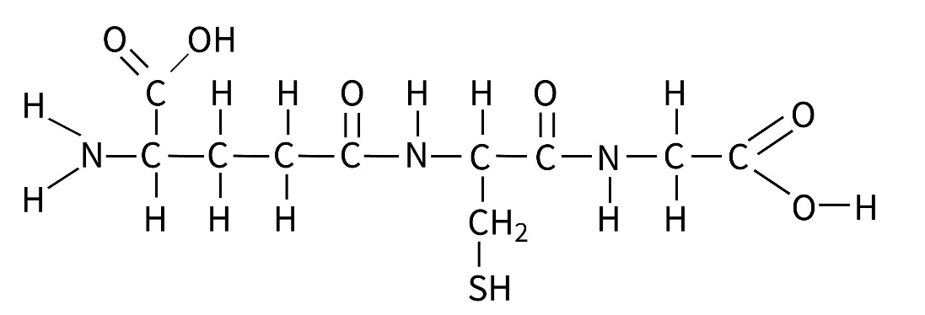
- Glutathione is a tripeptide that protects cells in humans by acting as an antioxidant. It is naturally produced in the body. The structure of glutathione is shown below. Write a balanced equation to show the complete hydrolysis of this molecule to its amino acid residues.

- Thin layer chromatography (TLC) is a technique used to separate and identify amino acids in a mixture. A TLC plate made up of a thin layer of silica acts as the stationary phase and a solvent mixture acts as the mobile phase. The amino acids will have differing solubilities between the silica gel stationary phase and the solvent mobile phase depending on the polarity and size of the variable R group.

The more soluble the amino acid is in the solvent mobile phase the faster it moves up the plate; the more it is attracted to the silica plate the less it moves.

The Rf value is an important quantitative measure in TLC to identify amino acids in a mixture.

Rf = distance moved by amino acid / distance moved by solvent

Figure A shows how the Rf value is measured.

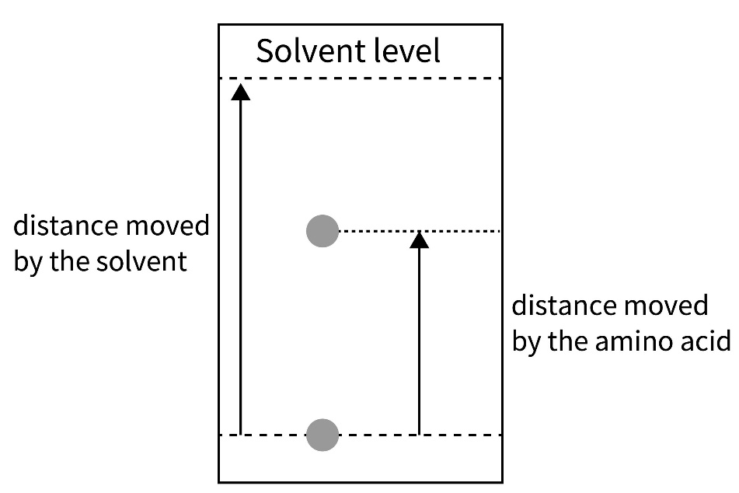
Figure A

In Figure B the TLC separation of alanine, glycine, glutamic acid and serine is shown using a methanol solvent.

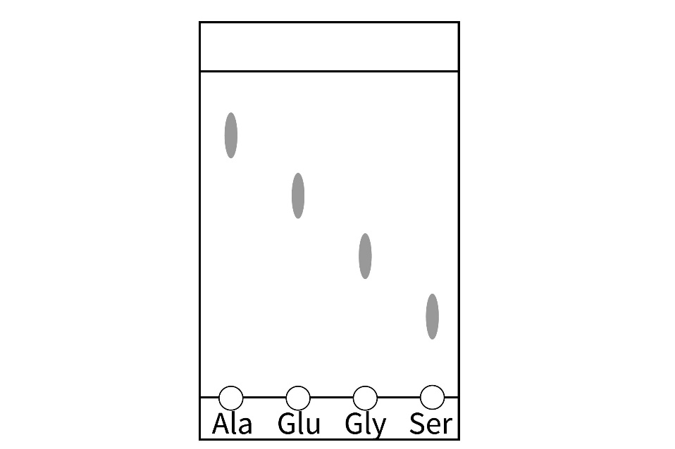
Figure B

An analyst estimates the Rf values in no given order as 0.60, 0.74, 0.46 and 0.22.

Complete the table below matching the estimated Rf value to the correct amino acid and measuring the ‘corrected’ Rf value to two significant figures.
Amino acid | Estimated Rf value | Corrected Rf value
Alanine (ala)
Glutamic acid (glu)
Glycine (gly)
Serine (ser)

- The tripeptide tyroserleutide consists of the amino acids tyrosine, serine and leucine (from left to right). Tyroserleutide is used to inhibit the growth of human lung cancers and its structure is shown below.
- Identify the peptide link(s) in this structure.
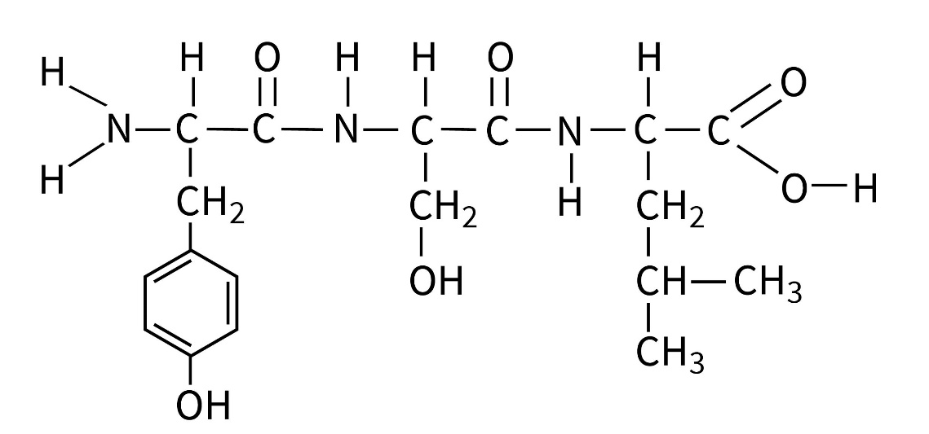

Tyroserleutide was completely hydrolysed and the component amino acids analysed using TLC with a water solvent as the mobile phase. The separate amino acids were spotted on the baseline of the plate using a teat pipette.

Rf values were measured as 0.43, 0.59 and 0.65 but are not in a particular order.
- Draw the displayed formulas of the molecules produced following hydrolysis.

- Using your knowledge of polarity state, explain which of the component amino acid molecules will be most soluble in the mobile phase.

- Complete the table below, assigning the appropriate Rf value to each amino acid.

Amino acid | Side chain polarity | Rf value
Tyrosine
Serine
Leucine

- The Rf values differed slightly from the data values for the same solvent. Give one possible reason why this may be the case.
- A second tripeptide was hydrolysed and analysed using TLC in a similar way. The chromatogram below was obtained.
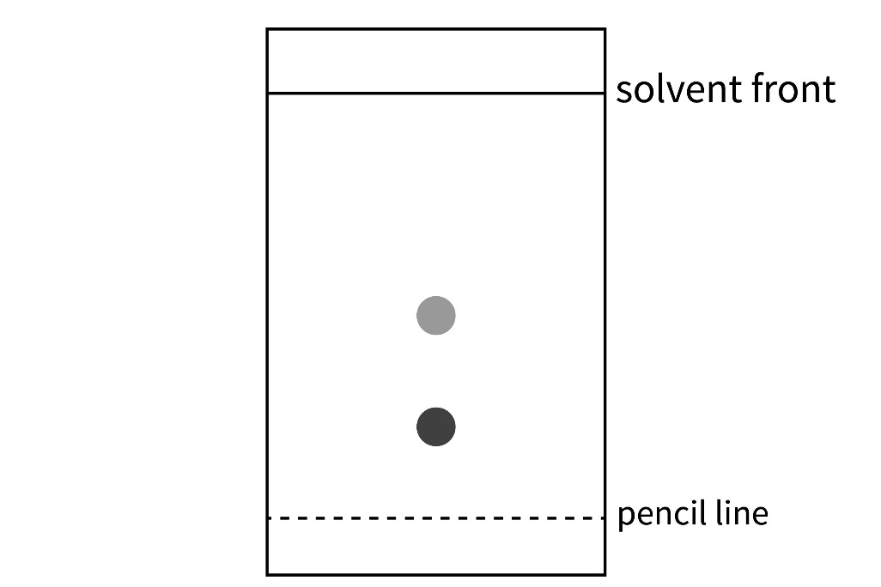
    - Measure and state the Rf values for the component amino acids.
    - Explain why there are only two spots on the chromatogram.

