F6 Recording data and uncertainty

This is the sixth lesson in an introductory course for post-16 chemistry learners covering key ideas in order of scale. Find out more about the course and approach here: [**rsc.li/4kGyaoN**](https://rsc.li/4kGyaoN)

Before each lesson, ask learners to complete the preparation worksheet to revise knowledge from their 14–16 courses or previous lessons and introduce the topic for the lesson.

Then, get them to complete the student sheet during the lesson. It includes all key content and challenges misconceptions. Each student sheet has a scale and a Johnstone’s triangle diagram at the top. Use these to help learners think about the relative scale of different aspects of chemistry and connect their understanding of sub-microscopic, macroscopic and symbolic representations.

This icon indicates that students will need access to learning materials e.g. textbook or online resources to support their learning, see [**rsc.li/4m4UObJ**](https://rsc.li/4m4UObJ) for links.

Begin each lesson by checking learners have completed the preparation work. Share the answers and ask learners to mark their own worksheets as part of their independent work.

Topics in this lesson

|  |  |  |
| --- | --- | --- |
| Beginning with solid fill | **Last lesson** | F5 Light and electron energy levels |
|  | **Preparation worksheet** | Revision: volumes  New content: making measurements |
|  | **Lesson worksheet** | Making measurements practise; uncertainty and percentage uncertainty; repeated measurements |
| End with solid fill | **Next lesson** | F7 Electronic structure: sub-shells and orbitals |

This lesson provides an introduction to laboratory work as learners use a range of measuring equipment to make measurements to the appropriate precision. They are asked to draw a diagram to show the correct way to fill volumetric glassware with a solution before moving on to practise. Then they predict and compare the accuracy of different pieces of glassware to measure 25 cm3 of water.

Answers

Revision: volumes

1. Drinks bottle = 500 cm3; sugar cube = 1 cm3; washing machine = 1 m3
2. Divide the volume in cm3 by 1 x 10-6 to get the volume in m3.
3. Multiply the volume in cm3 by 1000 to get the volume in dm3.
4. 1.35 1000 = 1350 cm3
5. 375 1,000,000 = 375,000,000 cm3
6. 6.54 10-3 m3

|  |  |  |  |  |
| --- | --- | --- | --- | --- |
| **Equipment** | **Burette** | **Thermometer** | **Measuring cylinder (cm3)** | **Measuring cylinder (cm3)** |
| Picture of  scale |  |  |  |  |
| Smallest  division | 0.1 cm3 | 1°C | 0.2 cm3 | 0.5 cm3 |
| Half of the  smallest  division | 0.05 cm3 | 0.5°C | 0.1 cm3 | 0.25 cm3 |
| Reading  shown in  diagram | 24.40 cm3 | 25.0°C | 2.4 cm3 | 17 cm3 |

New content: making measurements

All measured on the line. Therefore, e.g. the burette measurement is 24.40, whereas if the meniscus was between the lines, it would be 24.45.

Worksheet

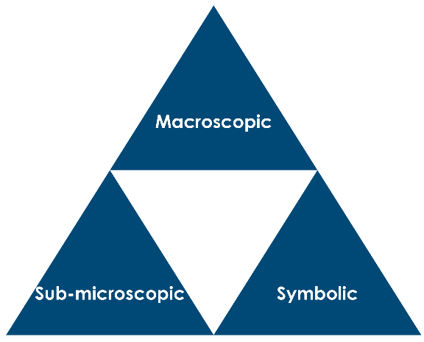

Measuring volumes and equipment

Uncertainty and percentage uncertainty

1. The instrument has a limitation; it’s not a mistake.
2. Volumetric glassware measures one amount very precisely.

Quantitative glassware measures an approximate amount.

|  |  |  |  |  |
| --- | --- | --- | --- | --- |
| **Measurement** | **Instrument** | **Uncertainty** | **Number of times scale used in measurement** | **% Uncertainty** |
| 25 cm3 | volumetric pipette | 0.06 cm3 | **1** |  |
| 25 cm3 | measuring cylinder with 1 cm3 division | **0.5cm3** | **1** |  |
| 25 cm3 | beaker, division 25 cm3 | **12.5cm3** | **1** |  |
| 25 cm3 | burette, division 0.1cm3 | **0.05** | **2** |  |
| 250cm3 | volumetric flask (250 cm3) | 0.24 cm3 | **1** |  |
| 12.22 g | balance (2 decimal places) mass measured by difference | **0.01** | **2** |  |
| 12.220 g | balance (3 decimal places) mass measured by difference | **0.001** | **2** |  |
| temperature change of 22.5 °C | thermometer (1°C division) | **0.5** | **2** |  |

= 0.09996

Smallest division on the scale is 2 x uncertainty

2 = 0.199

= 0.2 cm3

1. Note: scale = 1°C, therefore 0.5°C used for accuracy.

|  |  |  |  |
| --- | --- | --- | --- |
| **Experiment** | **Final temp. (°C)** | **Initial temp. (°C)** | **Temp. change (°C)** |
| 1 | 23.0 | 21.0 | 2.0 |
| 2 | 27.0 | 23.0 | 4.0 |
| 3 | 28.0 | 22.0 | 6.0 |
| 4 | 23.0 | 21.0 | 2.0 |

1. Not necessarily, because one or more of the measured values could be an anomaly
2. Accuracy is the closeness of a measurement to the accepted reference value.

Precision is when measurements taken are similar to one another.

1. To look for anomalies and to spot systematic errors.