**F6 Recording data and uncertainty**

Scale

|  |  |  |  |
| --- | --- | --- | --- |
| **Subatomic** | **Atom** | **Molecule** | **Giant structure** |
|  |  |  |  |

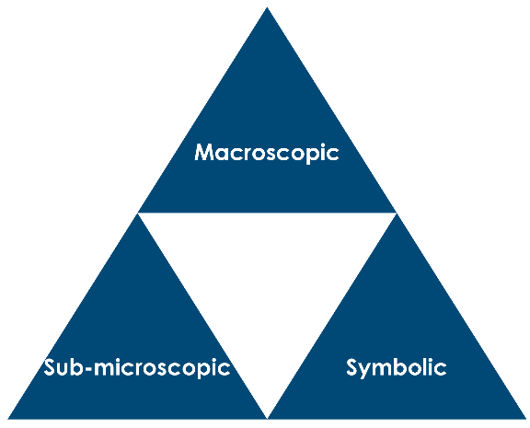

Uncertainty and percentage uncertainty

1. Explain why every measurement you make has a degree of uncertainty.
2. Explain the difference between volumetric glassware (pipettes, flasks etc.) and qualitative glassware.
3. State the equation needed to calculate the % uncertainty for a measurement, explaining each of the quantities.
4. Use the equation in Q3 to calculate the percentage uncertainty for each of the following measurements.

|  |  |  |  |  |
| --- | --- | --- | --- | --- |
| **Measurement** | **Instrument** | **Uncertainty** | **Number of times scale used in measurement** | **% Uncertainty** |
| 25 cm3 | volumetric pipette | 0.06 cm3 |  |  |
| 25 cm3 | measuring cylinder with 1 cm3 division |  |  |  |
| **Measurement** | **Instrument** | **Uncertainty** | **Number of times scale used in measurement** | **% Uncertainty** |
| 25 cm3 | beaker, division 25 cm3 |  |  |  |
| 25 cm3 | burette, division 0.1cm3 |  |  |  |
| 250cm3 | volumetric flask (250 cm3) | 0.24 cm3 |  |  |
| 12.22 g | balance (2 decimal places) mass measured by difference |  |  |  |
| 12.220 g | balance (3 decimal places) mass measured by difference |  |  |  |
| temperature change of 22.5 °C | thermometer (1°C division) |  |  |  |

1. A chemist measures 25.0 cm3 of solution using a pipette with uncertainty 0.06 cm3. Calculate the % uncertainty.
2. A chemistry student measures 12 cm3 of solution using a measuring cylinder. The percentage uncertainty of this measurement is 0.833%. What was the smallest division on the scale?
3. A student measured the temperature change in a series of reactions by recording the initial and final temperature measurements. The diagrams below show the appearance of the thermometer scale at each reading. In each experiment, the thermometer on the left shows the initial reading, the thermometer on the right the final reading.

|  |  |
| --- | --- |
| **Experiment** | **Thermometer diagrams** |
| **1** | Thermometer diagrams to take a reading from |
| **2** | Thermometer diagrams to take a reading from |
| **3** | Thermometer diagrams to take a reading from |
| **4** | Thermometer diagrams to take a reading from |

1. Draw a table that displays the initial and final temperature measurements for each experiment and the temperature change. Don’t forget to add headings and units.
2. Calculate the mean average temperature change for the four experiments and show your working. Give your answer to one decimal place.
3. Calculate the percentage uncertainty in the average temperature change.
4. Would an average result always be more accurate than a single measurement?

Multiple/repeated measurements

|  |  |  |  |
| --- | --- | --- | --- |
| A dartboard with dots indicating where darts have hit they are grouped tightly around the bullseye (centre of the board) | A dartboard with dots indicating where darts have hit they are grouped tightly but are away from the centre of the board | A dartboard with dots indicating where darts have hit, they are around the bullseye (centre of the board) but are  not grouped tightly | A dartboard with dots indicating where darts have hit, they are all over the dartboard |
| **Accurate**  **Precise** | **Not accurate**  **Precise** | **Accurate**  **Not precise** | **Not accurate**  **Not precise** |

1. Use the target diagrams above to explain the difference between an accurate measurement and a precise measurement.
2. Why is it important to take repeat measurements?