Copper atoms and Copper ions: Johnstone’s triangle

This resource is from the **Johnstone’s triangle** series which can be viewed at: [rsc.li/43jMfSn](https://rsc.li/43jMfSn). It will help learners to understand the different ways you need to think in chemistry, building their mental models and understanding.

Learning objectives

1. Describe atoms and ions in terms of gain/loss of electrons.
2. Write atomic symbols for atoms and ions.
3. Observe that atoms and ions can have different properties.

How to use Johnstone’s triangle

Use Johnstone’s triangle to develop learners’ thinking about scientific concepts at three different conceptual levels:

* 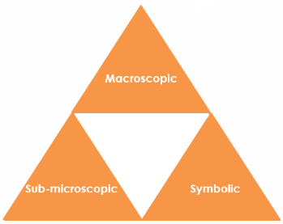Macroscopic – what we can see. Think about the properties you can observe, measure and record.
* Sub-microscopic – smaller than we can see. Think about the particle or atomic level.
* Symbolic – representations. Think about how we represent chemical ideas including symbols and diagrams.

For learners to gain a deeper awareness of a topic, they need to understand it at all three levels.

When introducing a topic, do not try to introduce all three levels of thinking at once. This will overload working memory. Instead complete the triangle over a series of lessons, beginning with the macroscopic level and introducing other levels, in turn, once understanding is secure.

The three levels are interrelated. For example, learners need visual representation of the sub-microscopic to develop mental models of the particle or atomic level.

Find further reading about Johnstone’s triangle and how to use it in your teaching at [rsc.li/44ae41B](https://rsc.li/44ae41B).

Scaffolding

It is important to share the structure of the triangle with learners prior to use. Tell them why you want them to use the triangle and how it will help them to develop their understanding. Use an ‘I try, we try, you try’ approach when you are introducing Johnstone’s triangle for the first time.

More resources

To further develop learner’s thinking in all areas of Johnstone’s triangle, try our **Developing understanding** worksheets ([rsc.li/4mkBWq9](https://rsc.li/4mkBWq9)). These include icons in the margin referring to the conceptual level of thinking needed to answer the question.

Demonstration: copper displacement

Equipment (per demonstration)

* 1 x spatulas or forceps to dispense metals (magnesium ribbon) from containers
* 1 x test tube
* Safety equipment: safety spectacles

Preparation

* A red and black sign with a exclamation mark

  AI-generated content may be incorrect.0.1 mol dm-3 copper sulfate solution (5 cm3)   
  WARNING: skin and eye irritant  
  Image: © Shutterstock
* magnesium ribbon (1 cm long)

Safety

Read our standard health and safety guidance and carry out a risk assessment before running any live practical, at: [rsc.li/3IAmFA0](https://rsc.li/3IAmFA0)

Refer to the SSERC hazardous chemicals database and the CLEAPSS Hazcards and recipe sheets. Hazard classification may vary depending on chemical supplier.

**Instructions**

1. Place 5cm3 of 0.1 mol dm-3 solution into the test tube.
2. Ask the learners to describe what they see.
3. Then, add the magnesium ribbon to the test tube.
4. Ask learners to record observations.

Disposal

Used pieces of magnesium ribbon can be added to 1 mol dm-3 ethanoic acid solution. Heat or spray may be produced. Test the solution with indicator and add more ethanoic acid until the mixture is just acidic. Pour the neutralised mixture down a foul-water drain with further dilution.

Rinse dilute (below 0.2 mol dm-3) solution, which will also contain some , away down the foul-water drain.

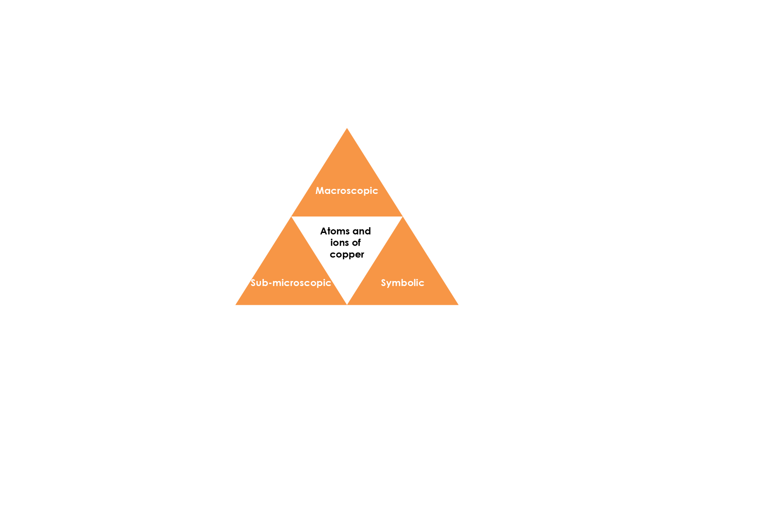

Image adapted from © Shutterstock / Craig Walton and Zelenskaya

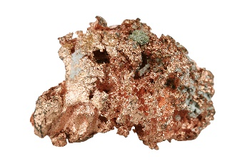

Sub-microscopic – smaller than we can see

Choose the correct word to complete the following:

An electron has a **~~positive~~/negative** charge. A proton has a **positive/~~negative~~** charge.

When an ion is formed the number of **~~electrons~~/protons** does not change. Adding an electron to an atom makes a **~~positively~~/negatively** charged ion. Losing an electron from an atom makes a **positively/~~negatively~~** charged ion.

In this reaction copper ions are changed back to atoms. A copper atom is formed from a positive copper ion by the **~~loss~~/gain** of two electrons.

**Copper ions**

**Copper atoms**

Symbolic – representations

In the reaction above, copper metal, which is neutral, is formed from copper ions (which have a 2+ charge).

Give the symbol for:

A copper atom:

A copper ion with a 2+ charge:

A negative electron:

The overall equation for the reaction above is:

Label the copper atoms and copper ions in the equation. Sometimes, it is hard to identify the ions without the charges being marked, so we can use a half equation:

Macroscopic – what we can see

Watch the demonstration – what does the copper solution look like to begin with?

**A blue solution.**

What does the copper metal formed look like? (Use the image to help you).

**The metal formed may look black or copper coloured, the lump of copper in the image is copper coloured and shiny.**