F3 Nuclear fusion

Scale

|  |  |  |  |
| --- | --- | --- | --- |
| **Subatomic** | **Atom** | **Molecule** | **Giant structure** |
|  |  |  |  |

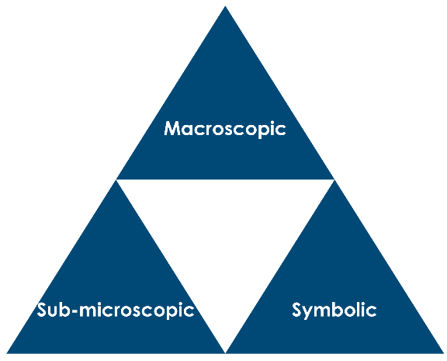

1. What type of particles take part in fusion?
2. Explain what happens in nuclear fusion.
3. Give the conditions in the core of the Sun where fusion occurs.
4. Explain why these conditions are required for nuclear fusion.
5. The density of the material at the centre of the sun is approximately 150 g cm-3.
6. Estimate the volume you would be if compressed to this density.
7. If hydrogen nuclei have a mass of 1.67 x 10-27 kg, calculate how many 1H nuclei are present in 1 cm3 of core material?
8. Complete the table of symbols for particles frequently involved in nuclear reactions.

|  |  |  |  |  |
| --- | --- | --- | --- | --- |
| **Particle** | **Alpha particle** | **Beta particle** | **Proton** | **Neutron** |
| Alternative name |  |  |  | N/A |
| Nuclear symbol |  |  |  |  |

1. Complete/write the balanced nuclear equation for each fusion reaction.
2. + →
3. 12C + 12C →
4. The fusion of three helium-4 nuclei to form a carbon nucleus.
5. The reaction between alpha particles and nitrogen-14 to produce oxygen-17. (When written this way, the number indicates **the mass** of the isotope.)
6. A nucleus absorbs a proton then disintegrates into two identical fragments.
7. The production of 14C and another particle by collision of a neutron with an atom of 14N.
8. Collision of an alpha particle with a nucleus of selenium-79, releasing a proton and forming another element.
9. The collision of an alpha particle with an atom of aluminium-27 to form phosphorous-30.
10. Fusion of two carbon-12 nuclei and seven helium-4 nuclei to make iron.
11. Fusion of two neon isotopes to make oxygen and magnesium nuclei (create the mass numbers yourself).
12. Nuclear synthesis of new elements. These fusion examples also release other subatomic particles. Complete the balanced nuclear equation.
13. The formation of einsteinium-248 from uranium and nitrogen nuclei.
14. The formation of californium-246 from uranium and carbon nuclei.
15. The formation of lawrencium-257 from californium and boron nuclei.
16. The formation of americium-241 from plutonium and neutrons.
17. The ‘birth’ of elements starts with **nuclear fusion**reactions in stars.

One fusion cycle in very hot stars is called the CNO cycle. It is represented in the diagram below.

1. There are pairs of nuclei in the above cycle that have the same mass number. Complete the table below for any one pair.

|  |  |  |
| --- | --- | --- |
| **Isotope** | **Number of protons** | **Number of neutrons** |
|  |  |  |
|  |  |  |

1. The isotope in the CNO cycle is formed as a result of two previous fusion reactions occurring in the star:

Give the full nuclear symbols for isotopes P and Q.

Nuclear fusion in stars

Stars larger than eight times the mass of our Sun begin their lives the same way smaller stars do: by fusing hydrogen into helium. However, a large star burns hotter and faster, fusing all the hydrogen in its core to helium in less than 1 billion years. The star then becomes a red supergiant, similar to a red giant, only larger. Unlike red giants, these red supergiants have enough mass to create greater gravitational pressure, and therefore higher core temperatures. They fuse helium into carbon, carbon and helium into oxygen, and two carbon atoms into magnesium. Through a combination of such processes, successively heavier elements, up to iron, are formed (see the table).

Each successive process requires a higher temperature (up to 3.3 billion kelvins) and lasts for a shorter amount of time. The structure of a red supergiant becomes like an onion (see Figure), with different elements being fused at different temperatures in layers around the core. Convection brings the elements near the star’s surface, where the strong stellar winds disperse them into space.

|  |  |  |  |  |
| --- | --- | --- | --- | --- |
| **Fuel** | **Main product** | **Secondary products** | **Temperature (billion kelvins)** | **Duration (years)** |
| H | He | N | 0.03 | 1 x 107 |
| He | C, O | Ne | 02 | 1 x 106 |
| C | Ne, Mg | Na | 0.8 | 1 x 103 |
| Ne | O, Mg | Al, P | 1.5 | 0.1 |
| O | Si, S | Cl, Ar, K, Ca | 2.0 | 2 |
| Si | Fe | Ti, V, Cr, Mn,  Co, Ni | 3.3 | 0.01 |

1. For how many days is iron produced by fusion from silicon?
2. For what percentage of a star’s life is iron produced by fusion from silicon? Assume the star ‘lives’ for 0.1 billion years.
3. Iron can be formed from silicon in silicon burning, by fusing it with alpha particles, one after another. Show the steps to form progressively heavier nuclei starting with silicon-28 and ending with iron-52.
4. Suggest an explanation for the change in temperature required to get heavier nuclei to fuse.
5. Use the cards to help you complete the equations in the table below.

|  |  |  |  |  |  |
| --- | --- | --- | --- | --- | --- |
| **Reaction number** | **Reacting nuclei** | | |  | **Product/s** |
| 1 |  | + |  | → |  |
| 2 |  | + |  | → |  |
| 3 |  | + |  | → |  |
| 4 |  | + |  | → |  |
| 5 |  | + |  | → |  |
| 6 |  | + |  | → |  |
| 7 |  | + |  | → |  |