F6 Recording data and uncertainty

Revision: volumes

The standard unit for volume is the metre cubed, m3. However, the volumes of solutions used in chemistry labs are usually much less than 1 m3. Instead, cm3 or dm3 (decimetre cubed) are used.

**1 m3 = 1,000,000 cm3 = 1000 dm3**

**1 dm3 = 1000 cm3 = 1 litre**

Nowadays, litres and millilitres are rarely used in written chemistry, but 1 ml = 1 cm3 and many pieces of glassware still show ml.

1. Complete the table by choosing the approximate volume units from the options in bold and estimating the volume for each of the everyday items (images not to scale).

**cm3  dm3  m3**

|  |  |  |  |
| --- | --- | --- | --- |
|  | **A small watter bottle** | **a single sugar cube** | **a standard washing machine**  Images © Shutterstock |
|  | **Drinks bottle** | **Sugar cube** | **Washing machine** |
| **Approximate volume** |  |  |  |

1. Give the calculation to convert a volume in cm3 to m3.
2. Give the calculation to convert a volume in dm3 to cm3.
3. For each example below, convert the volume units.
4. A helium balloon has a volume of 1600 cm3. Convert this volume into dm3.
5. An experiment requires 1.35 dm3 of hydrochloric acid solution. What volume is this in cm3?
6. A swimming pool contains 375 m3 of water. What is the volume in cm3?
7. A carbon dioxide cylinder has a volume of 6.54 dm3. What is the volume in m3?

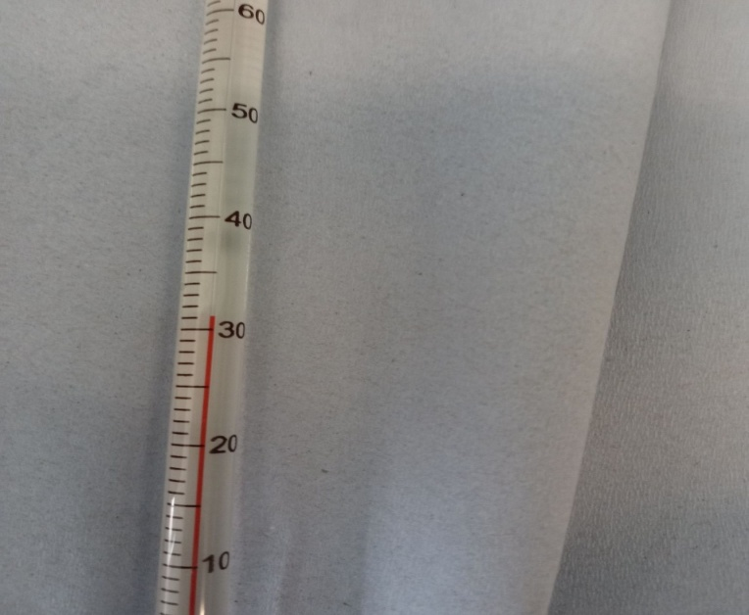New content: making measurements

The value recorded for a measurement must be related to the scale used.

Usually, for graduated scales (made from lots of lines) we work out the value on the scale of half the smallest division. On the thermometer shown here, the smallest division between lines is 1°C, so half the smallest division is 0.5°C.

This means that we must record measurements on this thermometer to the nearest 0.5°C and therefore give one decimal place.

Every reading should be to one decimal place, with the number after the decimal being either ‘0’ (on the line) or ‘5’ (between lines). We cannot give a measurement more precisely than the nearest 0.5°C on this scale, so the number after the decimal cannot be 6 or 2 or 3 etc., as that would be more precise than the nearest 0.5°C.

So, the measurement in the image is 31.0°C.

If a different scale is used, the decision about the number of decimal places must be made again, but the principle of using half the smallest division is the same.

1. Now, read each of these instruments giving the answer with the appropriate precision.

|  |  |  |  |  |
| --- | --- | --- | --- | --- |
| **Equipment** | **Burette** | **Thermometer** | **Measuring cylinder (cm3)** | **Measuring cylinder (cm3)** |
| Picture of  scale | Photograph of a measuring cylider with liquid | Thermometer with value reading at half way between 20 and 30 | **Measuring cylinder with liquid** | Measuring cylinder with liquid |
| Smallest  division |  |  |  |  |
| Half of the  smallest  division |  |  |  |  |
| Reading  shown in  image |  |  |  |  |