Melting ice and boiling water: Johnstone’s triangle

Learning objectives

1. Describe what happens to a substance when it is heated or cooled in terms of state changes.
2. Use melting and boiling point information to work out the state of a substance at a given temperature.

Introduction

Substances can exist in different states and can change between states at specific temperature points.

Johnstone’s triangle

In chemistry we make sense of the things that we can see by representing what we can’t see using formulas, equations, diagrams and models.

Johnstone’s triangle is a way of thinking about these different concepts as different corners of a triangle:

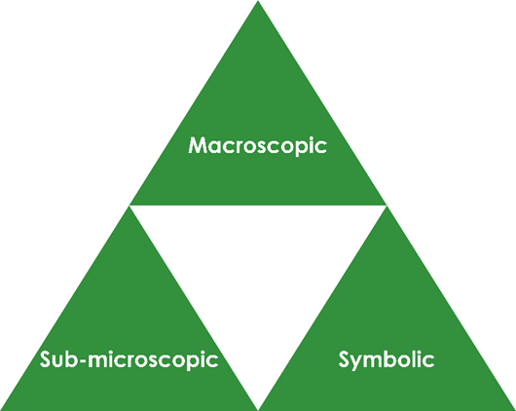

* Macroscopic – what we can see. Think about the properties we can observe, measure and record.
* Sub-microscopic – smaller than we can see. Think about the particle or atomic level.
* Symbolic – representations. Think about how we represent chemical ideas, including symbols and diagrams.

Being able to connect and move between these three different levels is important for scientific understanding.

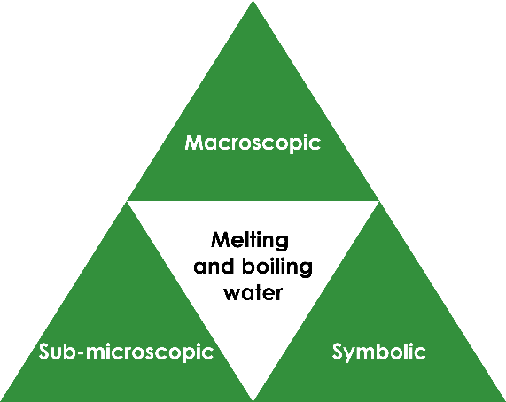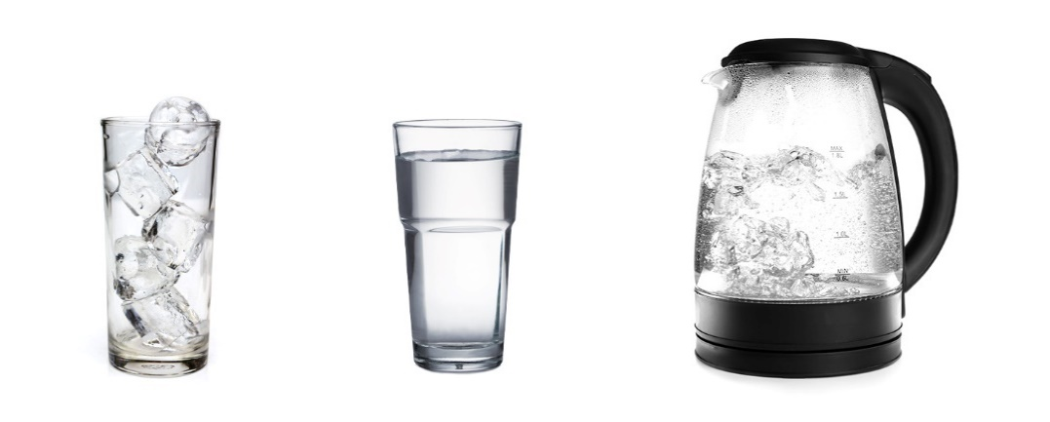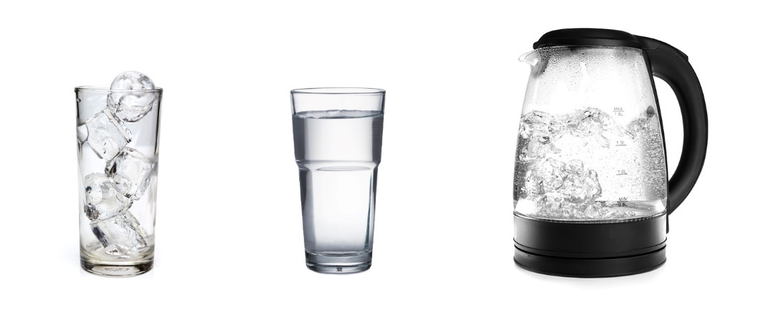

Image adapted from © Shutterstock

Symbolic – representations

The diagram shows the particle diagrams for the three states of matter with arrows to show the different changes of state.

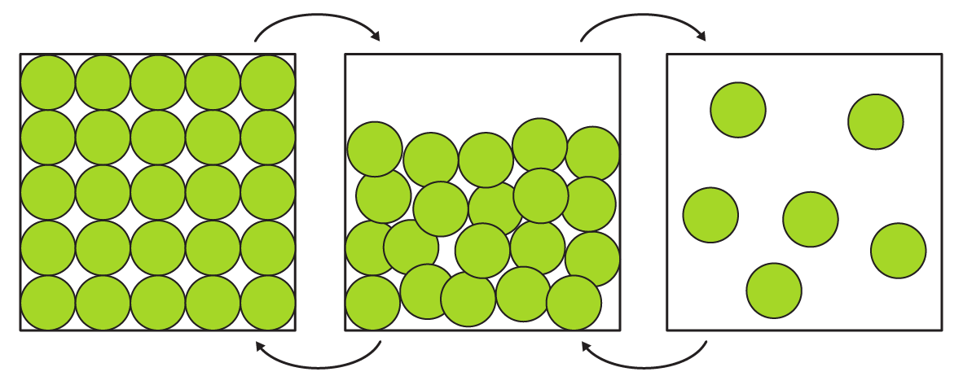

Add a label to each arrow to name the change of state.

**melting boiling freezing condensing**

Sub-microscopic – smaller than we can see

Water has a melting point of 0°C and a boiling point of 100°C.

Work out the state at the temperatures given below and complete the particle diagram for each. Write the state beneath your diagram.

-34°C 109°C 54°C

______________ ______________ ______________

Macroscopic – what we can see

Name the changes of state that are happening:

1. To the ice cube __________________________
2. In the kettle __________________________

Describe how the kettle turns water from the liquid to gas state.