**F2 Counting protons, neutrons and electrons**

This is the second lesson in an introductory course for post-16 chemistry learners covering key ideas in order of scale. Find out more about the course and approach here: [**rsc.li/4kGyaoN**](https://rsc.li/4kGyaoN)

Before each lesson, ask learners to complete the preparation worksheet to revise knowledge from their 14–16 courses and introduce the topic for the lesson.

Then, get them to complete the student sheet during the lesson. It includes all key content and challenges misconceptions. Each student sheet has a scale and a Johnstone’s triangle diagram at the top. Use these to help learners think about the relative scale of different aspects of chemistry and connect their understanding of sub-microscopic, macroscopic and symbolic representations.

This icon indicates that students will need access to learning materials e.g. textbook or online resources to support their learning. See [**rsc.li/3UgK9i6**](https://rsc.li/3UgK9i6) for links.

Begin each lesson by checking learners have completed the preparation work. Share the answers and ask learners to mark their own worksheets as part of their independent work.

Topics in this lesson

|  |  |  |
| --- | --- | --- |
| Beginning with solid fill | **Last lesson** | F1 Developing a model of the atom |
|  | **Preparation worksheet** | Revision: atoms and subatomic particles  New content: counting subatomic particles |
|  | **Lesson worksheet** | Subatomic particles and the periodic table; isotopes; relative atomic mass |
| End with solid fill | **Next lesson** | F3 Nuclear fusion |

Answers

Revision: atoms and subatomic particles

|  |  |  |
| --- | --- | --- |
| **Subatomic particle** | **Relative mass** | **Relative charge** |
| Proton | **1** | **+1** |
| **Neutron** | 1 | **0** |
| **Electron** |  | **–1** |

1. 14 protons = 14+

14 electrons = 14-

The charges cancel out.

1. 14 protons + 15 neutrons = 29 atomic mass units
2. 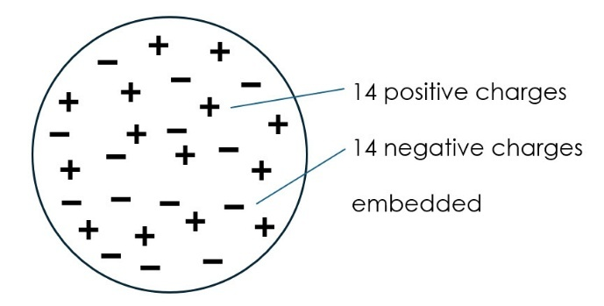
3. 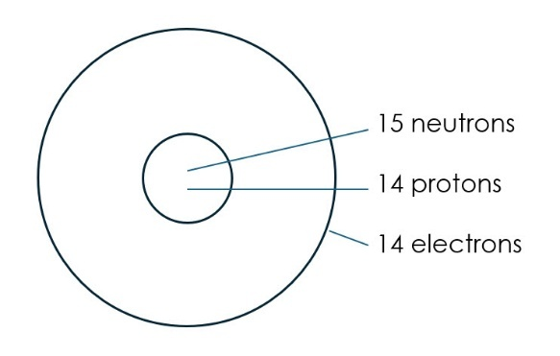
4. Both have 14 positive charges and 14 negative charges. Diagram i. is low density, whereas diagram ii. has a high-density nucleus surrounded by mostly empty space. Diagram ii. has neutrons but diagram i. does not.

New content: counting subatomic particles

1. Fe Iron
2. S Sulfur
3. 47
4. 116 Livermorium
5. 1 Hydrogen
6. 11 Sodium Na

Worksheet

Scale

|  |  |  |  |
| --- | --- | --- | --- |
| **Subatomic** | **Atom** | **Molecule** | **Giant structure** |
| Protons, neutrons, electrons | Fusion creating new nuclei |  |  |

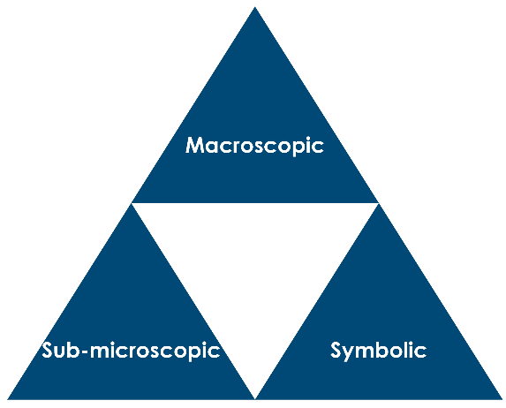

Equation for fusion

Neutrons, protons, electrons, atoms, isotopes

symbol

mass number protons + neutrons

atomic number = number of protons or number of electrons

1. 11 protons, so 11+

11 electrons, so 11–

Same number of positive and negative charges.

1. Isotopes
2. 6
3. 7
4. Cl has 20 neutrons

Cl has 18 neutrons

1. chlorine–37, chlorine–35
2. Relative atomic mass is an average of the masses of all the isotopes, taking their abundance into account.
3. it loses one electron
4. it gains one electron
5. 18 electrons, 16 protons, charge = 2–
6. 16S2–

|  |  |  |  |  |  |
| --- | --- | --- | --- | --- | --- |
| **Species** | **Atom or ion?** | **Mass number** | **Number of protons** | **Number of electrons** | **Number of neutrons** |
| 9Be | **Atom** | **9** | **4** | **4** | **5** |
| 19F | **Atom** | **19** | **9** | **9** | **10** |
| 28Si | **Atom** | **28** | **14** | **14** | **14** |
| 29Si | **Atom** | **29** | **14** | **14** | **15** |
| 96Nb | **Atom** | **96** | **41** | **41** | **55** |
| **103Rh** | Atom | **103** | 45 | **45** | 58 |
| 23Na+ | **Ion** | **23** | **11** | **10** | **12** |
| Cl- | **Ion** | 35 | **17** | **18** | **18** |
| O2- | **Ion** | 16 | **8** | **10** | **8** |
| **Mg2+** | **Ion** | **24** | 12 | 10 | 12 |
| **Al3+** | **Ion** | 27 | **13** | 10 | 14 |

|  |  |  |
| --- | --- | --- |
|  | **Similarities** | **Differences** |
| 19F- and 20Ne | same number of neutrons and electrons | number of protons, charge |
| 19F and 20Ne | same number of neutrons, charge | number of protons and electrons |
| 37Cl- and 41K+ | same number of electrons | number of protons and electrons, charge |
| 5Be and 6Be | same number of protons and electrons, same element | neutrons |

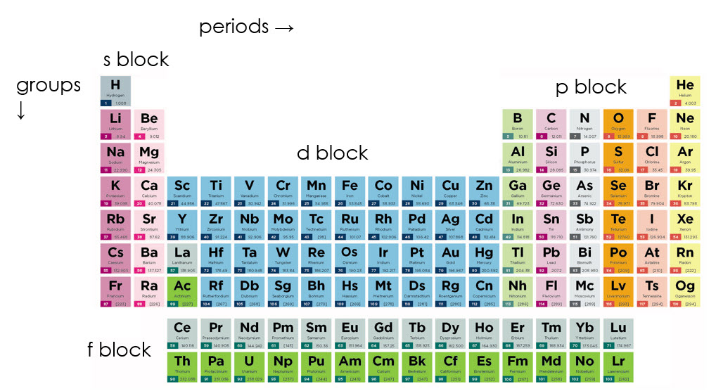

1. The number of protons increases along each period from left to right and down each group from top to bottom.

Hinge questions

1. (c) 30Al
2. (e) 19F-
3. (e) aluminium-27