Breakthrough method produces flexible diamond films

*Original article by Tim Wogan. Adapted by Nina Notman.*

**Scientists discover new method for producing ultraflexible diamond films on an industrial scale**

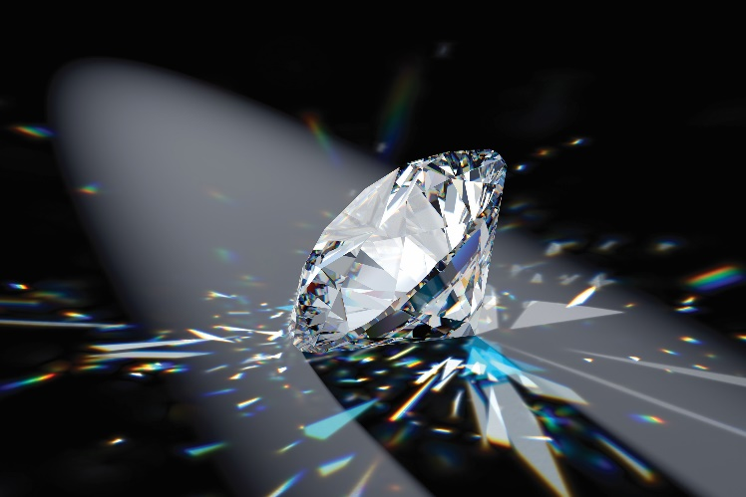Researchers in Hong Kong have used sticky tape to produceultrathin,flexible diamond films. Potential uses for these films include heat sinks in the electronics industry. Miniaturising electronics needs the continued development of materials that can better dissipate heat.

Diamond is among the hardest and most brittle materials on Earth. However, thin diamond films are surprisingly flexible. Growing diamond films on silicon surfaces has been possible for a number of years, but removing them without damage has proven difficult, especially for films with a large surface area.

*Source: © Sergey Lifanov/Getty Images*

*Diamond is the hardest known natural mineral and incredibly brittle. However, scientists have grown it in ultrathin films that are surprisingly flexible*

Zhiqin Chu, a professor at Hong Kong University, was inspired to use sticky tape to remove diamond films from silicon surfaces by the single-layer graphene discovery story. Konstantin Novoselov and Andre Geim won the 2010 Nobel prize in physics for demonstrating that you can strip a single layer of graphene from graphite (the material in pencil leads) using sticky tape.

Using the same sticky tape method, Zhiqin’s team produced circular diamond films approximately five centimetres in diameter. The films were less than one micrometre thick and ultraflexible. The scientists report that this technique is suitable for industrial scale manufacturing of diamond films.

This is adapted from the article **Exceptionally flexible diamond film exfoliated using Scotch tape** in *Chemistry* *World.* Read the full article: bit.ly/41o5oD0