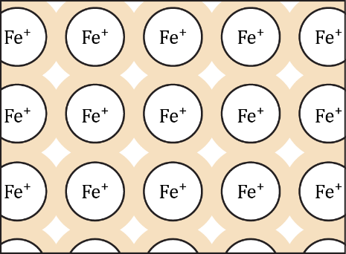Iron – a metal: true or false?

The statements below refer to the diagram of the structure of iron. The diagram shows part of a slice through the three-dimensional structure.

Read each statement carefully and decide if it is correct or not. **Circle your answer.**

|  |  |
| --- | --- |
| 1. Iron has a type of bonding called metallic bonding. | **True / False** |
| 1. Iron atoms do not have a full outer shell of electrons and this makes iron very reactive. | **True / False** |
| 1. Iron is a silvery-grey metal because iron atoms are silvery-grey. | **True / False** |
| 1. Iron can conduct electricity because iron atoms can slip over their neighbours and move through the solid. | **True / False** |
| 1. Iron can be re-shaped, without changing the shape of iron atoms. | **True / False** |
| 1. Iron rusts because iron atoms will rust if exposed to damp air. | **True / False** |
| 1. In iron metal, each atom is bonded to each of the other iron atoms surrounding it. | **True / False** |
| 1. Iron conducts electricity because iron atoms are electrical conductors. | **True / False** |
| 1. Iron is a solid because that is the natural state for metals. | **True / False** |
| 1. A metal consists of positive metal ions and negative electrons which move around the solid between the ions. | **True / False** |
| 1. An iron atom will reflect light and so freshly polished iron shines. | **True / False** |
| 1. Iron becomes a liquid when heated because the bonds melt. | **True / False** |
| 1. Iron conducts electricity because it contains a ‘sea’ of electrons. | **True / False** |
| 1. The atoms in iron are held together by ionic bonds. | **True / False** |
| 1. Iron conducts heat because there is room between the atoms for hot air to move through the metal. | **True / False** |
| 1. Iron is hard because iron atoms are hard. | **True / False** |
| 1. Iron contains molecules held together by magnetism. | **True / False** |
| 1. If iron is heated to a very high temperature, it will become a gas. | **True / False** |
| 1. Iron expands when it is heated because iron atoms get bigger. | **True / False** |
| 1. Chemical bonds are needed to hold the atoms together in iron, even though all of the atoms are of the same type. | **True / False** |