# Investigating different browning reactions: teacher notes

***Education in Chemistry***March 2020  
rsc.li/2NQoV8S

**This activity investigates some of the factors involved in the browning reactions of fruit and the Maillard reaction.**

**What causes cut apples to go brown: enzymes or microbes?**

Apples, avocadoes and potatoes all change colour when peeled or cut and left to stand.

**Practical note**: The experiments in this activity can be carried out in the laboratory. The browning reaction speed can be increased by adding a few drops of a 1% benzene-1,2-diol solution. This is a harmful solution so students should wear gloves when using it.

A student wanted to investigate if microbes or enzymes caused cut apples to go brown. This is the method the student used first:

1. Take three pieces of apple.
2. Crush one piece.
3. Break one piece in two.
4. Cut one piece in two.
5. Observe the rate of browning in the three pieces.

The quickest to turn brown was the crushed piece and the slowest to turn brown was the one broken in two.

* 1. Suggest reasons for the different browning speeds.
* The crushed piece has many disrupted cell walls – enzymes are most readily exposed to air.
* Breaking an apple piece tends to break the apple between cells, so more stay intact – the apple is less exposed to air.
* Cutting an apple causes cell walls to be broken.
  1. Explain whether enzymes or microbes are more likely to be found inside the fruit.
* Enzymes are used to regulate the reactions inside cells.
* Microbes are not usually found inside cells (unless diseased).

In the next experiment, the student used a solution of phenol that would kill microbes but not affect enzymes. This is the second method the student used:

1. Cut an apple in half.
2. Soak one half of it in a phenol solution for one minute.
3. Soak the other half in distilled water for one minute.
4. Remove the apple halves from the solutions and allow to stand in air.
5. Observe the browning rate.
   1. Draw the structure of phenol.

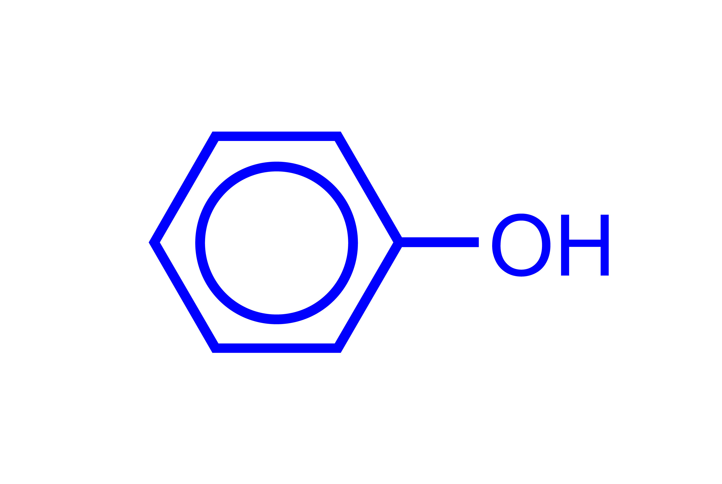

* 1. Why did the student soak one half of the apple in distilled water and one half in phenol solution?
* The disinfectant will kill any microbes present.
* The distilled water is a control.
  1. The student observed that the rate of browning was the same in both halves of the apple. Explain what the student can conclude from these results.
* Browning is not due to microbial action.
  1. The student wanted to investigate the effect of temperature on the rate of browning in an apple using the following temperatures: 20°C, 40°C, 60°C, 80°C and 100°C. Plan a method the student could use, giving the control variables.
* Five identical pieces of apple.
* Five different water baths at 20°C, 40°C, 60°C, 80°C and 10°C.
* Place each piece of apple in each water bath for one to two minutes.
* Ensure that all of the pieces are in the water for the same amount of time.
* Take them out of the water and leave them to stand in the air.
* Observe the rate of browning.
  1. The student found the apple at 40°C browned the fastest and that the apples did not turn brown at any temperatures greater than 60°C. Explain how these results support the hypothesis that enzymes cause browning in apples.
* 40°C is the optimum temperature for enzyme reactions.
* At temperatures of lower than 40°C, enzyme reactions will be slower.
* At temperatures greater than 60°C, the enzymes will be denatured and the reaction will not occur.
  1. Suggest how the results for the experiment investigating the effect of the temperature would differ if microbes caused the browning reaction.
* The reaction would be faster as the temperature increased due to faster rates of growth of the microbes.
* The reaction would therefore be faster at temperatures above 40°C.
* Microbes may be killed at temperatures near 100°C, so could be slower at this temperature.
  1. The reaction turning the apples brown is an oxidation reaction. Suggest how the student could investigate the hypothesis that oxygen from the air is necessary for the browning reaction.
* They could place apple pieces in different gas jars with oxygen, nitrogen and/or carbon dioxide.
* They could place apple pieces in a reduced pressure environment or a vacuum.
* They could observe the rates of browning in the different cases.

## How to stop apples and potatoes from going brown

2.1 Freshly cut potatoes can be prevented from browning by ‘blanching’ them. (This can be done by placing them in boiling water for one minute.) Explain how blanching stops the potatoes from browning.

* The high temperature denatures the enzymes and stops the browning reactions.

A student investigated using acids to stop the browning reactions. They used:

* 0.1 mol dm-3 hydrochloric acid
* 0.1 mol dm-3 citric acid
* 0.1 mol dm-3 ascorbic acid (vitamin C)

All of the acids stopped the browning reaction in the apples.

2.2 Explain why acid solutions can stop the browning reaction.

* Acid solutions denature the enzymes.
* Acid solutions remove the copper cofactor necessary for the enzymes to work (from article).

2.3 Each of the three acids used had a different pH. Suggest the order of decreasing pH for the three acids and explain your reasoning. The structure of citric acid is provided below.



* Highest to lowest pH: ethanoic acid > citric acid > hydrochloric acid
* Hydrochloric acid is a strong acid. It is completely ionised in solution. More dissociated hydrogen ions, so lowest pH.
* The other two acids are weak acids, partially ionised in solution, so lower concentrations of hydrogen ions.
* Citric acid has three carboxylic acid groups, so will produce a higher concentration of hydrogen ions than ethanoic acid.

2.4 Which of the above acids would be most suitable to add to a fruit salad to stop the fruit browning?

* Citric acid is best as it’s naturally found in fruit.
* Ethanoic acid would affect the taste – it would be vinegary.

**Investigating the Maillard reaction**

The Maillard reaction causes foods like meat and onions to go brown when cooked.

3.1 Two functional groups react together at the start of the Maillard reaction. What are these functional groups and what type of natural molecules are they found in?

* The carbonyl/aldehyde groups found in reducing sugars.
* The (deprotonated) amine groups found in amino acids/proteins.

3.2 A student investigated the following four mixtures to compare the extent of browning due to the Maillard reaction.

1. Solution of alanine at pH 2 and glucose
2. Solution of alanine at pH 11 and glucose
3. Solution of lysine at pH 2 and glucose
4. Solution of lysine at pH 11 and glucose

Each mixture was heated at 140°C for 10 minutes. Mixtures **A** and **C** did not change colour. Mixture **B** turned light brown and mixture **D** turned dark brown. Explain the results.

* Refer to the formulae of the amino acids at the different levels of pH.
* Refer to the likely first step of the mechanism in the Maillard reaction.

The structures of alanine and lysine are given below.

alanine lysine

* The amine groups need to be deprotonated to react with the carbonyl.
* The lone pair on the nitrogen in the amine group acts as a nucleophile and is attracted to the partial positive charge on the carbon in the carbonyl.
* At a low pH, the amines are protonated and so cannot act as nucleophiles. For example:

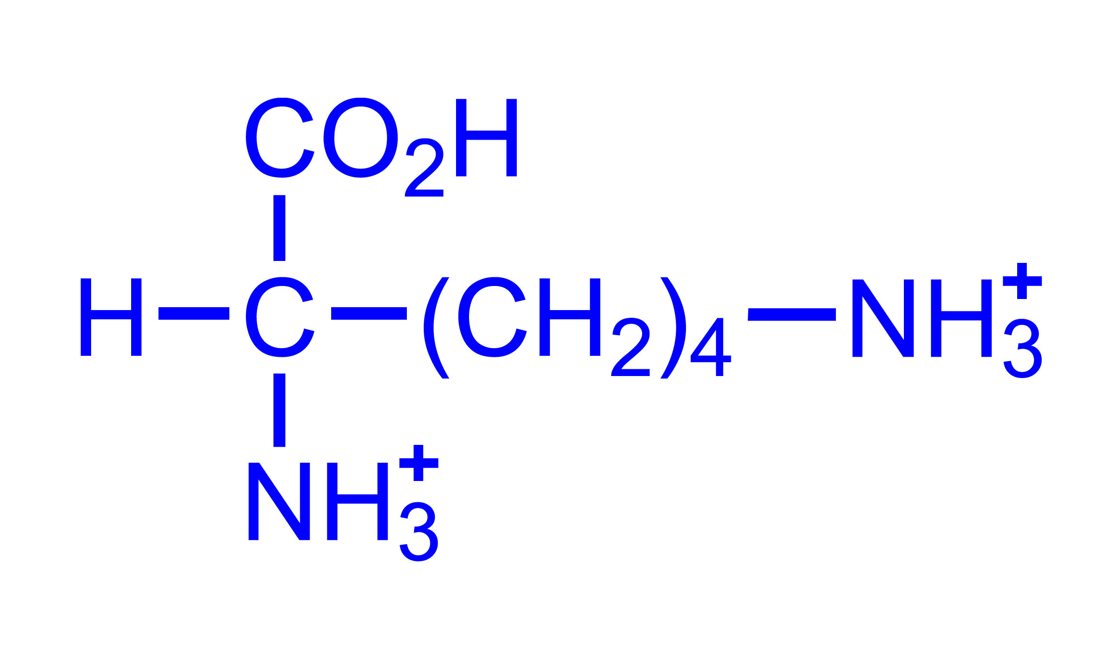

* At a high pH, the amines are deprotonated and so can react to form the brown colours. For example:

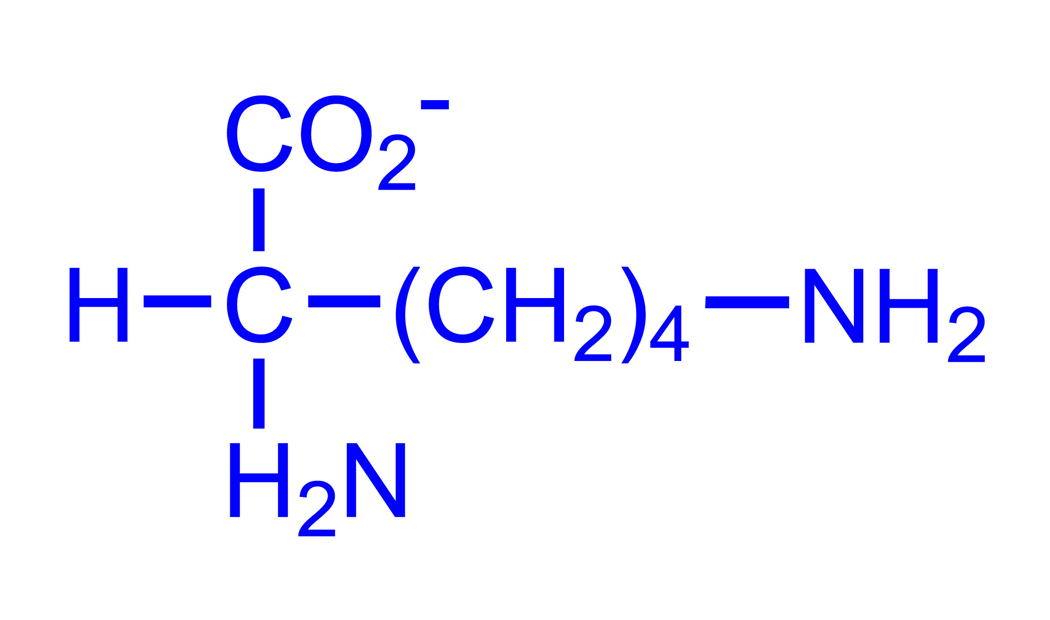

* Lysine has two amine groups per molecule and both can react with carbonyl groups. The browning reactions occur to a greater extent and the colour is darker.