Metallic structure and bonding

Introduction

These questions are designed to help you to develop your mental models (pictures in your mind) of metallic structure and bonding. Use the icon in the margin to find out which level of understanding the question is developing.

|  |  |
| --- | --- |
| An icon used to indicate the Macroscopic part of Johnstone's triangle. | **Macroscopic:** what we can see. Think about the properties that we can observe, measure and record. |
| An icon used to indicate the Sub-microscopic part of Johnstone's triangle. | **Sub-microscopic:** smaller than we can see. Think about the particle or atomic level. |
| An icon used to indicate the Symbolic part of Johnstone's triangle. | **Symbolic:** representations. Think about how we represent chemical ideas including symbols and diagrams. |

Questions

1. Copper can be represented by two different models.

|  |  |
| --- | --- |
| A metallic structure model diagram consisting of 16 identical circles arranged in four rows of four. Each circle is touching four of its neighbours. | A metallic bonding model diagram consisting of 9 pale orange circles, each with a positive sign in the centre. The circles are arranged in a square grid, 3 by 3. The circles are not touching each other. Between the pale orange circles are nine small dark red circles with a negative sign on them. These are not arranged in a uniform pattern and are neither touching each other or the pale orange circles. |
| **Model A** | **Model B** |

Model A shows the arrangement of metal atoms. Model B shows the delocalised electrons and the remaining positively charged ions.

The metal copper is ductile. It can be drawn into electrical wires.

1. State which model helps to explain why copper is ductile.

___________________________________________________________

1. Complete the sentence to explain why copper is ductile.

Copper is ductile because the atoms can __________________________________________

__________________________________________________________________________________

1. State the type of sub-atomic particle that moves when copper conducts electricity.

__________________________________________________________________________________

1. Explain why Model A cannot help to explain why copper conducts electricity.

__________________________________________________________________________________

__________________________________________________________________________________

1. Brass is an alloy of copper and zinc. Diagrams A and B show two different models of brass.

|  |  |
| --- | --- |
| A diagram consisting of 9 pale orange circles, each with a positive sign in the centre. The circles are arranged in a square grid, 3 by 3. The circles are not touching each other. Three of the circles are larger than the others, one on each row. Between the pale orange circles are nine small dark red circles with a negative sign on them. These are not arranged in a uniform pattern and are neither touching each other or the pale orange circles. | 17 pale orange circles and two much larger dark red circles. The circles are close together and touching but due to the differences in sizes they are not arranged in a regular pattern. |
| **A** | **B** |

1. Select the model that will best help you to explain why brass is stronger than pure copper. ______
2. Give the reason for your choice.

__________________________________________________________________________________

__________________________________________________________________________________

1. Select the model that will best help you to explain why brass still conducts electricity. _____
2. Give the reason for your choice.

__________________________________________________________________________________

__________________________________________________________________________________

1. A sodium atom has 11 electrons.
2. Complete the diagram to show the arrangement of electrons in a sodium atom. Remember to add the symbol in the centre.

Three concentric circles. These are suitable to be drawn on to complete the electron configuration diagram of sodium.


1. Sodium atoms form positive ions with +1 charge ().  
   Draw an electron configuration diagram for a sodium ion.
2. The nucleus of a sodium atom is made up of 11 protons and 12 neutrons.  
   Give the charge of a sodium nucleus. ______
3. Explain why a sodium ion is positively charged.

__________________________________________________________________________________

__________________________________________________________________________________

__________________________________________________________________________________

1. A metallic bonding diagram shows a simplified model of the structure of a metal.

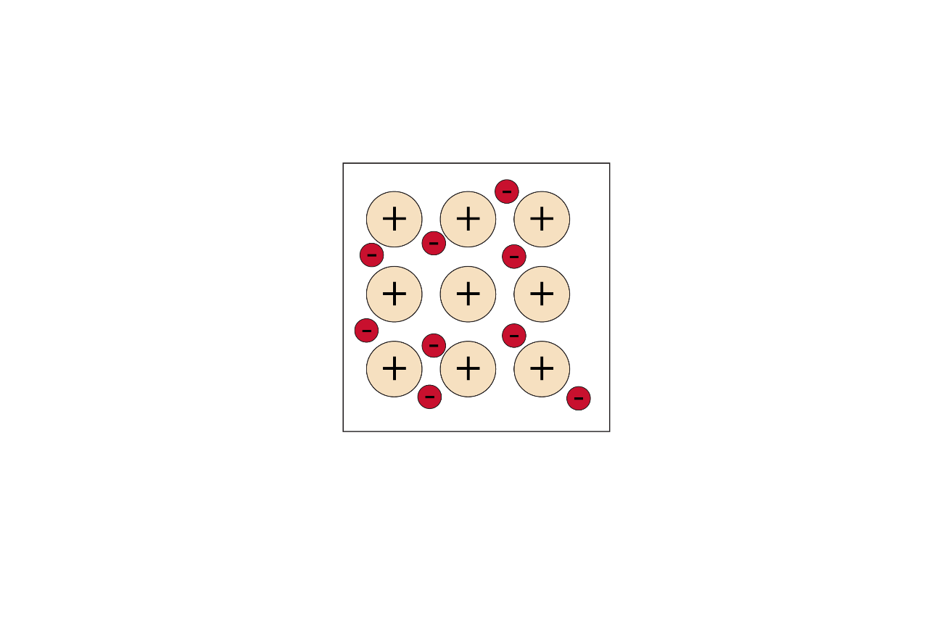

The following diagram shows the different parts of an atom.

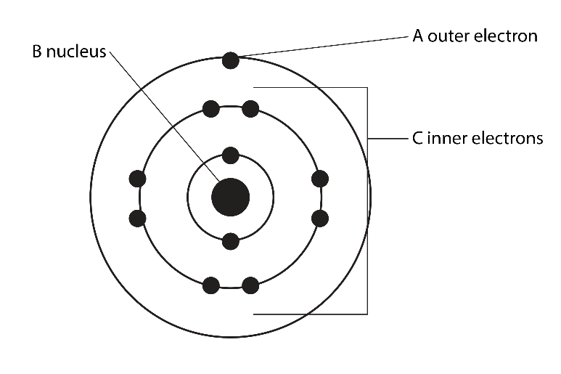

In the metallic structure diagram, state which part (or parts) of an atom are represented by:

|  |  |  |
| --- | --- | --- |
| (a) | A small red circle with negative sign in the centre. | _________________________________________________________ |
| (b) | A larger pale orange circle with a black cross in the centre. | _________________________________________________________ |

1. An aluminium atom has 13 electrons.
2. Draw the electron configuration diagram of an aluminium atom.
3. State the number of protons in the nucleus of an aluminium atom. ______
4. Use the electron configuration diagram to determine the charge of an aluminium ion. ________
5. Draw a diagram to show which part of an aluminium atom is represented by the following part of a metallic bonding diagram:

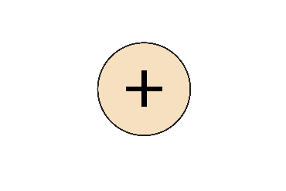

1. Give the number of delocalised electrons from each aluminium atom. Give reasons for your answer.

__________________________________________________________________________________

__________________________________________________________________________________

1. Describe the nature of metallic bonding. Answer in terms of forces of attraction.

__________________________________________________________________________________

__________________________________________________________________________________

__________________________________________________________________________________

1. Different diagrams are used to represent the model for metallic bonding. Sometimes the delocalised electrons are described as a ‘sea of electrons’.

The diagram below shows a diagram of this model.

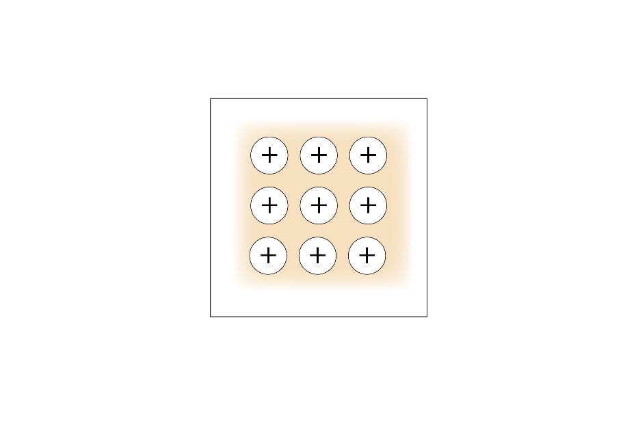

1. Describe how this model helps to explain why a metal can conduct electricity.

__________________________________________________________________________________

__________________________________________________________________________________

__________________________________________________________________________________

__________________________________________________________________________________

__________________________________________________________________________________

1. Give two disadvantages of this model.

__________________________________________________________________________________

__________________________________________________________________________________

__________________________________________________________________________________

__________________________________________________________________________________

__________________________________________________________________________________

__________________________________________________________________________________

__________________________________________________________________________________