Ionic structure

This resource is from the **Johnstone’s triangle** series which can be viewed at: [rsc.li/3M0gZzQ](https://rsc.li/3M0gZzQ)

Use this resource after completing our **Ionic bonding in table salt: Johnstone’s triangle** worksheet which can be viewed at: [rsc.li/3WGzpdx](https://rsc.li/3WGzpdx)

Learning objectives

|  |  |  |
| --- | --- | --- |
| **LO** | **Objective** | **Where assessed** |
| **1** | Recognise a diagram that shows the structure of sodium chloride. | Q1 |
| **2** | Draw electronic structure diagrams of common ions. | Q2a and b |
| **3** | Use the idea of electron energy levels to compare the size of ions. | Q2c |
| **4** | Interpret ionic lattice diagrams of an unfamiliar ionic compound. | Q3 |

How to use the resource

Use these questions to develop your learners’ mental models of the different structures of carbon. The icons in the margin indicate which level of understanding the question is developing. Ask learners to first complete the **Ionic bonding in table salt: Johnstone’s triangle** worksheet, then refer to it to support them in answering these questions.

|  |  |
| --- | --- |
| An icon used to indicate the Macroscopic part of Johnstone's triangle. | **Macroscopic:** what we can see. Think about the properties that you can observe, measure and record. |
| An icon used to indicate the Sub-microscopic part of Johnstone's triangle. | **Sub-microscopic:** smaller than we can see. Think about what is happening at a particle or atomic level. |
| An icon used to indicate the Symbolic part of Johnstone's triangle. | **Symbolic:** how we represent what is happening. Think about the models you use to represent what you cannot see including diagrams and symbols. |

For questions with the ‘macroscopic’ icon in the margin, it is useful for learners to observe these macroscopic properties first-hand. You can circulate examples of substances in the classroom or show a teacher demonstration of properties. For questions with the ‘symbolic’ icon in the margin, it is useful for learners to have physical models to use and manipulate, such as a Molymod™ kit.

You can use this resource in a variety of ways. It works best as a follow up activity to an initial teaching or discussion of ionic structure. Use the worksheet straight away in the same lesson or as a homework. If completing as an in-class activity it is best to pause and check at intervals, as often one question builds on the previous one. You can also use the resource as a retrieval/revision activity later on to check that students do not have any misconceptions. Depending on the learners, the activity should take from 15 to 30 minutes. The resource works well as a worksheet for independent work but you can also use the questions for group or class discussions.

Scaffolding

The earlier questions are designed to be accessible to all learners. The activity becomes more challenging in the latter stages. You can choose to give extra explanations for the more challenging questions.

Answers

1. E
2. (a)

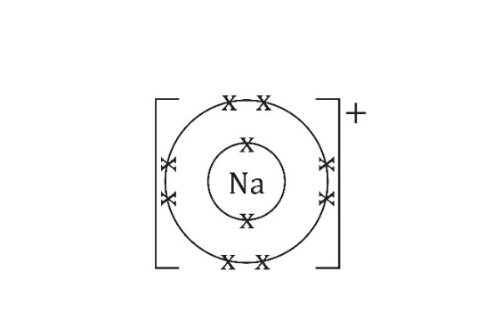

1. 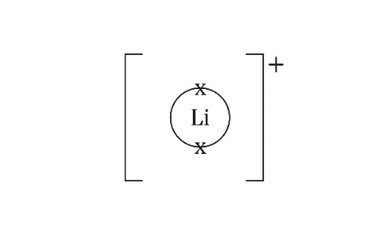

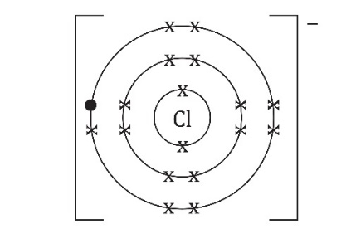

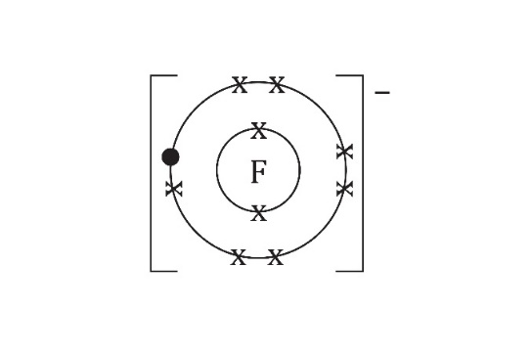

1. A sodium ion is **smaller** than a chloride ion.
2. A chloride ion is **larger** than a fluoride ion.
3. A lithium ion is **smaller** than a fluoride ion.
4. 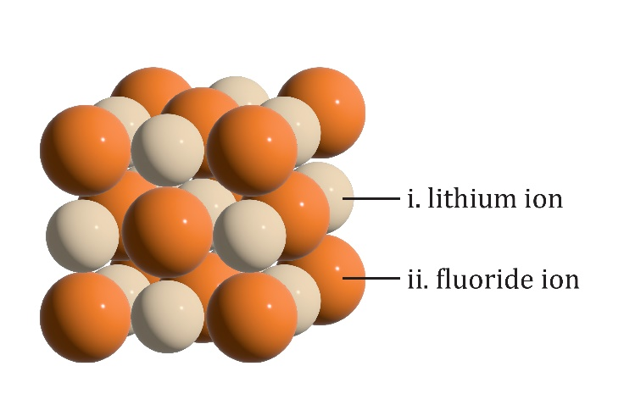
5. (a) The lithium ions in lithium fluoride are much smaller than the fluoride ions. The caesium ions are closer in size to the chloride ions. Fewer chloride ions can fit around each caesium ion so the pattern of ions in the lattice has to be different.
6. The ball-and-stick model shows more clearly how the ions are arranged. It is easier to see how many chloride ions surround a caesium ion. The model shows the ionic bond as separate sticks when an ionic bond is an attractive force not an object.  
     
   The space-filling model shows the ionic lattice more clearly as a lattice of spherical ions but it is harder to see or work out the arrangement of ions as it does not show the inside of the structure.