Cool it

Learning objectives
- Describe and explain the changes that take place during an endothermic reaction.
- Devise a method to lower the temperature of water at room temperature to 6.5°C.
- Write an investigation report including what you did, your results and conclusion.

Introduction

As our planet continues to warm, scientists are looking for new solutions to keep both us and fresh food products cool. Scientists are currently investigating a number of different cooling technologies, some of which depend on endothermic changes.

Questions

- Give two ways in which cooling technology contributes to global warming.

1. _______________________________________________________________________________

__________________________________________________________________________________

__________________________________________________________________________________

2. _______________________________________________________________________________

__________________________________________________________________________________

__________________________________________________________________________________

- Define an endothermic reaction.

__________________________________________________________________________________

__________________________________________________________________________________

__________________________________________________________________________________
- The reaction between citric acid and sodium hydrogencarbonate is endothermic. Predict how the temperature of the surroundings will change during the reaction.

__________________________________________________________________________________

__________________________________________________________________________________

- Sketch a reaction profile for the reaction between citric acid and sodium hydrogencarbonate on the axis below:

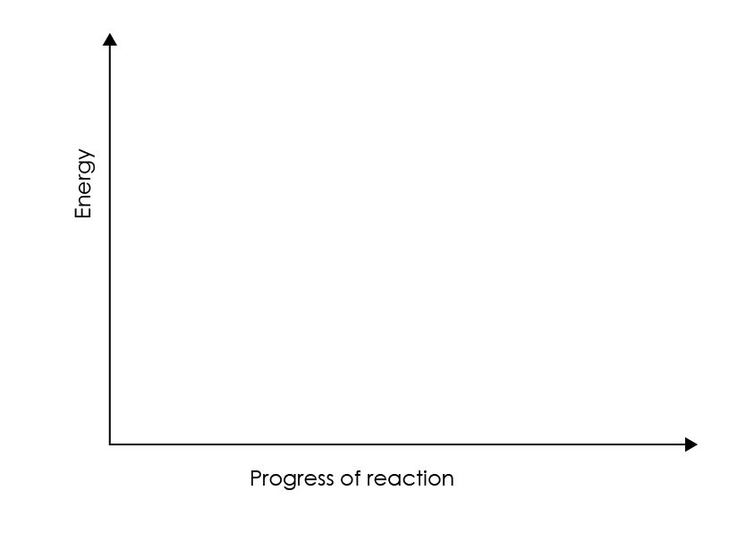

Explain the shape of your profile.

__________________________________________________________________________________

__________________________________________________________________________________

__________________________________________________________________________________

__________________________________________________________________________________

__________________________________________________________________________________

Cooling investigation

Using the samples of citric acid and sodium hydrogencarbonate provided, devise a method to reduce the temperature of water to 6.5°C. The temperature should be reached 1 minute after the reaction starts.

Make sure you consider health and safety in your plan. Check your plan with your teacher before starting the experiment.

When you have completed the practical work, write up a report of your investigation including what you did, your results and conclusion.

Equipment and materials

Safety glasses.

General
- Polystyrene cup and lid
- -10 to +100°C thermometer
- Stirring rod
- Stop watch
- Spatula
- Two 50 cm³ measuring cylinders
- Deionised or distilled water

Per group
- 10 g citric acid
- 10 g sodium hydrogencarbonate

Group report

Use the following headings in your report:
- Problem
- Method
- Results
- Conclusion

Members of your group could be responsible for a section each. You may use diagrams and photographs to show the equipment and set-up.

