Atomic structure

1. (a) Complete the sentences by selecting the correct words from those provided. You can use the words more than once.

protons neutrons electrons

An atom consists of a nucleus surrounded by __________________ in shells. The nucleus of most atoms contains __________________ and __________________.

All atoms of the same element have the same numbers of __________________ and __________________.

(3 marks)

The diagram represents an atom of beryllium.

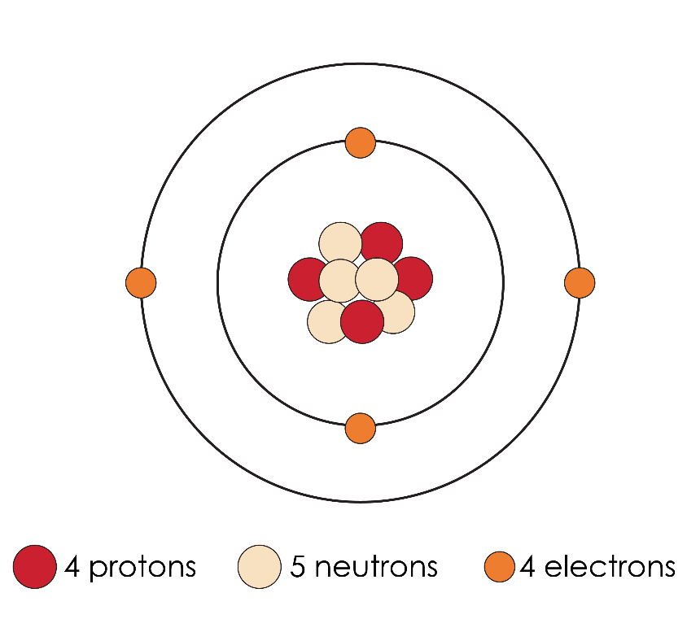

* 1. State the atomic number of beryllium.

_____________________________________________________________________________________ (1 mark)

* 1. State the mass number of beryllium.

_____________________________________________________________________________________ (1 mark)

* 1. An atom of sodium can be represented as:

Complete the symbol for beryllium:

(1 mark)

* 1. Complete the table to show the relative masses and charges of the   
     sub-atomic particles.

|  |  |  |
| --- | --- | --- |
| **Sub-atomic particle** | **Relative mass** | **Relative charge** |
| proton | 1 | +1 |
| neutron |  |  |
| electron |  |  |

(2 marks)

* 1. Explain why an atom of beryllium has no overall electrical charge.

____________________________________________________________________________

____________________________________________________________________________

(1 mark)

1. Atoms are very small.
2. Where is most of the mass of an atom found?

_____________________________________________________________________________________ (1 mark)

1. Which is the correct approximate radius of an atom? Circle the correct answer.

(1 mark)

1. m
2. m
3. nm
4. nm

**3** (a) Which equation shows how the number of neutrons in an atom can be calculated from its atomic number and mass number? Circle the correct answer.

(1 mark)



(b) These are the atomic numbers and mass numbers of some atoms. Complete the table to show the numbers of protons, neutrons and electrons. Some have been done for you.

|  |  |  |  |  |  |
| --- | --- | --- | --- | --- | --- |
| **Atom** | **Atomic number** | **Mass number** | **Number of protons** | **Number of neutrons** | **Number of electrons** |
| aluminium | 13 | 27 | 13 |  |  |
| phosphorus | 15 | 31 |  | 16 |  |
| scandium | 21 | 45 |  |  | 21 |

(3 marks)

**4** These diagrams represent atoms of isotopes of carbon.

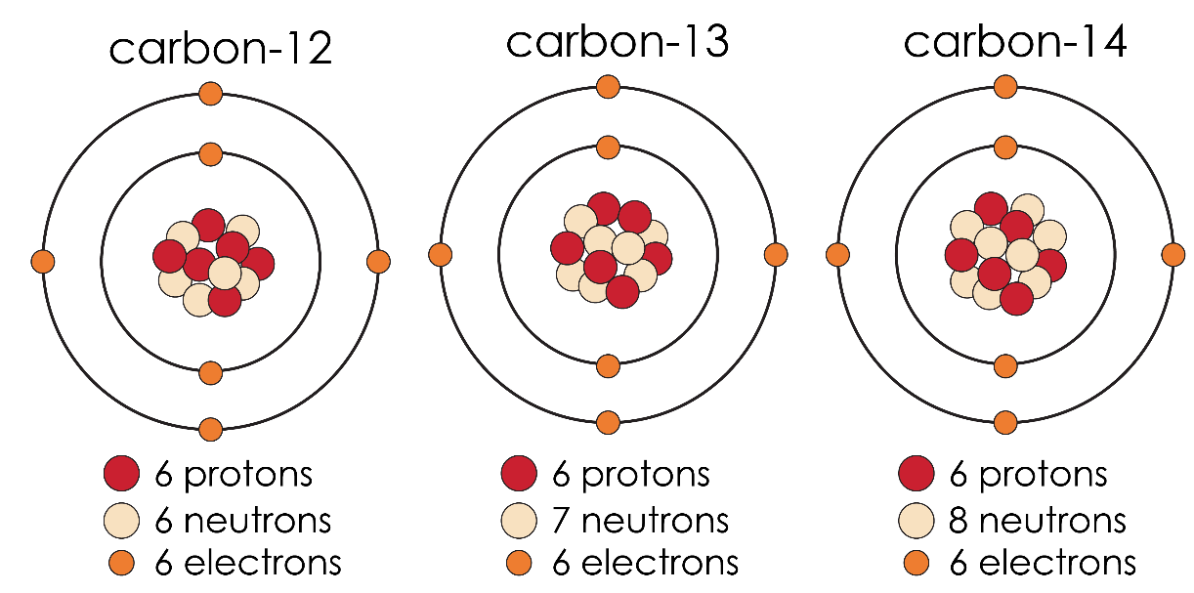

Source: Adapted from © Shutterstock

* 1. Complete the sentences defining isotopes by adding the correct words from those provided.

atomic mass protons neutrons electrons

Isotopes of an element have the same number of __________________ and __________________, but different numbers of __________________.

They have the same __________________ number but different __________________ numbers.

(5 marks)

* 1. The symbol for carbon-12 is . Write similar symbols for:

1. carbon-13 __________________________________________________ **(1 mark)**
2. carbon-14 __________________________________________________ **(1 mark)**
   1. Two isotopes of chlorine are and .
3. How many neutrons are present in one atom of ?

______________________________________________________________ **(1 mark)**

1. How many neutrons are present in one atom of ?

______________________________________________________________ **(1 mark)**

[Total: 24 marks]

Which question(s) did you get wrong? Why?

What will you do next time you’re asked a similar question?