Ionic structure and bonding in rubies

Rubies, like the one shown in the diagram, are valuable gemstones. They are used to make stunning jewellery, as well as being used as parts in watches and lasers.

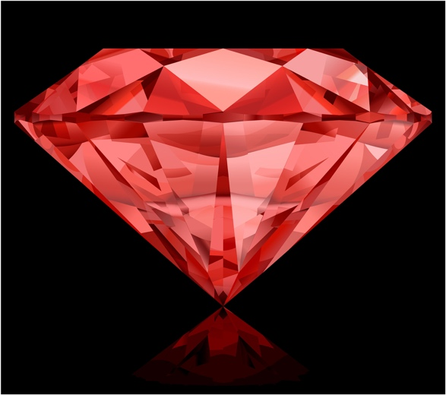

Source: © Shutterstock

1. Rubies are mostly made up of the ionic compound aluminium oxide.
   1. Which of the following describes the structure of a ruby?

Circle the correct answer.

**A** giant covalent

**B** giant ionic

**C** metallic

**D** simple molecular

* 1. Aluminium is in group 3. What is the charge on an aluminium ion?

Circle the correct answer.

**A** 1+

**B** 2+

**C** 3+

**D** 4+

* 1. What type of forces make the ionic bond between the aluminium ions and oxide ions?

____________________________________________________________________________

* 1. Which of the following is most likely to be the melting point of a ruby crystal?

Circle the correct answer.

**A** 100°C

**B** 0°C

**C** 100°C

**D** 2000°C

1. The dot and cross diagram shows the arrangement of electrons in   
   aluminium oxide.

Two aluminium ions shown as two separate circles containing the symbol Al enclosed within square brackets with a three plus written at the top right corner on the outside of the right hand bracket. 
Next to the two Al ions are three oxide ions drawn as three circles containing the symbol O enclosed within square brackets and a two minus at the top right corner on the outside of the right hand bracket. Each circle has six dots and two crosses drawn onto it.

* 1. What is the chemical formula of aluminium oxide?
  2. The ions in aluminium oxide are arranged in a giant lattice. A giant lattice contains a large number of ions. Consider a small part of the lattice containing 20 aluminium ions. How many oxide ions will it have?

____________________________________________________________________________

* 1. Complete the table to show the electron configurations of the ions in aluminium oxide.

|  |  |  |
| --- | --- | --- |
| **Element** | **Electronic configuration of atom** | **Electronic configuration of ion** |
| aluminium | 2, 8, 3 |  |
| oxygen | 2, 6 |  |

* 1. Which noble gas has the same electron configuration as:

1. an aluminium ion?
2. an oxide ion?

[Hint: use your periodic table]

1. (a) Calculate:

i. the relative formula mass, *M*r, of aluminium oxide, .

*A*r aluminium = 27 *A*r oxygen = 16

*M*r  (2 __________________) (3 __________________)

__________________ __________________

__________________

ii. the percentage by mass of aluminium in aluminium oxide, .

Give your answer to one decimal place.

of Al in .

(b) A ruby weighs 0.20 g. Calculate the mass of aluminium it contains. Assume the ruby is pure aluminium oxide.

Give your answer to two decimal places.

Hint: Consider your answer to **question 3(a) ii**.

(c) Pure aluminium oxide crystals are colourless and clear. The ruby is red because it contains 0.05% chromium(III) oxide, , as an impurity.

Calculate the mass of chromium(III) oxide the 0.20 g ruby contains. Give your answer in grams.

Which question(s) did you get wrong? Why?

What will you do next time you’re asked a similar question?