# 4D bioprinting

***Education in Chemistry***May 2020  
[rsc.li/35DFlcB](https://rsc.li/35DFlcB)

## 3D and 4D printing is becoming of increasing use in the healthcare industry. In this activity you will look at some of the polymers used in 3D and 4D printing.

## Bioinks

Biological materials that can be 3D printed are called bioinks.

Bioinks generally consist of a support medium with live cells embedded in them. The support mediums are usually gels that can flow under the right conditions, and they need to be biocompatible.

Gelatine, collagen, cellulose and alginates are all used as support media. Often a combination of these materials are used.

Cellulose and alginates are polysaccharides.

Cellulose is composed of glucose molecules joined together in a condensation reaction. **Figure 1** shows the repeating unit of cellulose.

**Figure 1**

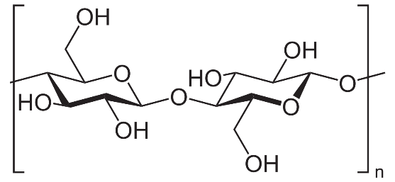

* 1. What other substance will be formed in the condensation reaction between glucose molecules to form cellulose?
  2. What is the functional group linking the glucose molecules together in cellulose?
  3. Several cellulose chains can often line up closely together to form strong microfibrils. Explain what sort of intermolecular force holds the chains together.

Gelatine and collagen contain polypeptides. A typical length of polypeptide in gelatine contains a glycine (Gly) residue every third residue in the chain (eg -Ala-Gly-Pro-Arg-Gly-Glu-).

Glycine has the structure NH2 – CH2 – CO2H. Alanine has the structure

* 1. Give the IUPAC names for glycine and alanine.
  2. Explain why glycine does not rotate plane polarised light.
  3. Draw the structure of a dipeptide formed between alanine and glycine.

## Polymers used in 4D printing

Biodegradable polymers are used to make stents and splints using 4D printing.

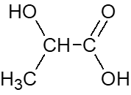Two polymers used are polylactic acid and polycaprolactone.

Polylactic acid is made from lactic acid. The structure of lactic acid is:

* 1. Give the IUPAC name for lactic acid.
  2. Lactic acid molecules join together to form a polyester. Draw three repeating units of polylactic acid.
  3. Two lactic acid molecules can also react together to form a cyclic diester. Draw the structure of the cyclic diester.

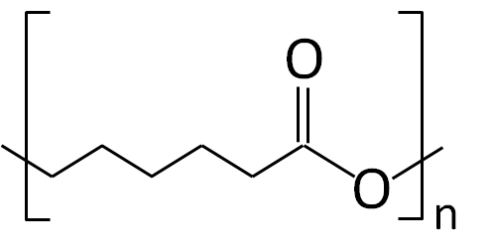

The repeating unit of polycaprolactone is

The monomer caprolactone is a cyclic ester.

During the polymerisation reaction the C-O bond breaks in the cyclic ester and it joins to other monomer molecules to form the polymer.

* 1. Draw the skeletal formula of caprolactone.
  2. Explain why polylactic acid and polycaprolactone are both biodegradable.