Covalent bonding: Johnstone’s triangle

This resource is from the **Johnstone’s triangle** series which can be viewed at: [rsc.li/3LWofwD](https://rsc.li/3LWofwD). Use this resource alongside our **Developing understanding** worksheets which can be downloaded from: [rsc.li/3WXETCj](https://rsc.li/3WXETCj)

Learning objectives

1. Describe a covalent compound based on observations.
2. Use symbolic models to represent a covalent compound.
3. Explain how the type of bonding in a covalent compound relates to the properties you can observe.

How to use Johnstone’s triangle

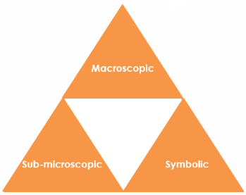Use Johnstone’s triangle to develop learners’ thinking about scientific concepts at three different conceptual levels:

* Macroscopic – what we can see
* Symbolic – what we use to represent what we’ve seen
* Sub-microscopic – smaller than we can see

For learners to gain a deeper awareness of a topic, they need to understand it at all three levels.

Read more about how to use Johnstone’s triangle in your teaching with these *Education in Chemistry* articles:

* Develop deeper understanding with models: [rsc.li/3YFHVw6](https://rsc.li/3YFHVw6)
* Improve students’ understanding with Johnstone’s triangle: [rsc.li/3SGQi6U](https://rsc.li/3SGQi6U)

Scaffolding

It is important to share the structure of the triangle with learners prior to use. Tell them why you want them to use the triangle and how it will help them to develop their understanding.

Ask learners to complete the Johnstone’s triangle worksheet independently, in small groups or as a whole class activity.

Use an ‘I try, we try, you try’ approach when you are introducing Johnstone’s triangle for the first time, as detailed in the article *Develop deeper understanding with models*, link above.

Next steps

Get your students to use the completed Johnstone’s triangle as a support document to refer back to when they move on to complete the associated **Developing understanding** worksheet ([rsc.li/3WXETCj](https://rsc.li/3WXETCj)).

These worksheets contain icons in the margin referring to the level of thinking needed to answer the question.

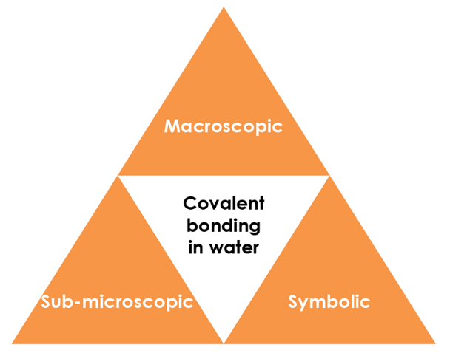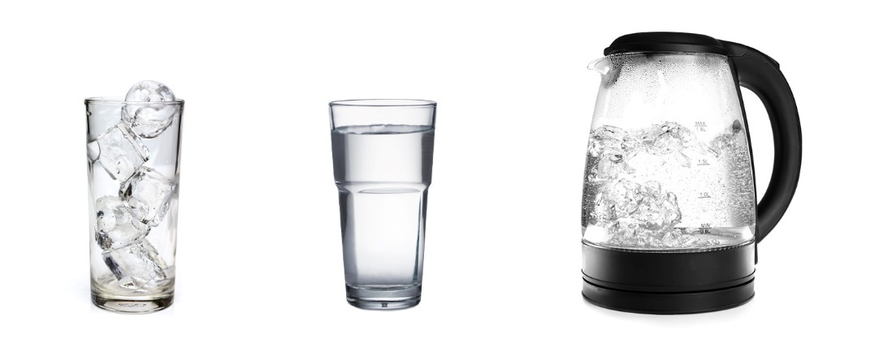

Macroscopic

What do we observe?

Observe water in the solid, liquid and gas state.

Note to teacher: *if possible, demonstrate these during the lesson.*

What is the freezing and boiling temperatures of water?

**Freezing point = 0°C, Boiling point = 100°C**

What state is water in at room temperature?

**Water is a liquid at room temperature.**

What do you see when water boils?

**Bubbles of gas form throughout the liquid and rise to the surface**.

Symbolic

How do we represent it?

What is the chemical formula of water?

Draw a particle diagram for water as a solid, liquid and gas.

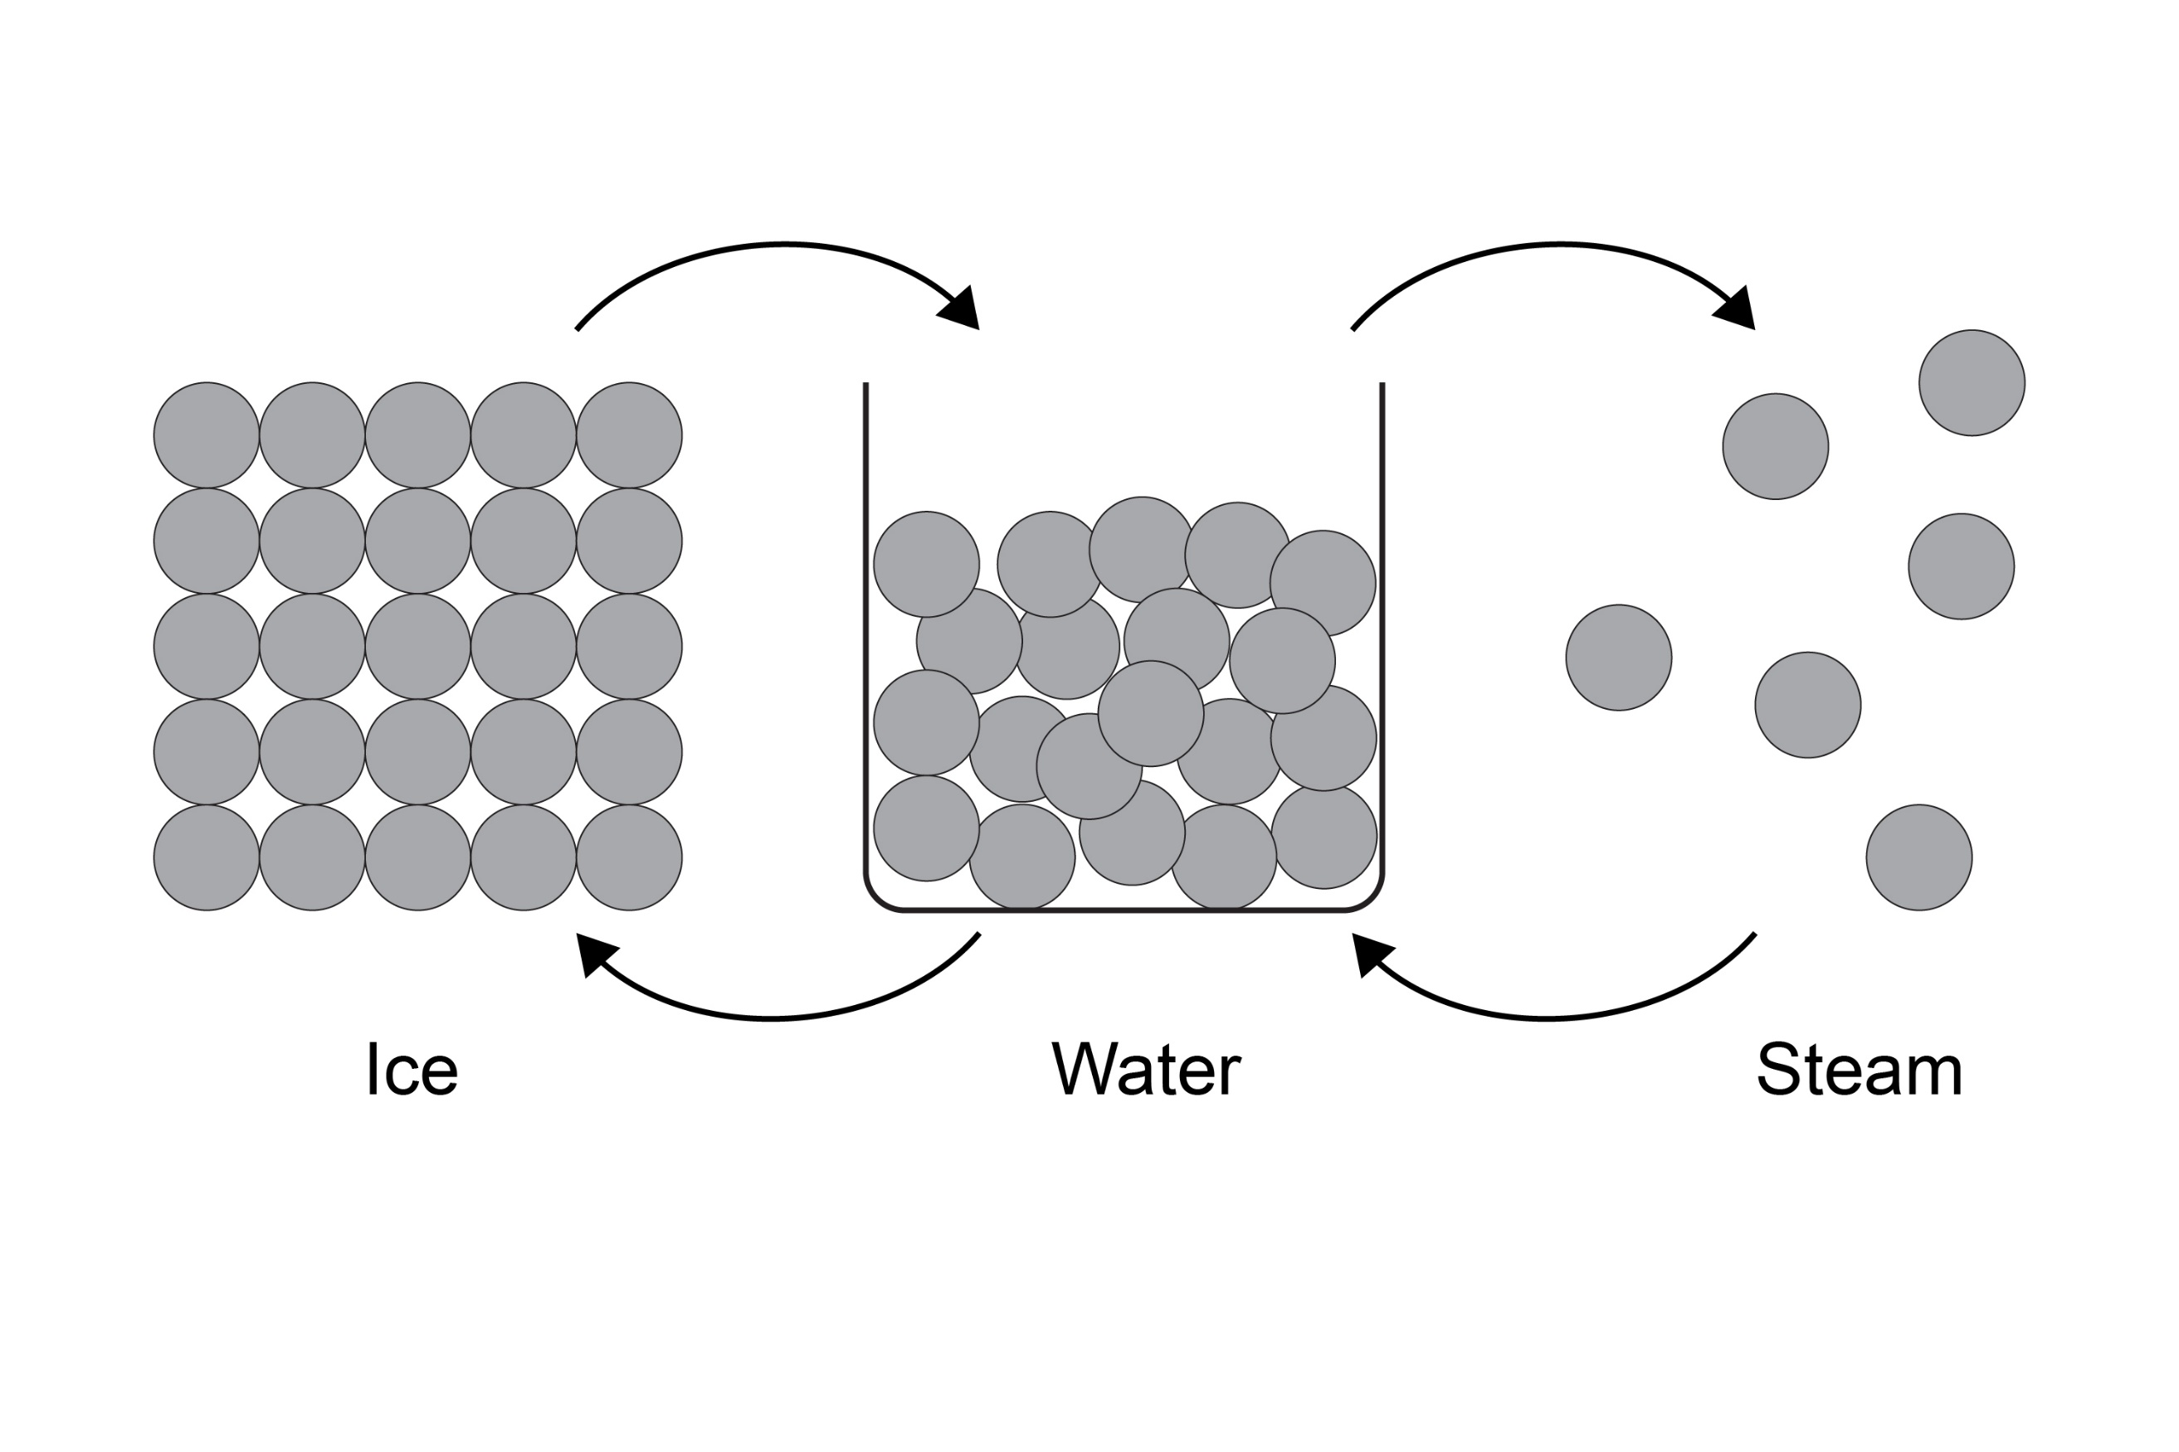

Draw a dot and cross diagram for water.

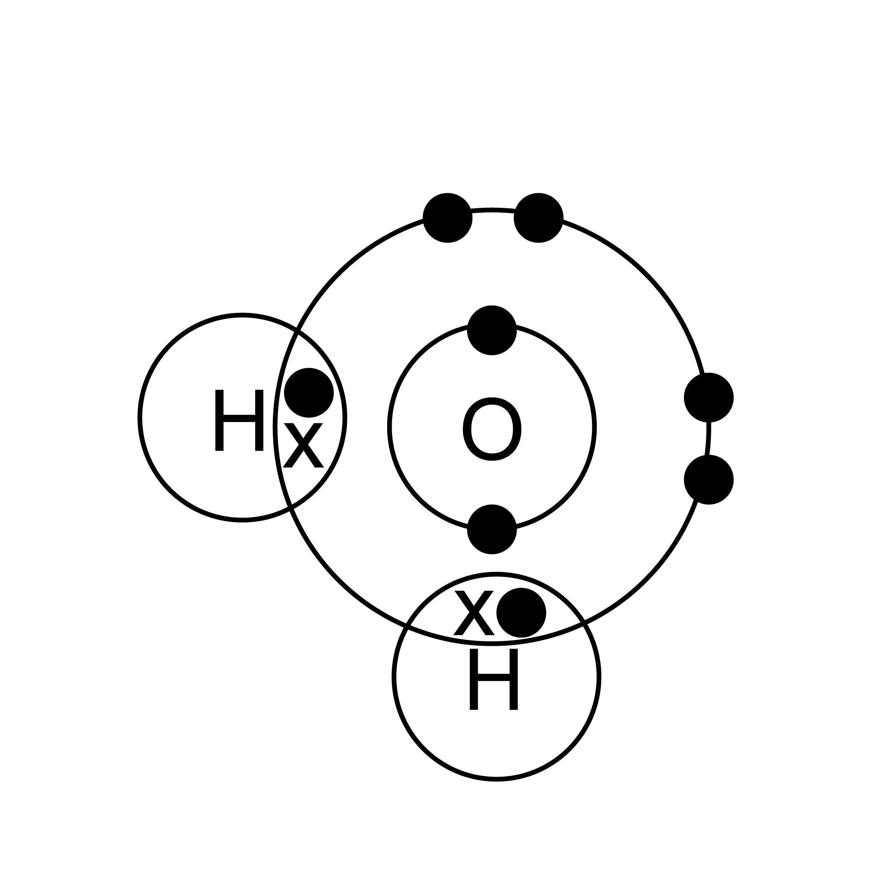

Sub-microscopic

What is happening that we can’t see?

Is water a simple covalent molecule or a giant covalent compound?

**Simple covalent molecule**

On the diagram below label a covalent bond and an intermolecular force.

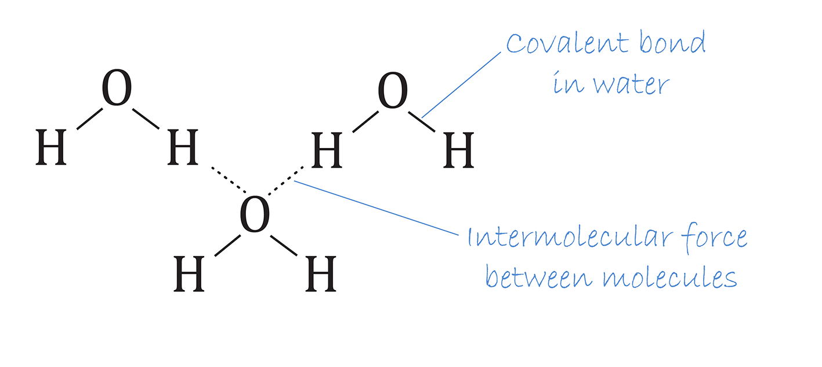  
Which of these are the strongest in water?

**covalent bond intermolecular force**