Melting and freezing stearic acid

Learning objectives

1. Determine the melting and freezing point of a sample of stearic acid by setting up and carrying out an experiment.
2. Carefully make temperature readings and record them in a table.
3. Plot and interpret a heating and/or cooling curve.
4. Use particle theory to explain what happens during melting and freezing.

Introduction

In this experiment, a solid turns into a liquid and then the liquid turns into a solid. The energy changes are examined.

Equipment

Apparatus

* Safety glasses
* Beaker (250 cm3)
* Boiling tube
* Thermometer (0–100°C)
* Stop clock
* Clamp, stand and boss
* Bunsen burner
* Tripod
* Gauze
* Heat resistant mat

Chemicals

* Stearic acid (octadecanoic acid) (less than 5 g)

Health and safety

* Wear eye protection
* Do not handle hot equipment

Method

1. Put about 150 cm3 water into the beaker.
2. Heat it on a tripod and gauze until the water just starts to boil.
3. Set up the apparatus as shown in the diagram and start the timer. Keep the water boiling, but not vigorously.
4. Using a suitable results table, record the temperature of the stearic acid every minute until it reaches about 80°C. Note on your results table the point at which you see the solid start to melt.
5. Use the clamp stand to lift the tube from the hot water. Record the temperature every minute as the stearic acid cools until it reaches about 30°C. Note on your results table the temperature at which you see the stearic acid begin to solidify.

Diagram

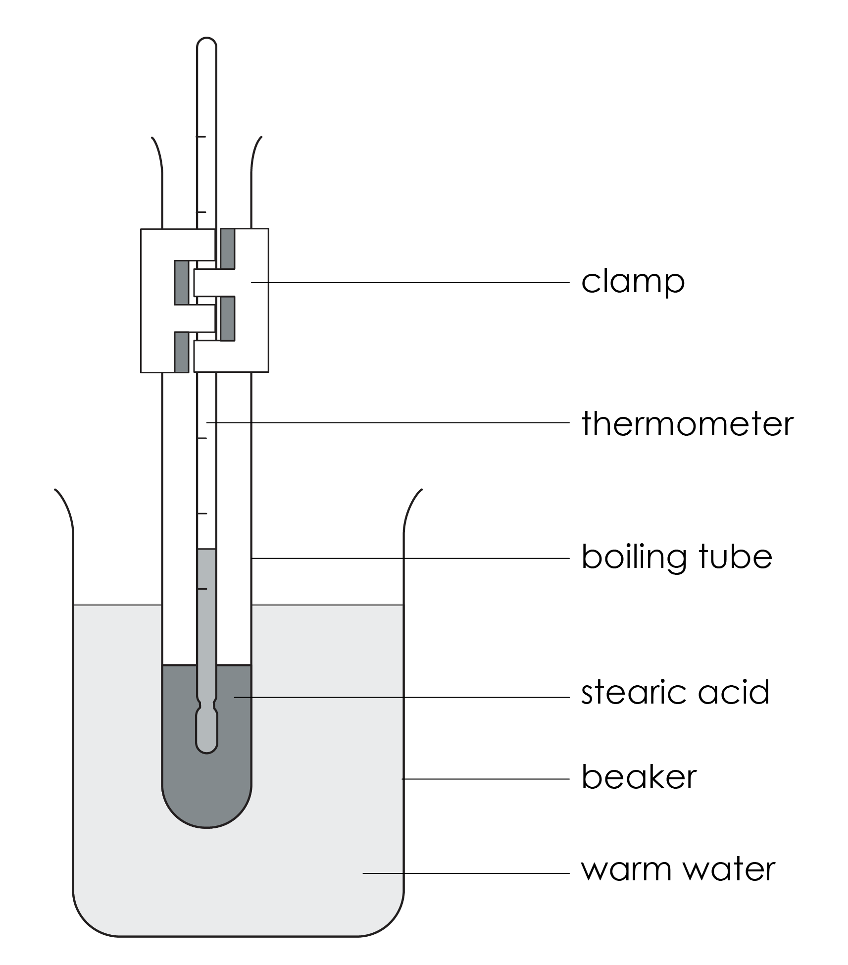

Questions

1. Plot a graph of the results and draw a line of best fit.
2. Describe the shape of the line graph you have drawn.

__________________________________________________________________________________

__________________________________________________________________________________

__________________________________________________________________________________

__________________________________________________________________________________

1. Label the parts of that graph that show stearic acid:
2. as a solid
3. as a liquid
4. melting
5. freezing
6. Use your graph to determine the:
7. melting temperature
8. freezing temperature
9. Draw a diagram to show how the particles are arranged in:

|  |  |
| --- | --- |
| 1. Solid stearic acid | 1. Liquid stearic acid |
|  |  |

1. Use particle theory to explain what happens when stearic acid melts.

__________________________________________________________________________________

__________________________________________________________________________________

__________________________________________________________________________________

__________________________________________________________________________________

__________________________________________________________________________________

__________________________________________________________________________________

__________________________________________________________________________________

__________________________________________________________________________________

__________________________________________________________________________________

__________________________________________________________________________________