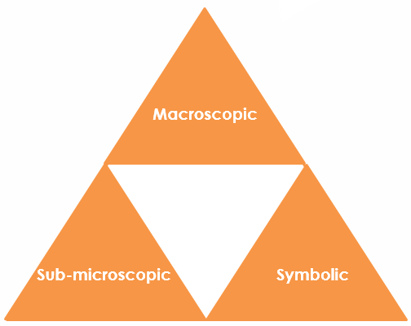Metallic bonding in copper: Johnstone’s triangle

Learning objectives

1. Describe a metal and its uses based on observations.
2. Use symbolic models to represent metallic bonding.
3. Explain how the type of bonding in a metallic compound relates to the properties you can observe.

Introduction

Copper is a metal with many uses in electrical appliances, plumbing, building and for its aesthetic qualities.

Johnstone’s triangle

In chemistry we make sense of the things that we can see by representing what we can’t see using formulas, equations, diagrams and models.

Johnstone’s triangle is a way of thinking about these different concepts as different corners of a triangle:

* Macroscopic – what we can see. Think about the properties we can observe, measure and record.
* Sub-microscopic – smaller than we can see. Think about the particle or atomic level.
* Symbolic – representations. Think about how we represent chemical ideas including symbols and diagrams.

Being able to connect and move between these three different levels is important for scientific understanding.



Macroscopic – what we can see

Match the common uses of copper below with the properties that make it suitable.

Electrical wires Ductile

Saucepans Malleable

Water pipes Lustrous (shiny)

Jewellery Good conductor of heat

Good conductor of electricity

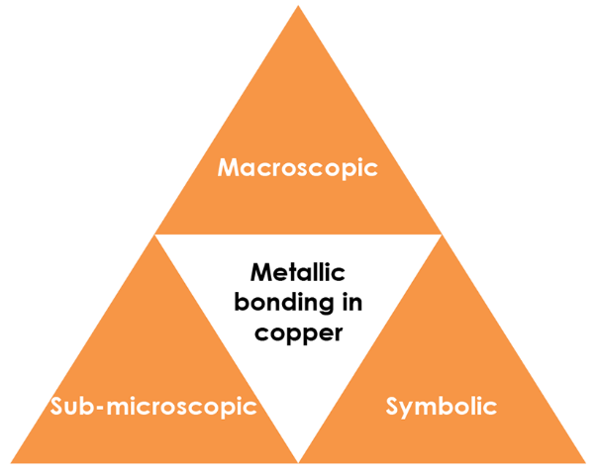

Symbolic – representations

Complete this metallic bonding diagram for copper by adding electrons.

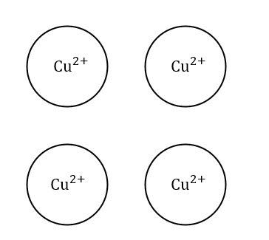

Sub-microscopic – smaller than we can see

With reference to the structure and bonding in metals explain why:

* Copper is malleable
* Copper is a good conductor of electricity