Seawater system slashes methane emissions

*Original article by Sean Browner. Adapted by Nina Notman.*

**Scientists develop reactor system to convert methane into carbon dioxide (CO2) using seawater**

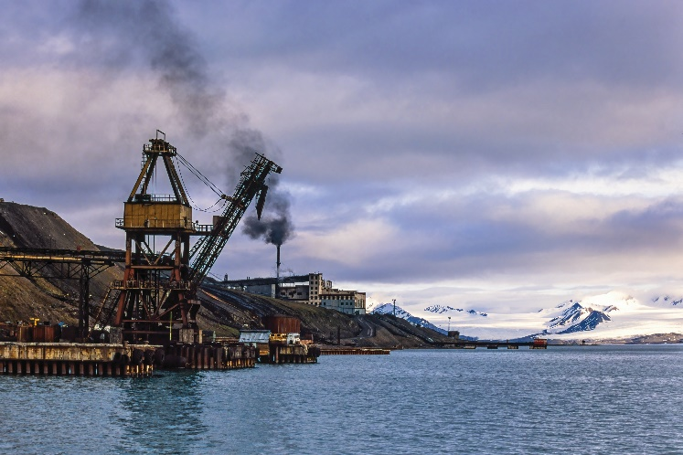A team of international researchers has developed a reactor system that they say could reduce methane emissions in the atmosphere. Methane is a potent greenhouse gas that traps heat in our atmosphere more effectively than carbon dioxide. It has accounted for a third of our planet’s warming since the industrial revolution.

*Source: © Lasse Johansson/Shutterstock*

Coal mines are one of the largest sources of methane emissions – this new method uses seawater to convert methane into the less harmful carbon dioxide

Slashing methane emissions will play a crucial role in limiting further warming. Since its launch in 2021, 159 countries have signed the Global methane pledge agreeing to reduce worldwide methane emissions by at least 30% from 2020 levels by 2030, a significant international commitment. Capturing human-caused methane emissions at the source will play an important role in achieving this goal.

**Brine breakthrough**

The research team led by Qingchun Yuan, at the Aston University, UK, is developing a new approach to tackling methane emissions from landfills and the ventilation exits of underground coal mines.

The system uses electricity and UV light to break down salt in seawater, creating highly reactive particles called chlorine radicals. These chlorine radicals are halogen atoms with an unpaired electron. They react with methane gas, oxidising it into less harmful carbon dioxide. The scientists say that they can recycle or store the reaction’s byproducts, including carbon dioxide, safely.

Development of the reactor system is currently in its early stages. The team need to do further research to determine its practicality in real-world settings and its cost-effectiveness compared to existing methane reduction methods, such as combustion for electricity generation.

This is adapted from the article **Chlorine radicals could be used to destroy methane heading for the atmosphere** in *Chemistry* *World.* Read the full article: [rsc.li/41UyatV](https://rsc.li/41UyatV)