F2 Counting protons, neutrons and electrons

Scale

|  |  |  |  |
| --- | --- | --- | --- |
| **Subatomic** | **Atom** | **Molecule** | **Giant structure** |
|  |  |  |  |

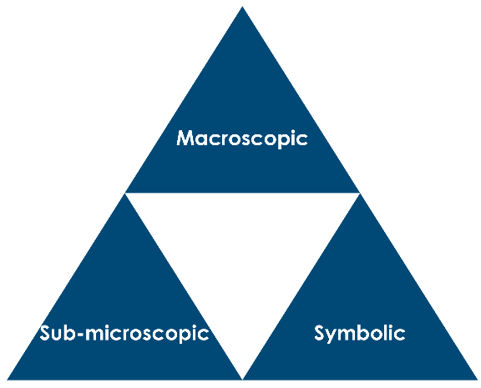

1. Write the symbol for a carbon-12 atom (i.e. 12C). Label the symbol, mass number and atomic number and state what the atomic number and mass number represent in terms of protons, neutrons and electrons.
2. Give the total charge on the nucleus of a sodium **atom**. Give the total charge on the electrons in a sodium atom. Explain why an atom is neutral overall.
3. State the scientific word that is used to describe two atoms with the same number of protons and a different number of neutrons.
4. Mass numbers are often indicated in text in the form carbon-12, where the 12 indicates the mass of the atom.
5. How many neutrons are there in carbon-12?
6. How many neutrons are there in carbon-13?
7. Write the nuclear symbols for two chlorine atoms, one with 18 neutrons and the other with 20 neutrons.
8. Write the names for the two isotopes above in the style described in question 4.
9. Compare the symbols for the chlorine atoms in question 5 to those in your periodic table. Explain why the relative atomic mass for chlorine is not a whole number.
10. Explain what happens to an atom when it forms:
11. an ion with charge +1
12. an ion with charge –1
13. Explain why a species with 18 electrons and an atomic number of 16 is not neutral overall.
14. Give the nuclear symbol for this species and show the charge.
15. Complete the atomic number, mass number and number of protons, electrons and neutrons of an element from the periodic table.

|  |  |  |  |  |  |
| --- | --- | --- | --- | --- | --- |
| **Species** | **Atom or ion?** | **Mass number** | **Number of protons** | **Number of electrons** | **Number of neutrons** |
| 9Be |  |  |  |  |  |
| 19F |  |  |  |  |  |
| 28Si |  |  |  |  |  |
| 29Si |  |  |  |  |  |
| **Species** | **Atom or ion?** | **Mass number** | **Number of protons** | **Number of electrons** | **Number of neutrons** |
| 96Nb |  |  |  |  |  |
|  | atom |  | 45 |  | 58 |
| 23Na+ |  |  |  |  |  |
| Cl- |  | 35 |  |  |  |
| O2- |  | 16 |  |  |  |
|  |  |  | 12 | 10 | 12 |
|  |  | 27 |  | 10 | 14 |

1. Explain **in terms of subatomic particles**, how the following species are similar and different.

|  |  |  |
| --- | --- | --- |
|  | **Similarities** | **Differences** |
| 19F- and 20Ne |  |  |
| 19F and 20Ne |  |  |
| 37Cl- and 41K+ |  |  |
| 5Be and 6Be |  |  |

1. Label the periodic table below to show groups, blocks and periods.

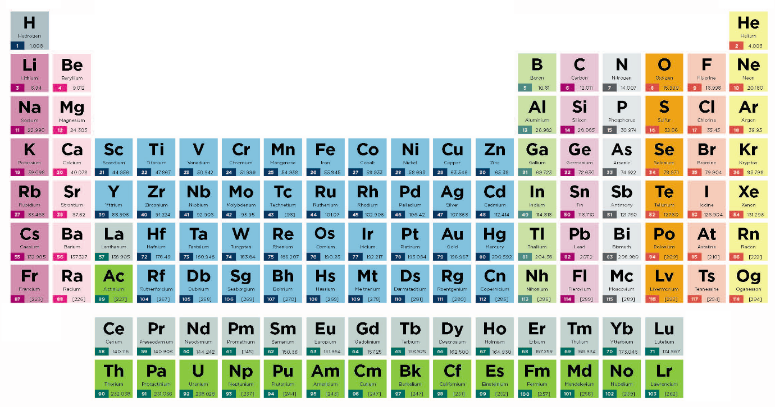

1. Describe in terms of **protons** how elements are arranged in the periodic table.

Hinge questions

1. Which of these atoms/ions has the most neutrons?
2. 29Al
3. 29Al+
4. 30Al
5. 31P
6. 32S2-
7. silicon-29
8. Which of these atoms/ions has the most protons?
9. 14N
10. 15N
11. 15N+
12. 15O
13. 19F-
14. carbon-14
15. Which of these atoms/ions has the most electrons?
16. 23Na
17. 23Na+
18. 24Mg
19. 24Mg2+
20. aluminium-27
21. 27Al3+
22. 19F-