Teaching rates of reaction post-16: assessment
Education in Chemistry
September 2021
rsc.li/3jV0WVq
A more creative way to assess whether students understand a concept is for them to apply their knowledge to solve a problem or to interpret and explain something. Try these four ideas.

Apply your knowledge of rates of reaction
- Watch the video of Rochelle’s salt reaction. What evidence suggests that the reaction is catalysed?
The reaction speeds up on addition of cobalt ions and the colour of the cobalt changes from pink to green and then back to pink.
- Describe and explain what the following diagram depicts.
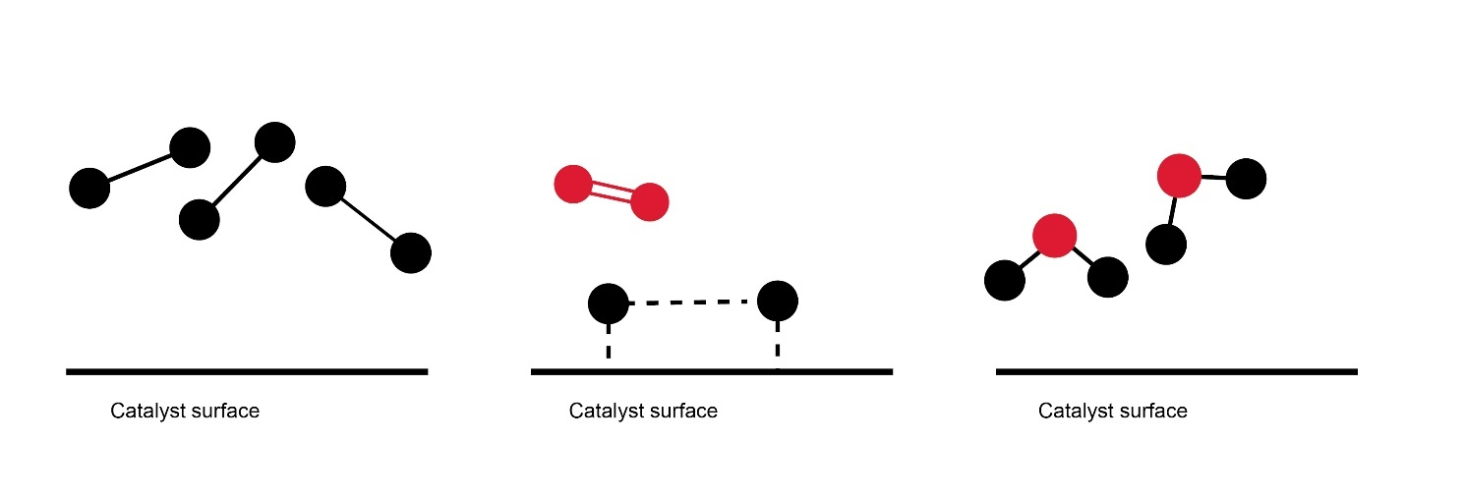
The catalysts hold the molecule in place increasing potential interaction times and the covalent bond is weakened because electron density is used to bond the molecule onto the catalyst’s surface.
- The following equations can be presented to students. Ask them to identify what represents the catalysts and what represents a transitional or intermediate state. What are the products? Can students write the overall equation for the reaction?
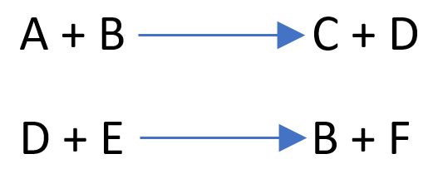
B = catalyst and D = intermediate/transitional species

- Now challenge students with this reaction equation. Can they identify the intermediate and catalyst species? Can they explain their choices?
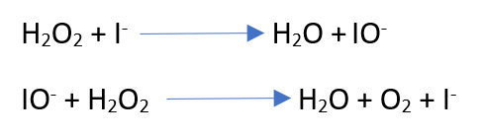
I⁻ = catalyst and IO⁻ is the transitional species

