Gold nanofilm can stop glasses fogging up

This resource forms part of the **particle model** topic package where you will find more resources to embed literacy skills development into your teaching. You can edit all the linked files in this resource to best suit the needs of your learners.

Learning objectives

1. Use active reading strategies to help you understand a science news story.
2. Use the glossary to support your understanding of unfamiliar words.
3. Know what key information to look for when reading a science news story.
4. Understand how people write about science differently depending on their audiences.
5. For extension – confidently talk about the science news story, with consideration for your audience.

Questions 3–6 in the student sheet support learning objectives 1 and 2. Question 6 supports learning objective 3. The ‘extra challenge with reading’ questions 1–3 support learning objective 4 and the ‘Present the news’ extension task supports learning objective 5.

Introduction

Reading about science is pivotal for understanding the world around us and the events and discoveries that effect our lives. In this reading comprehension, learners will actively engage with a simple text about a research article.

*Education in Chemistry* has collated and distilled a wealth of science research news stories (see [rsc.li/3YK8xv0](https://rsc.li/3YK8xv0)). This reading comprehension resource is based on one of these stories relevant to the **particle model** topic. This resource includes:

|  |  |  |
| --- | --- | --- |
|  | **Extension task** | |
| **Reading comprehension worksheet**  A simplified summary of a research article with comprehension questions and a glossary. | **Present the news slides**  Instructions for the extension task, plus hints and reflection questions. | **Present the news script**  A script template for learners to write into in groups. |

Reading comprehension activity

The story text has line numbers so you can easily direct learners to particular parts of the text. These can be disabled, more information: [bit.ly/4cHKkeW](https://bit.ly/4cHKkeW)

Model active reading

Read the story aloud with your learners and prompt them throughout to actively engage with the text. You can ask:

* ‘What do you think will happen next?’
* ‘How would you rephrase what’s just been said?’
* ‘What is this news story about’?

More info: [rsc.li/4jqaF3A](https://rsc.li/4jqaF3A)

Consider using playback or recording software, so that learners can listen to the text on a device as they read along.

Question 6 asks learners to write a summary of the news story for their classmates, using the prompts given. You can work through this question as a class first, before tasking learners to draw out the required information from the text independently. You can get learners to peer mark the summaries.

Extra challenge with reading

To answer the below challenge questions, learners will need access to a longer and more complex version of the reading comprehension text. This is available to download and print or can be viewed online. Learners will need a printed version to annotate in question 1. See: [rsc.li/4jDjBlG](https://rsc.li/4jDjBlG)

Scientists publish their findings in research articles. These are then written about by writers and journalists for different audiences. Research articles and other types of science writing can be very technical but they will mostly always cover the four prompts in question 6.

1. Read the story called ‘Gold nanofilm puts an end to foggy glasses’*.* This is based on the same research article but it is written for a different audience than the text at the top of your worksheet. With a pen or pencil, highlight bits of the article that link to each of the bullet points in question 6.

*Hint:* *You could number the bullet points 1–4 and use a different colour for each bullet point.*

1. How is this science writing different from the science writing at the top of this worksheet? Write down your answers.
2. Imagine you are a professional science writer. Explain how you would write about this research for:
3. a post on social media
4. a magazine article aimed at adults who work in the chemistry industry
5. a report for school that gets published on the school website for other learners to read, including learners who are younger than you.

*Hint: In each case, think about your audience (in other words, who will read it) and what they might want and need from the writing. This will help you answer the question.*

Glossary of relevant terms

The glossary is pre-populated with vocabulary from the story that learners may need support with. The Education Endowment Foundation recommends prioritising teaching tier 2 and tier 3 terms, which learners are less likely to hear or read outside of their science lessons. More information: [bit.ly/4imgii2](https://bit.ly/4imgii2)

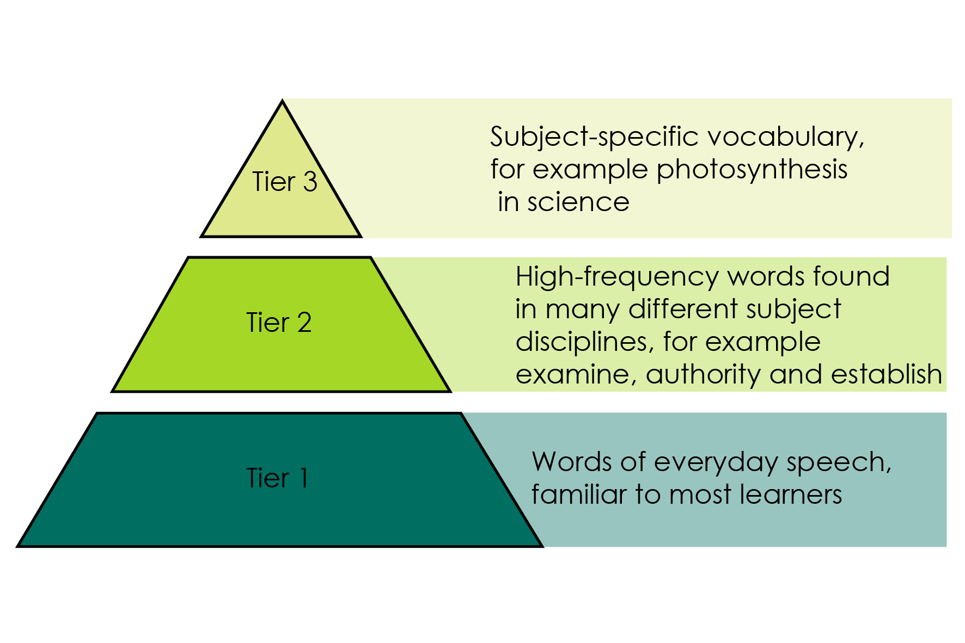Reproduced with permission from Guilford Press, copyright 2013.

The words listed in bold in the glossary are key terms and link with the key terms support resources (visit: [rsc.li/4cmvSbS](https://rsc.li/4cmvSbS)). For more challenge, remove or edit entries and task learners with researching and then populating the glossary.

Note: vapour is included in the glossary. It is in bold because it is a key term at 14–16, so learners will come across this word again.

Extension task: present the news

Instruct learners to present the science news story they have read as an item in a news programme.

Split learners into groups of three or four and assign each of them one of three roles – news anchor, reporter, or scientist. If there are more than three per group, assign multiple scientists. It’s important that everyone says something during the presentation.

* Project the ‘Present the news’ slides on the board. Explain the task (slide 2) and provide learners with printouts of what each role needs to do (slides 3–5).
* Talk through the slide called ‘What does a good news presentation look like?’ (slide 6) before inviting the groups to present (allow five minutes per group).
* Give learners the script template and direct them to prepare, as a group, what they want to say in the presentation. This will firstly involve reading the introduction on the script template, which you can do as a class if necessary. As a rough guide, allow about 45 minutes for learners to prepare.
* Direct learners to fill in the feedback sheet on the script template while their classmates are presenting. After all groups have presented, invite reflections and make notes of any learnings for the next speaking and listening activity.

Oracy Cambridge’s Oracy skills framework provides more information about speaking and listening skills. For more information, see: [bit.ly/4jBaTEG](https://bit.ly/4jBaTEG)

Metacognition

This resource supports learners to develop their metacognitive skills in three key areas.

|  |  |
| --- | --- |
| **Aspect** | **Ideas for prompts** |
| Plan | * Question 6 provides learners with a series of prompts to scaffold their summary of the science news story. * The ‘present the news’ script introduction contains questions for learners to ask themselves when planning the presentation, for example about keeping to time. |
| Monitor | * Ask learners questions when reading the text aloud (see section called model active reading’) to prompt them to monitor their understanding throughout the task. * The comprehension questions prompt learners to assess how much the active reading strategies help them to understand the text and what other strategies they can employ to aid their understanding. |
| Evaluate | * Invite feedback on answers to the questions which use the 1–10 scale and collate a reading strategies ‘cheat sheet’ as a class. Revisit this cheat sheet next time you do a reading comprehension activity. * Use the feedback sheet to reflect on the strengths of the presentations and identify things to work on next time you do a class speaking and listening activity. |

Example answers and guidance

1. Glasses help people who need them to see better. If you need glasses, then your eyes don’t bend incoming light in the right way to allow you to see clearly. The lenses on glasses make up for this by bending light so that it correctly hits the back of your eyes, which allows you to see clearly.
2. They are more likely to fog up when you walk from the outside into a warm building. This is because the water vapour in the air of the warm room cools down when it hits the relatively cold glasses and condenses into liquid. So, you end up with water on your glasses and this is what makes it difficult to see.
3. Condense: when a gas is cooled, energy is transferred from the gas to the gas’ surroundings and the gas turns into a liquid.
4. Nanofilm: a very thin layer of material which is nanometres thick.
5. Vapour: another word for a gas or mixture of gases.

Learners rate how much the glossary is helping them. Do a rough show of hands to gauge confidence and note learners’ responses.

1. Scientific words: nanofilm, condense, vapour, antifogging, contaminants, nanometre, absorbs, infrared, condensation. The point of this exercise is to prompt learners to consider which potentially unfamiliar words are specific to science or chemistry, compared to e.g. connecting words. The list above is an example and there may be variation in answers.
2. Look for a good understanding of the key message in the story. Example answer - glasses, gold layer, prevent condensation.

Learners rate how much circling words is helping them. Do a rough show of hands to gauge confidence and note learners’ responses.

Learners rate their confidence explaining the story. Do a rough show of hands to gauge confidence and note learners’ responses. Ask learners to share their strategies for the benefit of the class.

How learners rate the techniques in questions 3 and 4, and their confidence to explain the story, can inform your approach to future reading comprehension activities.

1. Invite learners to share what they’ve learned.
2. Indicative answers for summary of story

* *What have the scientists discovered? (Finding)*

Adding a very thin layer of gold coating on glasses can stop them from fogging up.

* *What was the problem they were trying to solve? (Context)*

Glasses can fog up when the wearer moves from a cold place to a warm place and the fogging can obscure vision.

* *Why does their discovery matter? (Relevance/application)*

It could mean glasses wearers can see better in different weather conditions. The phrase ‘readily scalable’ suggests it might be quite a quick development to implement.

It could apply to other types of glass too, for example glass used in car windscreens or windows.

There’s an implication that it’s better than other types of anti-fogging technology because other types attract contaminants.

* *Think about who it matters to and what impact it could have for them. (Impact)*

This matters to people who wear glasses, as it is inconvenient and potentially dangerous to not be able to see well.

This discovery could lead to non-fogging glasses which would mean people could have more consistent vision when transitioning between outside and inside.

This could be good news for people who make and sell glasses because it might lead to new products that they can make money from.

Extra challenge with reading - example answers

1. Learners should highlight the full article in different colours using the prompts. See the highlighted text below as an example.

* 1 - What have the scientists discovered?
* 2 - What was the problem they were trying to solve?
* 3 - Why does their discovery matter?
* 4 - Think about who it matters to, and what impact it could have for them.

**Gold nanofilm puts an end to foggy glasses**

Original article by Tim Wogan. Adapted by Nina Notman

**Self-warming coating containing a gold nanofilm stops surface fogging and outperforms current antifog technology**

A gold nanofilm coating for preventing fogging on spectacle lenses, and other transparent surfaces, has been developed by researchers in Switzerland. The coating selectively absorbs the infrared wavelengths of sunlight and converts this energy into heat, which warms the surface to prevent condensation. The coating is both scalable and durable, and has the potential to solve many of the issues with current antifog technologies.

Fogging occurs when warm, moist air encounters a relatively cold surface, causing water vapour to condense. Fogging on the lenses of glasses has always been an issue, especially when wearers come indoors on a cold day. The use of facemasks has made this much more of an issue. Car windows, windshields, mirrors and optical sensors are also susceptible to fogging.

**Striking gold**

The new coating was developed at ETH Zurich. It contains an approximately 5 nm thick gold layer sandwiched between two layers of titanium oxide. The coating is applied using vapour deposition, a manufacturing method already widely used in industry.

The coating selectively absorbs infrared energy from sunlight. Radiation in the visible range is not absorbed, which explains why the coating is transparent. When the sun is shining on it, the coating heats up the surface by around 8°C. ‘Even at very low sunlight intensity it’s still efficient,’ says Iwan Hächler, one of the researchers involved in developing the coating. ‘The slightest temperature increase has a very strong effect on the likelihood of fog forming,’ he adds.

Iwan and his colleagues tested their coating in a variety of applications, including on the spectacle lenses of an FFP2-mask wearer and on flexible polyester sheets. The coated surfaces performed far better than the uncoated surfaces they were tested against. The researchers have filed a patent application for this technology.

The article above has been truncated in these teacher notes, to save space. Visit Gold nanofilm puts an end to foggy glasses ([rsc.li/4jDjBlG](https://rsc.li/4jDjBlG))to access the full article.

1. Indicative list of differences.

* The article is longer.
* It uses subheadings to break up the text and inform the reader what each section is about e.g. ‘other approaches’.
* It goes into more detail about some parts of the story. For example, the shorter text mentions other antifogging coatings, but the longer article also talks about other ways of trying to stop fogging, including photothermal coatings.
* It talks about additional parts of the story, like who the scientists are, where they work and what other scientists think of the research. It also contains quotes from the scientists.

1. Look out for an awareness of different writing formats and an appreciation that different audiences have different needs or interests. For example:
2. shorter version, links to other interesting articles, key message up front
3. longer version, lots of detail including information on who did the research and maybe their contact information
4. simplifying complicated language, pictures to aid understanding.

Example script for Present the news

|  |  |  |
| --- | --- | --- |
| **Role** | **What to communicate** | **Example script** |
| News anchor | Introduce the issue – in one sentence, say how glasses fogging up is a problem. | If you wear glasses, you’ll know that when you walk from outside to inside on a cold day, glasses steam up and you can’t see properly for a while! |
| News anchor | Introduce the resolution – briefly say that scientists may have solved the problem. | But now scientists may have found a solution to the problem. |
| News anchor | Introduce your classmate reporter who will provide more information. | Our reporter [NAME OF REPORTER] has been looking into this… |
| Reporter | Talk about the problem in more detail, but only briefly. | Glasses fog up when warm air hits the cold lenses. When they do this, people wearing them cannot see very well and this can be dangerous. |
| Reporter | In one sentence, introduce the scientist/s and say what they have done to solve the problem. | [NAME OF SCIENTIST/S] has put a very thin layer of gold onto glasses. This stops the fogging. |
| Reporter | Ask the scientist how adding gold stops glasses fogging up. | Hello [NAME OF SCIENTIST/S]. How exactly does this work? |
| Scientist | Tell the reporter how gold on glasses lenses stops them fogging up. | The gold makes the lenses on the glasses warmer, because it absorbs a bit of energy from sunlight.  Fogging is **condensation** – it’s water vapour from the air hitting the cold lenses and therefore changing from gas to liquid.  So, since the lenses are warmer with the very thin gold layer on, less condensation happens. |
| Reporter | Ask the scientist why this discovery is important. | Why is this discovery important – what might it mean for people who wear glasses? |
| Scientist | Explain what difference this research could make to people. | A lot of people rely on glasses to see clearly and fogging gets in the way.  So, if people wear glasses with this thin gold coating on, this won’t happen as much and people won’t have this problem. |
| Reporter | Ask the scientist what they need to do next. | What do you need to find out next, to get these glasses to people who need them?  For example, if the gold makes the glasses warmer by absorbing energy from sunlight, will this coating work in the dark? |
| Scientist | Tell the reporter what else we need to know in order to move closer to getting these new glasses to people. | Good question! We need to test that. But we do know it works even with very low sunlight levels.  There are many things to find out next. For example, we need to know how much these glasses will cost, compared to uncoated glasses. |
| Reporter | Thank the scientist. | Thank you very much [NAME OF SCIENTIST/S]. |
| Scientist | Acknowledge the thanks. | Thank you. |
| News anchor | Say something in response to what the scientist and the reporter have said, which reflects what your audience might be thinking. Thank the reporter. This will end the presentation. | I’m looking forward to seeing these glasses in the shops! [NAME OF REPORTER] reporting there, speaking to [NAME OF SCIENTIST/S] Thank you all. |

Acknowledgements

Vocabulary tier diagram - Beck, Isabel L., Margaret G. McKeown, and Linda Kucan. *Bringing Words to Life: Robust Vocabulary Instruction*. New York: Guilford Press, 2013.